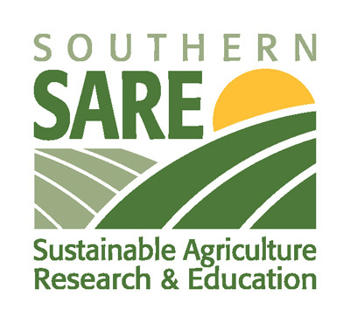
Labeling for Alternatives to Organic

Many US animal fiber producers are using sustainable production methods but finding it difficult to obtain organic certification for their wool under current USDA organic standards for livestock. Consumers of organic products, on the other hand, are looking for organically produced fiber products for a variety of reasons, some of which include a desire to support sustainable agriculture on the local level. For this reason, while organic remains the “gold standard” many of these consumers are willing to consider alternative labeling.
A research study conducted by faculty at Texas State University and the University of Delaware and funded by the USDA Southern SARE program, examined consumer willingness to pay for sustainably produced animal fiber products with a variety of labeling. The 255 Southern consumers were chosen from all walks of life and given the opportunity to bid on wool blend socks specially produced for the project with the help of the Zeilinger Wool Company (www.zwool.com) and ranchers in Texas, Virginia and Georgia. The socks were labeled first with a simple term such as “eco-friendly” or “sustainable”. After participants placed their bids, they were given definitions for these terms based on the production methods used by the ranchers who produced the fiber and then allowed to bid again. The highest bidders were able to purchase the socks. The definitions used in the project were:
Sustainable: The wool was produced using a ranching system that is capable of being continued with minimal long-term effects on the environment. This includes the management of natural resources, animal health, and the welfare and well-being of ranching families.
Eco-Friendly: The wool was produced with minimal impact to the environment.
All Natural: This wool is a renewable fiber that comes from a natural source, and was processed with non-hazardous, low-impact chemicals and dyes.

Bids from auction experiments are closer to actual prices because the participants risked real money and actually bought the products. The first set of bids tells us about how much these consumers valued the labels before they were provided with more information, which is the situation in a lot of stores. A comparison of these bids with the bids after the participants were given definitions allows us to estimate the impact of educating consumers about what these labels mean. We chose these definitions in part to help differentiate the label terms. We hope that this will allow producers and retailers to choose the alternatives to organic that best fit their production methods.
Before the consumers were told definitions for all the terms, including organic and conventional, the bids for socks labeled “All Natural” were only $0.14 less and the “Eco-Friendly” were only $0.15 less than the “Organic” socks, for which participants were willing to pay $3.31. The socks labeled “Sustainable”, while still worth more than the $2.28 participants would pay for the “Conventional” socks, were worth the least of the alternatives at $2.90. This changed after participants were given information about the terms. Reminding participants what “Organic” means increased their bids to an average of $3.50. The bids for socks labeled as “Sustainable also increased to $3.10 once this term was defined. “Eco-Friendly” and “All Natural” didn’t change in price after definition.
The results of this study suggest that producers and retailers who are confident that their products meet these definitions, which are not regulated by any government body but still must meet the FTC “Truth in Advertising” requirements, should use these alternatives where possible. If the term “Sustainable” is the best fit for the product, the definition of the term should be included to help consumers know what it means in the context of an animal fiber product. All of the products in the study were manufactured in the U.S. and all of the socks that were made from U.S. wool received higher bids than the same socks made from imported wool. Retailers should make an effort to highlight the local origins of their animal fiber products wherever possible.

