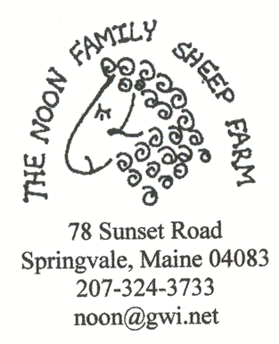

Charts

Series Group 1 Red – Control
Series Group 2 Green – Crystal Creek (Paratack)
Series Group 3 Blue – Garlic Juice
Series Group 4 Black – Farmstead – (Sustain & Restore)

The 2003 lambs grew very well and the first ones were marketed during early June. This caused the test group numbers to decline. Most of the male lambs were marketed by the end of July and all were gone Sept. 9. This made the weight record averages for the test groups inaccurate and may have influenced the results.

Coccidia (Eimeria) was one of the parasites that I counted during my testing. These are tiny parasites that live in the cells of the sheep’s intestines. They are thought to be little threat to the health of the sheep as the sheep usually develop resistance to them over time. They can however be problematic in lambs.
Group 1 Red – Control
Group 2 Green – Crystal Creek (Paratack)
Group 3 Blue – Garlic Juice
Group 4 Black – Farmstead – (Sustain & Restore)

This graph shows the onset of natural resistance in lambs to Coccidia. It is also interesting to see that the garlic juice was effective at the May treatment.

The most significant parasitic threat to lambs is Haemonchus Contortus (H. Contortus).
Here in the Northeast where there is quite a long period of winter and frequent frost between the end of September and the beginning of May, natural conditions determine the extent of survival of the parasites on the pasture. Pasture and contact with the soil is a critical portion of this parasite’s five-stage life cycle. Understanding this parasite’s life cycle is essential to mounting an effective preventative management strategy. Unfortunately there are gaps in our knowledge.

Sept. 3 two lambs in group 2 were treated with Garlic and Sept. 9 all remaining lambs (all Groups) were all treated with garlic.

My WORKS Spreadsheet would only show six lamb data lines in a chart at once.
Lambs #345 shows low natural resistance to H. Contortus

The weight charts show each lamb’s weight over time. When a weight line stops that indicates that the lamb was sold. When there is a gap in the data the lamb was missed or too wet to measure on a particular date(s). After the ewe lambs were removed from the feeder lambs they were not always tested on the same dates. In August I started to pull ewe lambs out into a separate feeding group. I did not want to waste grain and get them too fat. Their weights leveled off and some declined. They did continue in the same test group until Sept. 9 when all were treated with Garlic.

Lambs #341 and 349 show low natural resistance to H. Contortus
Sept. 9 remaining lambs were all treated with garlic.

Lambs #317 and 322 show low natural resistance to H. Contortus
Sept. 3 #322 treated with garlic Sept. 9 remaining lambs were all treated with garlic.

Lambs #334 shows low natural resistance to H. Contortus
Sept. 3 lamb# 334 treated with garlic and Sept. 9 remaining lambs were all treated with garlic.

I am not sure why this lamb tested high on 6/11 and 0 on 7/1. This could have been the initial infection and resistance built up naturally reducing the infection. Several resistant lambs did show a rise 6/11 and a decline afterward. (I have treated her with garlic again this fall as her numbers climbed again)

Lambs #306 and 318 show low natural resistance to H. Contortus
Sept. 9 remaining lambs were all treated with garlic.

Lambs #347 shows low natural resistance to H. Contortus
Sept. 9 remaining lambs were all treated with garlic.

This lamb is below 2000 and resistant.
Lambs #307 shows low natural resistance to H. Contortus
Sept. 9 remaining lambs were all treated with garlic.

Lambs #348 shows low natural resistance to H. Contortus.

Sept. 9 remaining lambs were all treated with garlic.

