Final Report

- Project name and contact information

Better Wine Grape Quality using Combined Vine Training and Canopy Management FNE09-662

Richard Lamoy
456 Soper Street
Morrisonville, NY 12962
Phone – 518-643-0006
e-mail – richL@charter.net

- Goals

The goal of the project was to see if it is possible to improve the quality of wine grapes by using a combination of training systems and canopy management to match the varieties. The objective was to use three existing varieties of wine grapes – Frontenac, Chardonel and Leon Millot and train them to both Vertical Shoot Positioning and 4 Arm Kniffen. Within those systems they were to be compared using Shoot Thinning, Cluster Thinning and use a control or check. Data results will compare yield and quality as measured by visual inspection of the fruit and sugar and acid measurements close to and at harvest.

- Farm profile

The farm name is Hid-In-Pines Farm located at 456 Soper Street in Morrisonville, NY. In the past it operated as a fresh vegetable and fruit farm as well as a small dairy. The farm is currently transitioning to a vineyard and soon a winery. The farm is an offshoot of Lamoy’s Produce and they are both part of the same physical farm of approximately 90 acres. The vineyard consists of three acres of cold hardy wine grapes. I am in the process of converting existing outbuildings into the new farm winery and am in the process of licensing as a Farm Winery and expect to open the winery in the next year.

- Participants

The technical advisor on this project was Kevin Iungerman who is the Cornell Cooperative Extension Northeast NY Commercial Fruit Program Specialist.
Others, while not direct paid consultants, who visited and provided some collaborative feedback in their specialties, were:
Justine Vanden Heuvel – Cornell University – Assistant Professor Viticulture
Wayne Wilcox – Cornell University – Professor Plant Pathology - Viticulture
Tim Martinson – Cornell University - Senior Viticulture Extension Associate
Anna Katharine Mansfield – Cornell University - Assistant Professor of Enology
Chris Gerling- Cornell University- Enology Extension Associate
- Project activities

The project began by examining the vines in the early spring after an unusually cold winter event. The temperatures were substantially colder than in the past fifteen years. Normal lows have been in the -10 to -12°F range and this year we reached -22°F two times. The results of the inspection indicated that the variety Frontenac was fine with very good bud survival. The Leon Millot was generally in good shape with an acceptable bud survival. The Chardonel suffered terribly with dieback to the snowline at the time of the cold event to about 15 inches above ground. That eliminated Chardonel from being useful in the trial. After consultation with the grant supervisor, a decision was made to switch that variety to LaCrosse which had good bud survival and was in an acceptable layout for the trial. Because of its trailing tendencies it was decided to be trialed using Top Wire Cordon and 4 Arm Kniffen. Each system has a panel of each treatment (4 vines). By way of example Frontenac trained to Vertical Shoot Positioning has 4 vines between posts (a panel rep) each for the Shoot Thinned, Cluster Thinned and the control or Check.

Work began in the vineyard doing preliminary dormant season vine pruning keeping in mind the training systems. The number of retained nodes (buds) was based on making bud cuts to determine bud mortality rates. The desired retained nodes were set at a base of 5 nodes per foot of canopy for Frontenac, 6 nodes per foot for Leon Millot and 6 nodes per foot for LaCrosse. The retained nodes were counted and recorded after pruning. Keep in mind that the foot canopy includes two levels with the 4 arm Kniffen and the number of nodes was divided between these two levels. For example, the Frontenac used 3 nodes per foot on the top wire and two nodes per foot on the bottom fruiting wire.

Shortly after spring pruning, the training systems were established. The Frontenac and Leon Millot had all previously been trained to Vertical Shoot Positioning (VSP). At pruning, two long canes near the trunk at the fruiting wire were retained. These were trained up to the top wire and tied down to it and thus the four arms were established. Some canes were a bit short to allow for a fully spread canopy on the top wire, so extra nodes were retained on the lower wire in those cases. The LaCrosse had been previously trained for 4 Arm Kniffen. It was decided to cut off the lower cordon arms to convert to Top Wire Cordon (TWC) instead of VSP. The top wire cordons were more completely formed in general leading to that decision.

To better understand the types of training systems used see Diagram 1
on the next pages.

s

Diagram 1
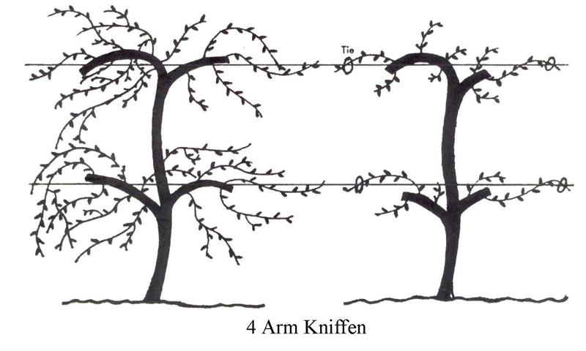
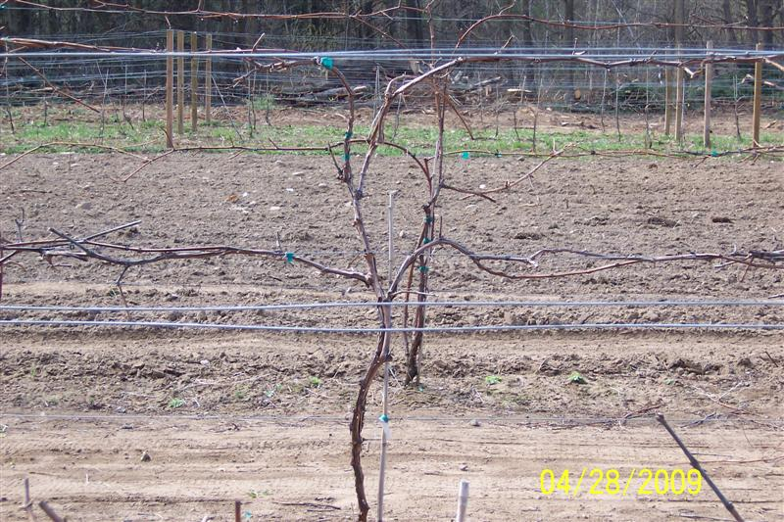

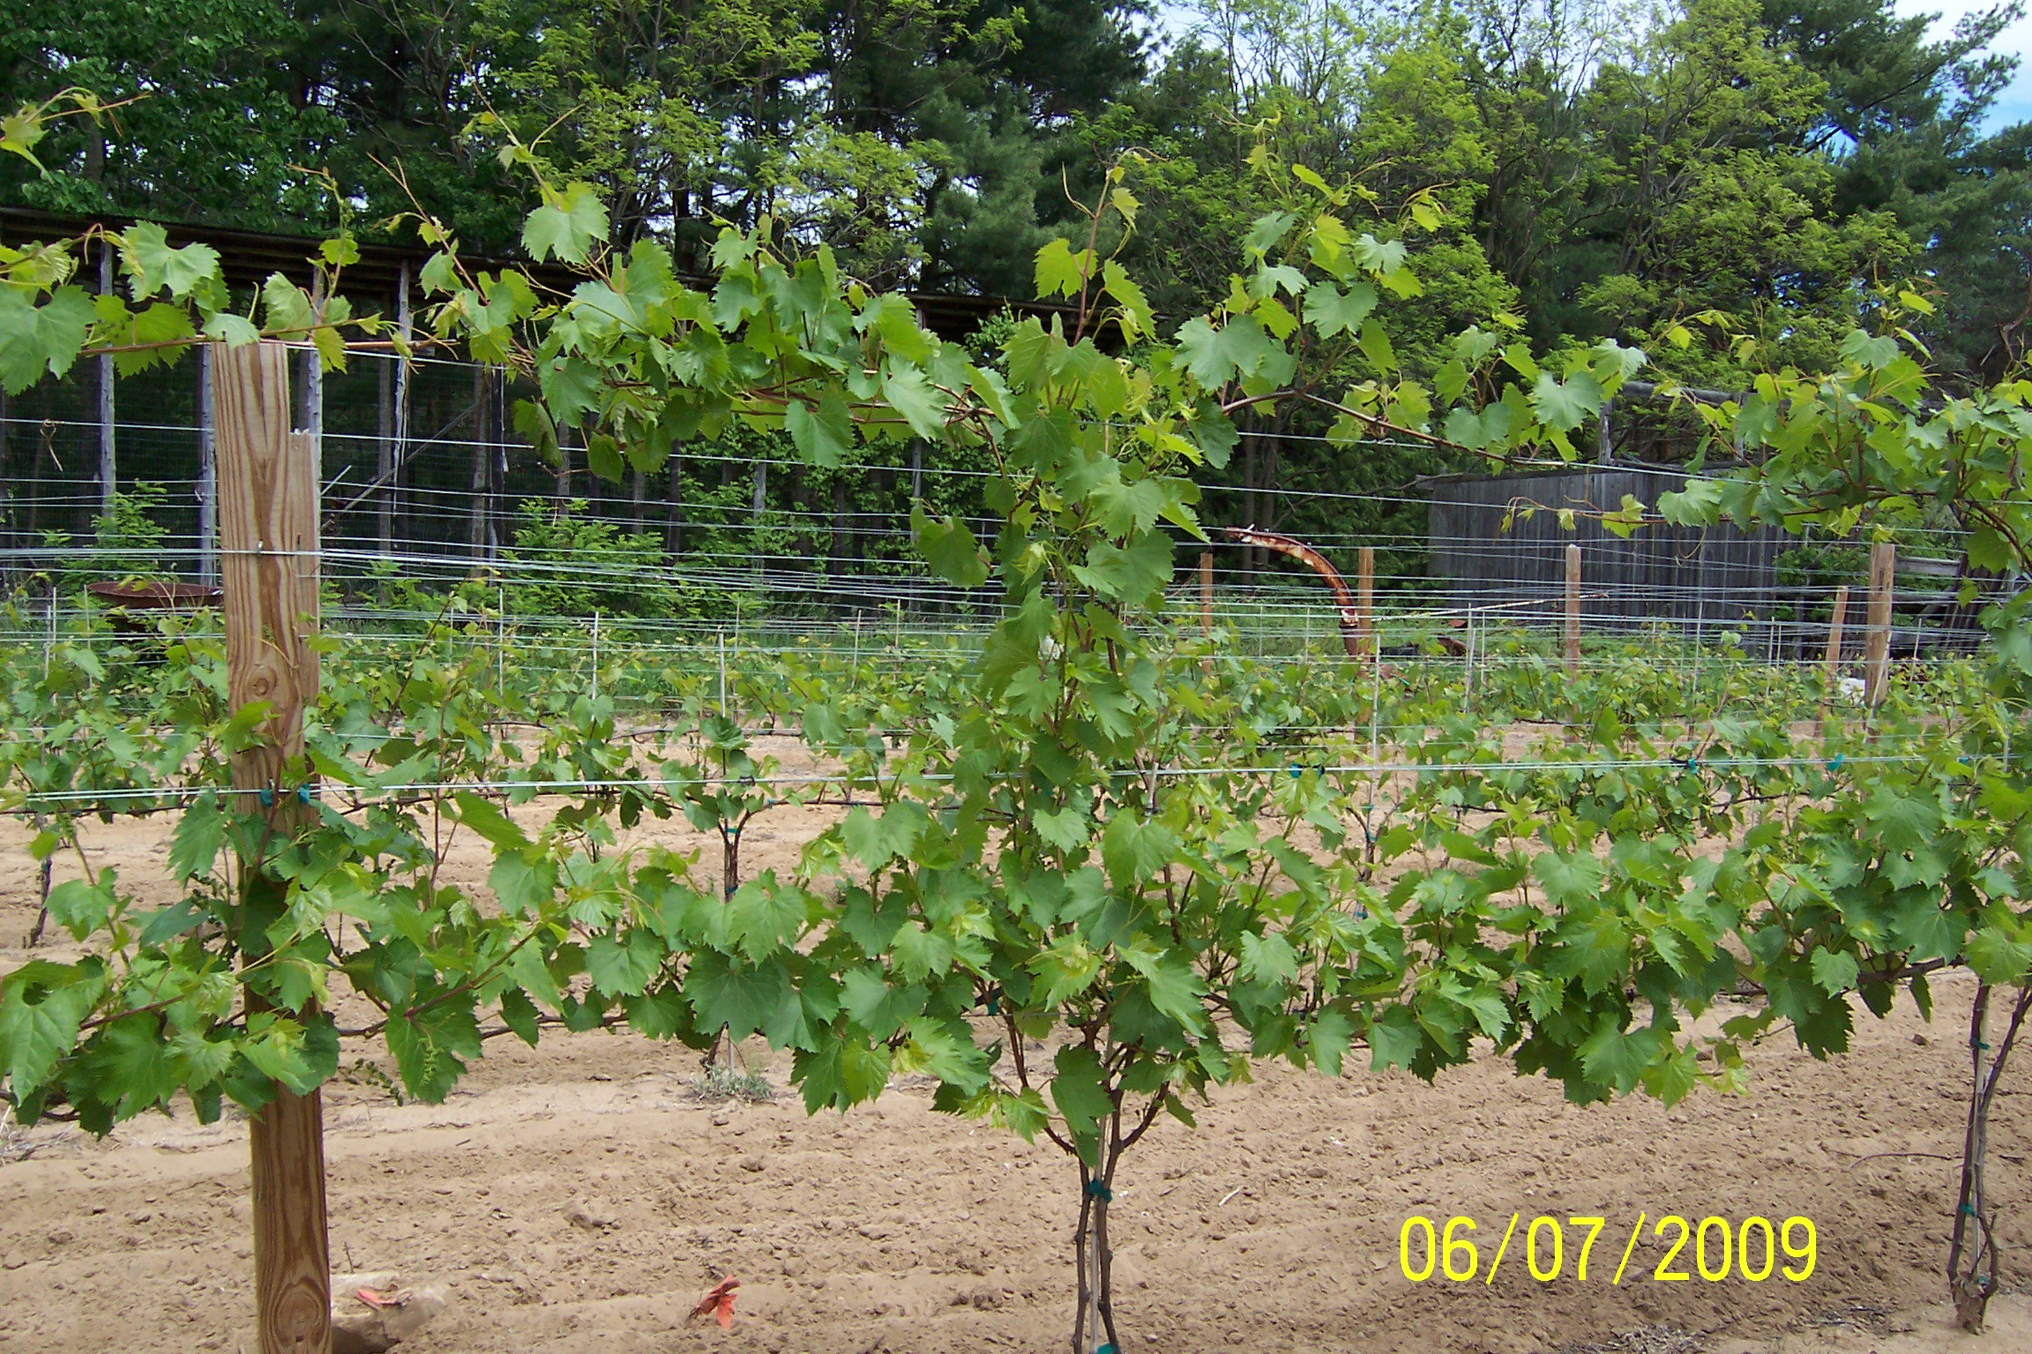
Vertical Shoot Positioning
Vertical Shoot Positioned (VSP)

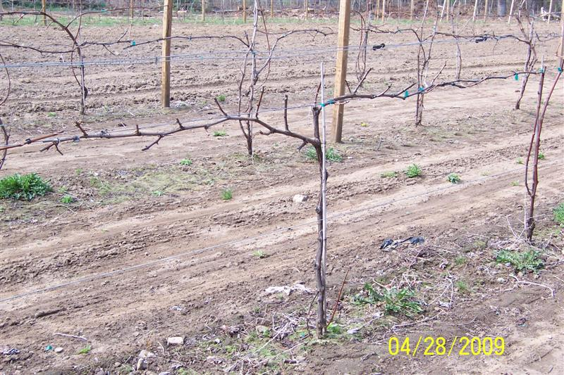

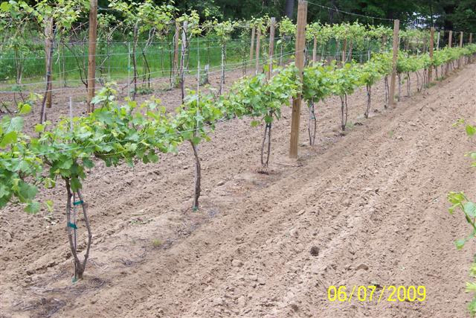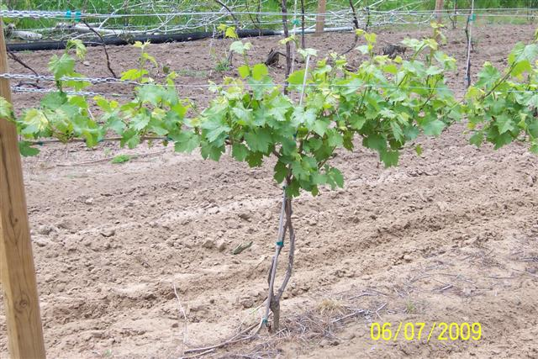

Top Wire Cordon (TWC)

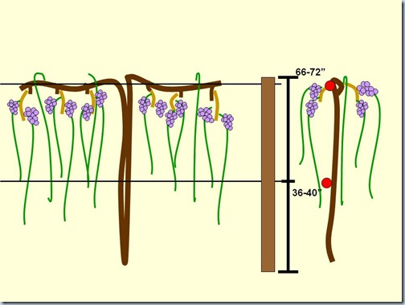

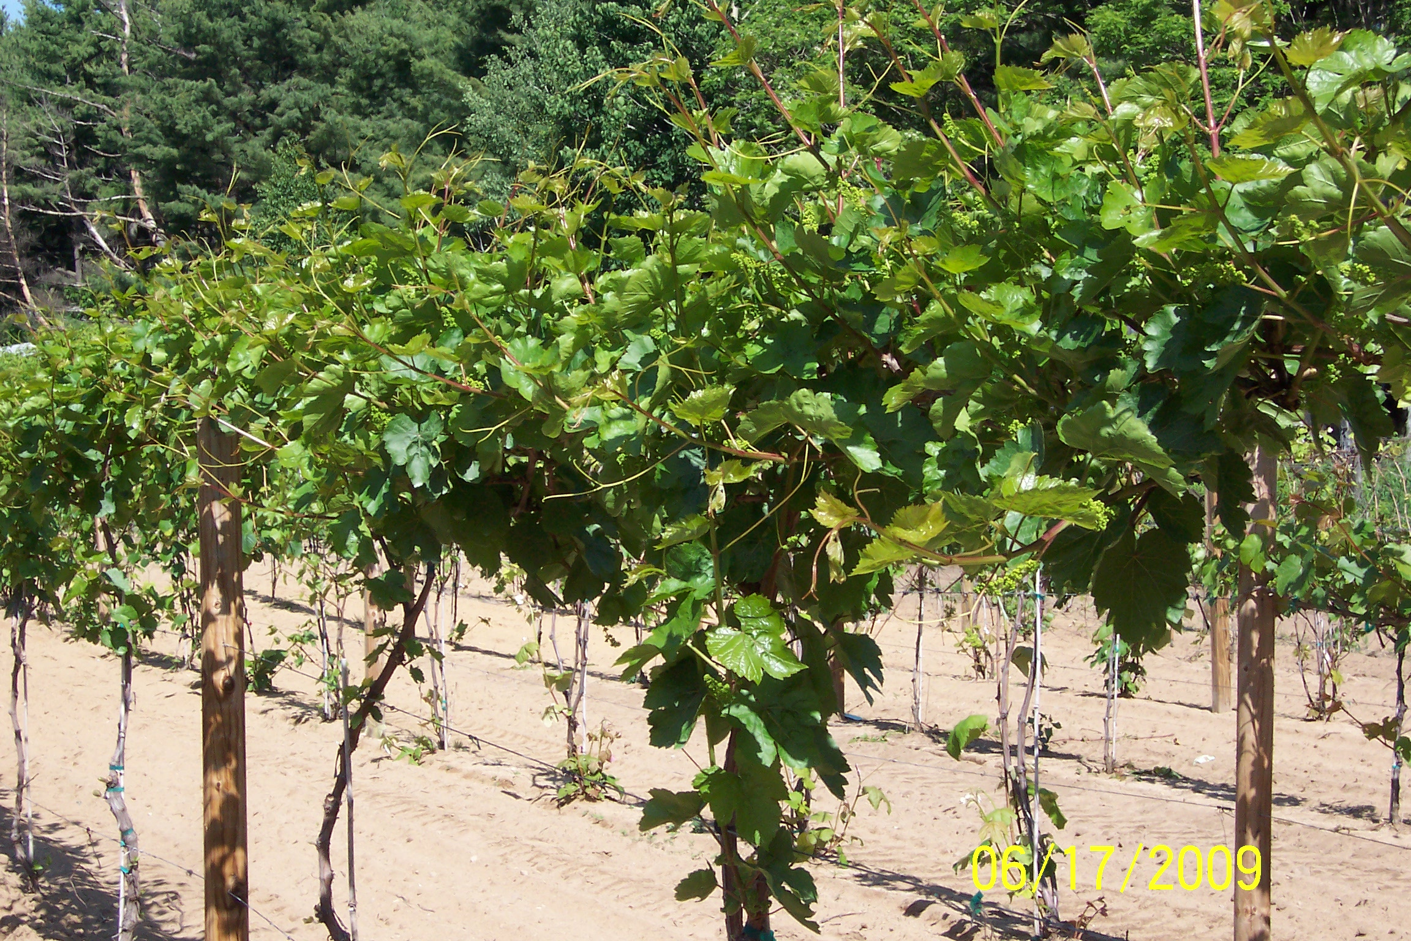
Early season LaCrosse Vine on Top Wire Cordon

In Season Pruning and Training

As the growing season progressed the vines were trained and maintained to the appropriate systems. Times needed for these operations were recorded and later tabulated for each treatment panel. These were listed as Pass One, Pass Two, etc.

The VSP shoots were trained between the catch wires. As the shoots grew over the top wire by a few feet, they were hedged off to just above the top wire.

The vines trained to the 4 Arm Kniffen were allowed to grow the shoots as long as they got. They were trained to droop down while straightening them out (combed). Any shoots that interfered with the tires of the tractor running over them for normal vineyard operations were cut off at the ground (skirted) to prevent the shoots from being broken off.

The Top Wire Cordon (TWC) vines were kept tied to the top wire and the new shoots were trained downward and combed to open the canopy up. If the vines touched the ground as above, they were skirted back.

Note:
Not all of the top wire cordons were well formed with the LaCrosse and adjustments were made to them to try to increase node count to the desired number. This surely influenced the results and because of this should be replicated again to improve the reliability of results.

At the appropriate time shoot thinning and cluster thinning were implemented aiming for the desired number of shoots and clusters per foot and recorded. Shoot thinning was aimed at a final shoot count of 5 shoots per row foot (combined wires) for both all treatments. All treatments, including the Check were appropriately hedged or skirted and leaf pulling took place to expose the fruit.

Pictures were taken as the year progressed to help document the results of these operations.

Sampling and Testing

Samples were taken of the fruit beginning in mid September to monitor ripening and potential differences in the fruit quality. Three samples were taken for each treatment approximately ten days apart. A final sample was taken at harvest to gather the final fruit quality sample. Fifty grapes were taken randomly from each panel of each variety. Each sampling period took readings of eighteen (18) individual samples. Each sample of the first test tested the sugar (brix) and acid (pH) and was recorded. The following samples, as well as the final sample, tested for brix, pH and TA (titratable or total acidity). All the samples were recorded in a spreadsheet as part of the final results and is available. Notes were also taken of fruit quality and canopy density as they became apparent.

The sample berries were crushed and the juice extracted for testing. The brix was measured using a handheld refractometer. The pH was measured using a portable electronic pH meter after calibrating. The TA was measured using a Hanna Instruments 84102 Mini Titrator with digital readout after calibration.

Harvest

Each variety of grapes was all harvested the same day so the results would be consistent. Frontenac was harvested first on October 15, 2009. LaCrosse was harvested October 17, 2009 and the Leon Millot was harvested on October 21, 2009.

Every vine of every treatment was picked into its own grape lug. They were individually weighed in pounds to the tenth pound and recorded. As the vines were picked, the harvested clusters were counted and recorded. These two measurements allowed for average vine and cluster weights for each treatment. It also makes it possible to give acre equivalent yields based on vine and row spacing.

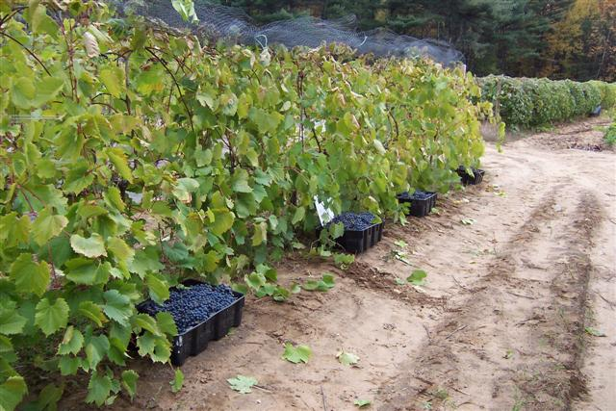
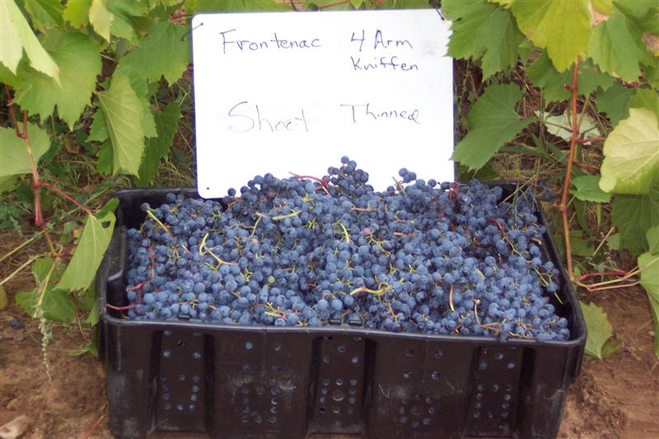

- Results

There was a lot of information gathered from this trial. In general I can say that based on a single year’s data collection, it certainly is possible to influence and increase the quality of wine grapes. I will list the information here in a condensed format for the results of the trial. After that I will try to interpret some of these results and what it can mean. Like any other study, the validity of the data would be enhanced with further testing in future years. Because of this I will be seeking an extension to the grant for further testing.

Frontenac

The VSP required more time for training and summer pruning than the 4 Arm Kniffen. It took three large hedgings to get the VSP down to a manageable size to not shade the fruit. The 4 Arm Kniffen stayed visibly more open with the fruit more exposed for ripening, reducing the need for pruning and leaf pulling.
To sum up the results of the Frontenac grapes, the highest quality grapes were obtained using 4 Arm Kniffen and Shoot Thinning. Final test results were a brix of 21.6, pH of 3.19 and a TA of 14 g/L. This was the best combination and at a yield of 28.3 pounds per vine average would give a yield of about 9.78 tons. This results in a great increase in the yields over of any of the VSP treatments and a 67% yield increase over VSP Shoot Thinned. In this case we obtained two thirds more yield of a higher quality product.
For comparison I assign a value of $1000 per ton for grapes of minimum brix level of 21, $900 for brix between 19.5 and 21, $800 over 18 but under 19.5 and $500 for a brix of under 18. Actual price differences will vary from area to area and variety to variety, but this shows how price drops for lower sugar and higher acids.
Following is a summary of comparative treatments:

Frontenac

AvgYield lbs Tons/Acre brix pH TA Price Value/Acre
VSP Shoot Thinned 17.0 5.87 19.2 3.04 16.7 $800 $4696
4 AK Shoot Thinned 28.3 9.78 21.6 3.19 14.0 $1000 $9780

VSP Cluster Thinned 18.4 6.34 18.7 3.02 16.1 $800 $5072
4 AK Cluster Thinned 29.1 10.05 20.0 3.14 15.2 $900 $9045

VSP Check 24.4 8.41 15.0 2.95 17.4 $500 $4205
4 AK Check 29.2 10.07 18.8 3.04 15.3 $800 $8056

The differences in this case between Shoot Thinned and Cluster Thinned are small and but demonstrates a big difference between VSP and 4 Arm Kniffen.

Leon Millot

The Leon Millot grapes were in two adjacent rows, with one having VSP training and the other the 4 Arm Kniffen. The training was implemented the same as the Frontenac, training the extra two arms from long center canes retained at dormant pruning. A higher than normal node count was retained at dormant pruning to allow for a forty percent dead primary bud count. Differences between the two systems was not as pronounced as with the Frontenac, but still existed. The 4 Arm Kniffen required less summer pruning and training time than did the VSP. The canopy was also visibly less dense than the VSP and in a normal year would have enabled at least one less spraying.

For comparison I assign a value of $1000 per ton for grapes of minimum brix level of 20, $800 over 18 but under 20 and $500 for a brix of under 18. Actual price differences will vary from area to area and variety to variety, but this shows how price drops for lower sugar and higher acids.
Following is a summary of comparative treatments:

Yield lbs Tons/Acre brix pH TA Price Value/Acre
VSP Shoot Thinned 8.3 2.85 19.0 3.14 9.1 $800 $2280
4 AK Shoot Thinned 9.0 3.11 20.0 3.18 8.3 $1000 $3110

VSP Cluster Thinned 6.1 2.11 19.0 3.13 9.3 $800 $1688
4 AK Cluster Thinned 7.5 2.57 20.0 3.26 7.0 $1000 $2570

VSP Control 5.4 1.87 19.2 3.12 9.2 $800 $1496
4 AK Control 8.6 2.97 18.6 3.21 7.4 $800 $2376

Although the yield differences aren’t as striking with the Leon Millot, they are still significant. The quality in general was also better resulting in almost a forty percent increase in value per acre for the 4 Arm Kniffen grapes over the VSP. Shoot thinning with this variety in this case resulted in definite yield and quality increases over cluster thinning.

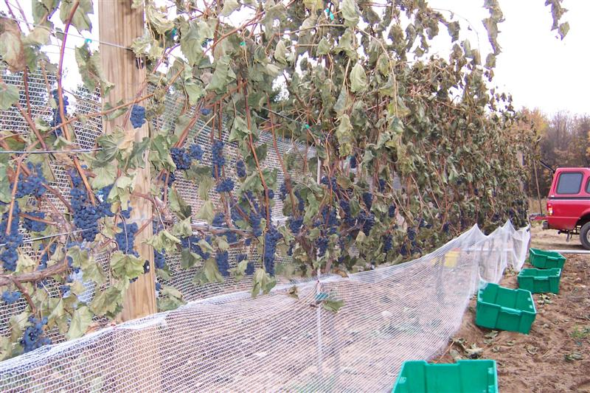
Leon Millot Grapes Before Picking- VSP Shoot Thinned

LaCrosse

The LaCrosse vines were trained to Top Wire Cordon (TWC) and 4 Arm Kniffen. The TWC vines were not all well formed so some of the yields and results may have been skewed. A follow-up year of testing should be done with better developed vines for more reliable results. Also the east side of the 4 Arm Kniffen LaCrosse were shaded for an hour or so in the morning which resulted in visibly more dew staying on the vines later in the day. A further year’s testing could include reducing the shading by removing a few trees.

For LaCrosse- a white grape -I assign a value of $1000 per ton for grapes of minimum brix level of 18, $800 over 15 but under 18 and $500 for a brix of under 15 . Actual price differences will vary from area to area and variety to variety, but this shows how price drops for lower sugar and higher acids.
Following is a summary of comparative treatments:

Yield lbs Tons/Acre brix pH TA Price Value/Acre
TWC Shoot Thinned 8.0 2.75 17.0 3.13 9.8 $800 $2200
4 AK Shoot Thinned* 15.2 5.25 15.4.6 3.08 11.1 $800 $4200

TWC Cluster Thinned 14.7 5.08 17.0 3.11 9.5 $800 $4064
4 AK Cluster Thinned 17.41 5.99 15.6 3.20 7.8 $800 $4792

TWC Control 8.4 2.88 18.0 3.11 9.7 $1000 $2880
4 AK Control 19.8 6.84 15.6 3.21 9.5 $800 $5472

*This panel of vines was shaded in September and October probably lowering potential sugars and possibly increasing expected acid levels.

In the LaCrosse because not all the vines were well formed and there was some shading, the results are less meaningful, but in general they demonstrated a yield increase with four cordons than two. Quality was alright, but brix levels were low due to the cool growing conditions. Acid levels were good in spite of this demonstrating that they were ripe, just low in sugar. That difference is easier to adjust for than high acid, so the value is good.

LABOR
The following table summarizes the time involved in the labor of training and tying the vines of each treatment during the growing season. It logs the actual times needed for each treatment. By gathering this information it takes any extra labor needed for any treatment into consideration. By way of example, the Frontenac VSP panel took an hour and 15 minutes per 4 vines to keep the canopy managed for this type of treatment. The Frontenac 4 Arm Kniffen took a total of 32 minutes or 43 minutes less per 4 vines. At a density of 691 vines per acre, the time savings would be 123 hours of labor per acre. This is a considerable time saving for one treatment over another.

 |  | Labor | 2009
 |  |  |  |  | Total Time
Labor Date |  |  |  |  | Hours: Minutes
 | Variety | Training | Canopy | Panel
 |  | System | Management | Number
 | Frontenac | VSP ** | Shoot Thinned | One | 1:15
 | Frontenac | VSP ** | Cluster Thinned | Two | 1:35
 | Frontenac | VSP ** | Control | Three | 1:29
 | Frontenac | 4 AK *** | Shoot Thinned | One | 0:35
 | Frontenac | 4 AK *** | Cluster Thinned | Two | 0:52
 | Frontenac | 4 AK *** | Control | Three | 0:55
 | Leon Millot | VSP | Shoot Thinned | One | 1:42
 | Leon Millot | VSP | Cluster Thinned | Two | 2:00
 | Leon Millot | VSP | Control | Three | 1:49
 | Leon Millot | 4 AK *** | Shoot Thinned | One | 1:13
 | Leon Millot | 4 AK *** | Cluster Thinned | Two | 1:32
 | Leon Millot | 4 AK *** | Control | Three | 1:34
 | LaCrosse | TWC * | Shoot Thinned | One | 0:29
 | LaCrosse | TWC * | Cluster Thinned | Two | 0:30
 | LaCrosse | TWC * | Control | Three | 0:26
 | LaCrosse | 4 AK *** | Shoot Thinned | One | 1:15
 | LaCrosse | 4 AK *** | Cluster Thinned | Two | 1:15
 | LaCrosse | 4 AK *** | Control | Three | 0:50

- Conditions
There are certain conditions that were encountered this year that may have caused some deviation in expected results. First of these was the unusual cold spell we had in January of this year. That affected the condition of the vines, with somewhat reduced bud survival. As a result some of the vines may have had less bearing shoots on them than expected- notably the LaCrosse and Leon Millot. Like was previously mentioned, Chardonel was supposed to be the third variety, but was switched with the LaCrosse because it was so badly damaged from the cold.

Also a factor this year was the cold, cloudy weather this spring, summer and fall. We ran about 200 degree days short of normal, logging about 2200 growing degree days instead of 2400 which is more typical. July and August were very wet months which dictated an extra spraying for disease over what might have normally been needed.

The trial vineyard encountered some shading from the native trees on the east side of the LaCrosse. I believe this led to lower brix and higher acid conditions than would be expected without the shading. This only affected the vines adversely in September and October, but this year those were cloudy and cool months compounding the problem of ripening. I will be seeking to remove or trim the trees which were causing the shading.

- Economics

In general it is certainly possible to increase the value of the wine grapes both through increased yields and improved quality. Furthermore net farm income could be increased by getting higher returns for the crop along with diminished labor requirement. Some of the treatments required substantially less labor input during the growing season as well as harvest labor.
Using Frontenac by example see the following:

Frontenac Labor Net
Tons/Acre Price/T Value/A Hours/$10x172*
VSP Shoot Thinned 5.87 $800 $4696 $2150 $2546
4 AK Shoot Thinned 9.78 $1000 $9780 $1003 $8777

VSP Cluster Thinned 6.34 $800 $5072 $2723 $2349
4 AK Cluster Thinned 10.05 $900 $9045 $1490 $7555

VSP Control 8.41 $500 $4205 $2551 $1653
4 AK Control 10.07 $800 $8056 $1576 $6479

*Spacing provides approximately 688 vines / Acre divided by 4 = 172
We can see in this example that even though the cluster thinned treatment of 4 Arm Kniffen and even the Control gave a greater yield, the greatest return was obtained by the Cluster thinned 4AK because of reduced labor needs. Should these grapes be made into wine instead of selling as grapes, there is the potential for even greater returns.

- Assessment

This trial project shows that there is great potential to maximize yield, increase quality and net farm profit. Further testing should be done to validate these findings. More years of data and expanded replications would be of value. I see this project as validating the concept and the additional testing would give reliability to the findings. In the future it would probably be worth expanding the number of training systems, and varieties this work was done with. It may be possible to reliably predict the best combination of variety, training system and canopy management type. Armed with that information, it would increase the net farm income and sustainability of adopting farmers.

- Adoption

At this point, I would advise caution in adoption of the results of this project trial. It certainly would value anyone considering adopting this to give it a try on their individual farm, possibly in a side by side comparison. The results may vary from farm to farm based on soil types, climate and inputs. After further testing on my vineyard, I will probably adopt these concepts to maximize farm income.

11. Outreach

I see the outreach part of this project as a continuing process and hope to continue the dissemination of the results for the next year or more. This current year the outreach consisted of several methods of dissemination.

On-site Field Meetings.

A tour and field meeting was held at the vineyard on July 17 and was attended by a number of local vineyard owners. Joining the group was Justine Vanden Heuvel and Wayne Wilcox both from Cornell. Justine reviewed the trial and made a few suggestions for canopy management. Mr. Wilcox checked the vineyard for disease since he is the Plant Pathologist expert at Cornell. He noted the lack of any disease pressure in spite of the rainy season. The following day the group and an expanded crowd attended a field session at the Willsboro Cold Hardy Grape Trial after visiting the UVM NE1020 Grape Trial in Burlington Vt. Justine gave a talk about Canopy Management such as I have implemented in this project. Wayne Wilcox discussed the value of canopy management in the control of plant disease pressure to minimize the number and amount of needed sprays. I showed the vineyard sprayer developed for the Willsboro trial based on my own I made and alluded to the value of such a sprayer in being able to control pests with a minimal spray program.

The next meeting was held here on August 15, 2009 and had approximately 15 attendees on hand. Notices were sent out through e-mail, the local press after contacting the local Extension office and online as posted through the UVM Cold Climate site at http://pss.uvm.edu/grape/ .An overall summary of the project was given out in a binder along with a site map showing the layout of the newly planted trial expansion and a PowerPoint slide show. The meeting covered the trial and its layout. We conducted a walking tour and included a discussion of what was being done, studied and compared. I went over data collection and basic training and canopy management.

A follow-up field meeting was held on September 10 and included a group from the Lake Champlain Grape Grower’s Association. We did a walking tour of the vineyard and I showed the vines involved in the trial. At that point the differences in Training Systems and Canopy Management were becoming very apparent. A number of attendees expressed an interest in adopting the training system used after seeing preliminary results. I cautioned that the results are very preliminary and not replicated yet so if they adopt the system, they should do so with guarded caution. We covered the test equipment being used to gather the sample data which I shared with the group at a later meeting.

There were eight volunteers that showed up to help with harvest in the larger vineyard. A number of them were growers with their own vineyards, so I showed them the different Training Systems and Canopy Management treatments of this trial. Many expressed an interest in the systems and asked to be sent the final data.

Networking with Extension

Cooperative Extension personnel were used wherever I could to help with the dissemination of data. Amy Ivy of Clinton County Extension helped write press releases. As stated above joint meetings and involvement of Extension or Cornell personnel were used whenever possible. Also visiting the vineyard was Tim Martinson, Cornell Head Extension Associate of Viticulture. He invited me to a meeting held November 12 in Burlington VT as part of a grant for studying ways Extension may help promote Cold Hardy Grapes. I made a presentation to the group of the results I obtained from this grant study. Head extension personnel from a number of states were there as well as industry leaders and representatives. Also visiting and discussing ways to improve grape quality for cold hardy grapes were Anna Katharine Mansfield and Chris Gerling. Chris is from Extension Viticulture and Anna Katharine is form the Enology Dept of Cornell.

Printed Material

As stated above, a pamphlet binder was handed out at a meeting which included initial planning, trellising and training in the trial along with a PowerPoint Presentation. A copy of this was also brought to the Clinton County Cooperative Extension office and added to their file of material available to interested parties. It is also available to other offices upon request.

A summary of this study is being prepared and will be available to all interested as either printed material or in an Excel Spreadsheet format. The summary data is also being sent to interested parties involved in the Burlington VT Cold Climate Grape Conference since a number of attendees requested the information.

News Media

With a press release from Kara Dunn, publicist for NY Farm Viability and others, a number of articles appeared in print and online. They were aimed at getting general information out to the public and improving exposure and public interest in cold hardy grapes. Some of the articles were in
Plattsburgh Press-Republican http://www.pressrepublican.com/sunday/local_story_284001033.html ,
Adirondack Harvest Newsletter
http://www.adirondackharvest.com/files/Summer-2009-low-res.pdf
Denton Publications
http://www.denpubs.com/Articles-c-2009-10-15-63579.113116-sub8589.113116_North_Country_becoming_wine_country_for_local_grape_growers.html#nogo
AdirondackAlmanack.com
http://www.adirondackalmanack.com/2009/10/north-country-grown-wines-win-awards.html
Strictly Business Monthly http://www.sbmonthly.com/magazine/2009/10/Growing%20Wine%20Grapes%20in%20the%20North%20Country.php
and Northern NY Agricultural Development site http://www.nnyagdev.org/press-09-30-09-b.htm.

An article has also been submitted to the American Agriculturist magazine to be run for January 2010.

Through this publicity I hope to develop a greater understanding from the public in this valuable crop and the future of it in our economy. This interest will help promote good will and increased sales to all wineries and vineyards and help foster an increased sustainability.

- Report Summary

The purpose of this project was to determine if it is possible to obtain better wine grape quality using a combination of vine training systems and canopy management. Several vine varieties were used in the project and were trained to two training systems each. They were further divided into two canopy management systems of Shoot thinning and Cluster thinning and also included a check or control in the project. Data was collected to give comparisons of each combination for each variety. The data included yield and comparative quality measurements through sugar and acid levels. Based on this one year’s data collection, it appears that an improvement in quality and yield is possible through these reproducible systems. A continuation of this study would help verify the results.

It was my observations based on this one year of experience that the Vertical Shoot Positioning System was the most time consuming of the ones trialed requiring about 40 percent more time per 4 vine panel. On my medium vigor site, the vines on VSP appeared to have too much vigor for the space and crop they carried making it hard to maintain an orderly open growth habit. It made the fruit more shaded and crowded which lead to some rot and unripe fruit. It appears that the 4 Arm Kniffen has an edge in this respect by having twice as much cordon length to spread the same or slightly higher number of shoots on to keep the shoot length down allowing for a more orderly, open and easier to maintain canopy. That translated into a slightly to moderately higher yield (up to 60 percent), higher quality fruit (see tables on pages 8, 9, and 10) and less required spray material. The Top Wire Cordon was only used with the LaCrosse and while the fruit quality obtained was higher, the yield in general was lower. Further study should be done with this system due to environmental affects this year.
Based on my positive results this year, I will be looking at repeating this work in the future. If the further data supports these results I will be adopting and incorporating these training systems to increase farm viability and prosperity.
Richard Lamoy, November 20.2009

