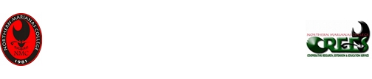

Artificial Cattle Insemination Workshop
December 16-18, 2009

Satisfaction Survey

Dear Client,

NMC-CREES is always striving to give you the best service possible, and we could not exist without the input from our stakeholders. It is of highest importance for us to know how we can serve you better.
Therefore, we would like to ask you to take a few minutes to fill in the attached survey form and simply return it to the lecturer at the end of the Workshop.
The form is easy to fill out. Most questions allow for simple Yes/No answers. Some questions ask you to grade us on a 1 (best) to 5 (worst) scale.

The topic of this workshop was interesting for me ______ (1-5)
The presenters were well prepared ______ (1-5)
The presenters were easy to follow ______ (1-5)
The media the presenters used were appropriate to the topic ______ (1-5)
The presenters could answer my question completely ______ (1-5)
The learning outcomes stated in the workshop agenda were met ______ (1-5)
Did you benefit from this workshop for your farming/ranching? ______ (1-5)
Overall, how would you rate the workshop? ______ (1-5)
Would you recommend this workshop to others? ______ (1-5)

Would you want to be kept up to date on NMC-CREES events or workshops?
Yes, my email address is _____________________________ No

Comments (use backside of this form if you need more space):
________________________________________________________________________________________________________________________________________________________________________________________________________________________________________________________________________________________________________________________________________________________________________
Thank you very much for your time – you NMC-CREES Extension Team

