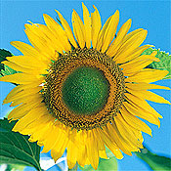 | Sunflower  The long-lasting flowers have large, bright yellow petals and a small center. Makes an excellent cut flower. Sow 1 seed every two inches in the garden when all danger of frost has passed. For earlier blooms, start indoors 4-6 weeks before last frost date. Enrich soil with compost. Harvesting tips. For cut flowers pick at peak of bloom, or leave for the birds to enjoy.  Planting Depth: 1"  Soil Temp. for Germ.: 60-70°F  Days to Germ.: 5-10  Plant Spacing: 1'-2'  Days to Maturity: 85-95, Full Sun, Moderate Water
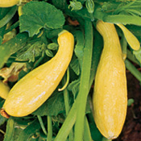 | Yellow Crookneck Squash  Easy-to-grow, bush, yellow summer squash has been a favorite for over 150 years. Sow 2-3 seeds every 2-3 feet in rows 3-6 feet apart when danger of frost has passed. Can be sown indoors in pots, 2-4 weeks before the last frost, and transplanted very carefully. Harvest young, when 6-8 inches long.  Planting depth: 1"  Soil temp for Germ.: 65-90°F  Days to germ.: 3-7  Plant Spacing: 3'  Days to maturity: 55, Full sun, Moderate water
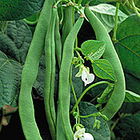 | Kentucky Wonder Pole Bean, 6-8 ft. Tender Annual  Introduced in Kentucky before 1864, this brown-seeded strain produces large, silvery-green, fleshy pods with a distinctive flavor. Pole beans do best with trellising. Pick when young and tender.  Planting Depth: 1"  Soil Temp. for Germ.: 60-80°F  Days to Germ.: 7-15  Plant Spacing: 6-10"  Days to Maturity: 60-65, Full Sun to Partial Shade, Moderate Water
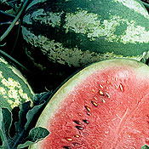 | Watermelon 15-20 lb fruit Tender Annual  hTis classic has juicy red flesh with high sugar content, few seeds, crisp texture, and rich flavor. Thrives in most climates.  Planting Depth: 1"  Soil Temp. for Germ.: 70-95°F  Days to Germ.: 3-8  Avg. Spacing: 4 seeds/ft. in rows 5-6 ft. apart  Days to Maturity: 85-100, Full Sun, Moderate Water
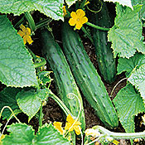 | Bush Champion Cucumber 8-10 in. Tender Annual  A champion slicer that doesn't take much space, this is a great choice for small gardens. Abundant fruits are born on compact bushes. (60-70 days)  Planting Depth: 1/2-1"  Soil Temp. for Germ.: 70-90°F  Days to Germ.: 4-12  Plant Spacing: 2-3'  Days to Maturity: 60-70, Full Sun/Partial Shade, Moderate Water

