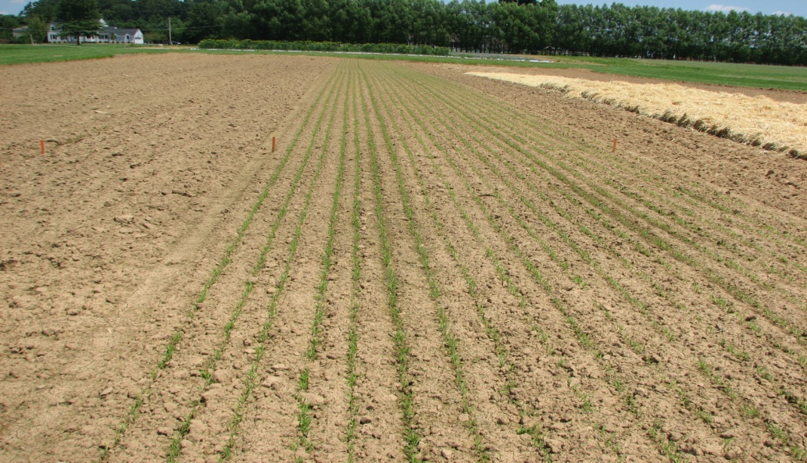
Figure 1 - Sudan Grass cover crop planted for weed suppression

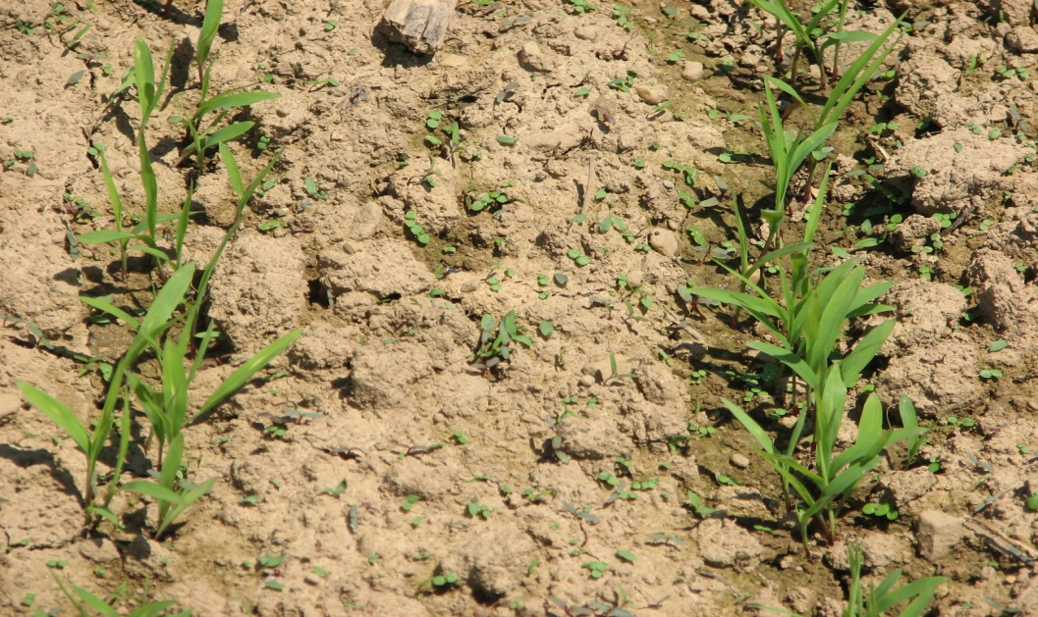
Figure 2 - Annual weeds competing with Sudan grass

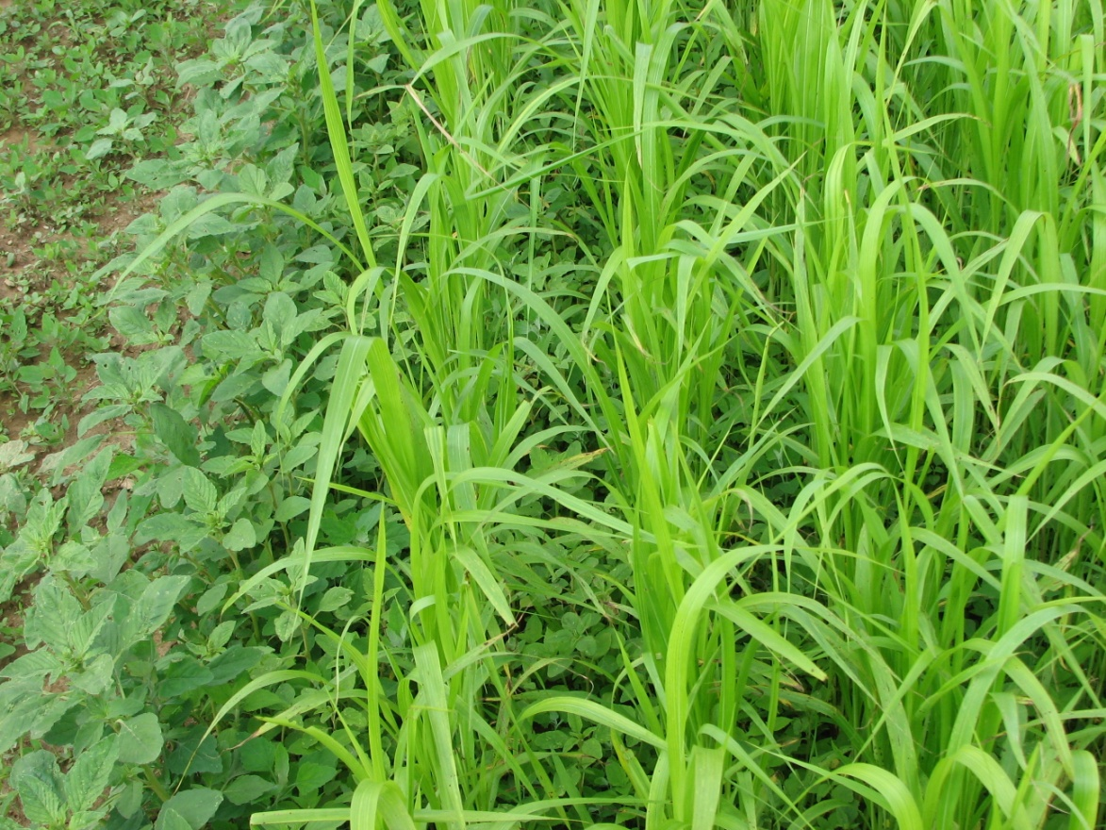
Figure 3 - Sudan grass and annual weeds competing

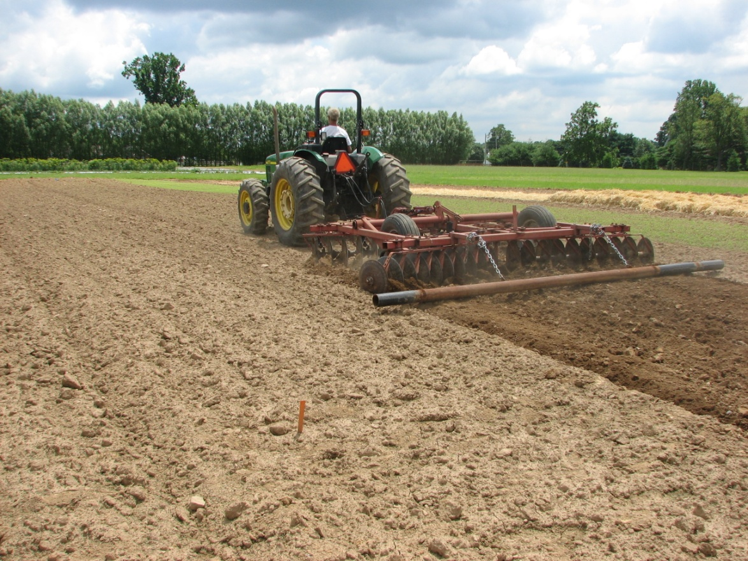
Figure 4 - Continuous tillage plot enhancing suicidal weed germination

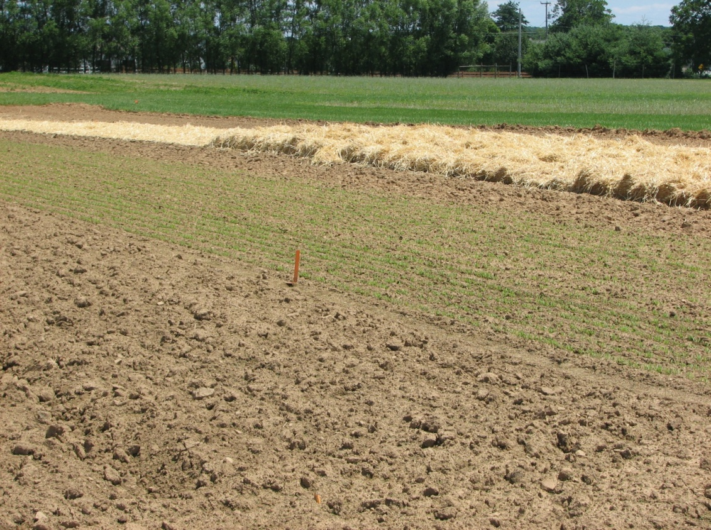
Figure 5 - Continuous tillage, cover crops and mulch plots [L to R]

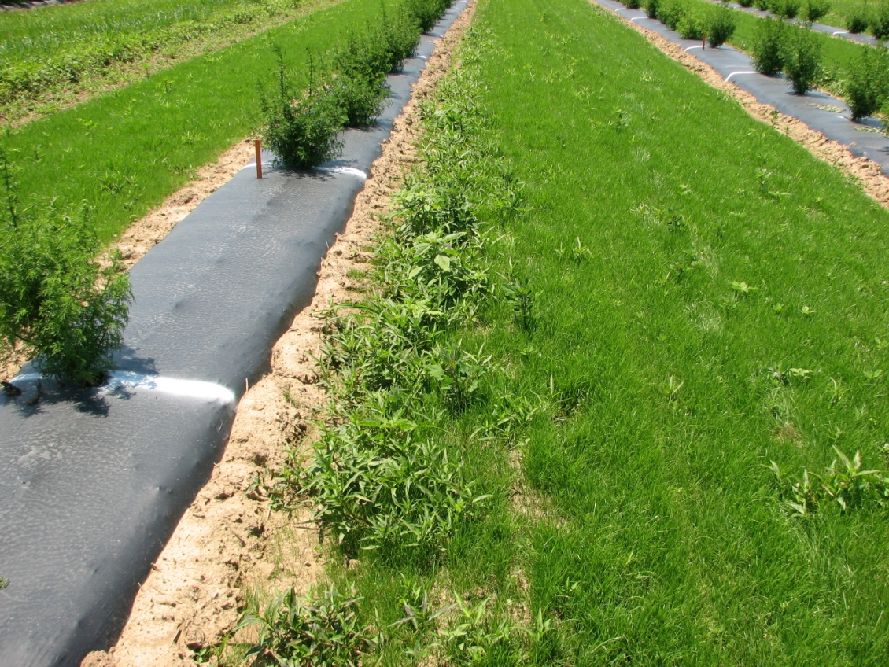
Figure 6 - Rutgers 2009 Artemisia medicinal plant studies utilizing ryegrass as living mulch with black plastic for weed control- note weed competition at edge

