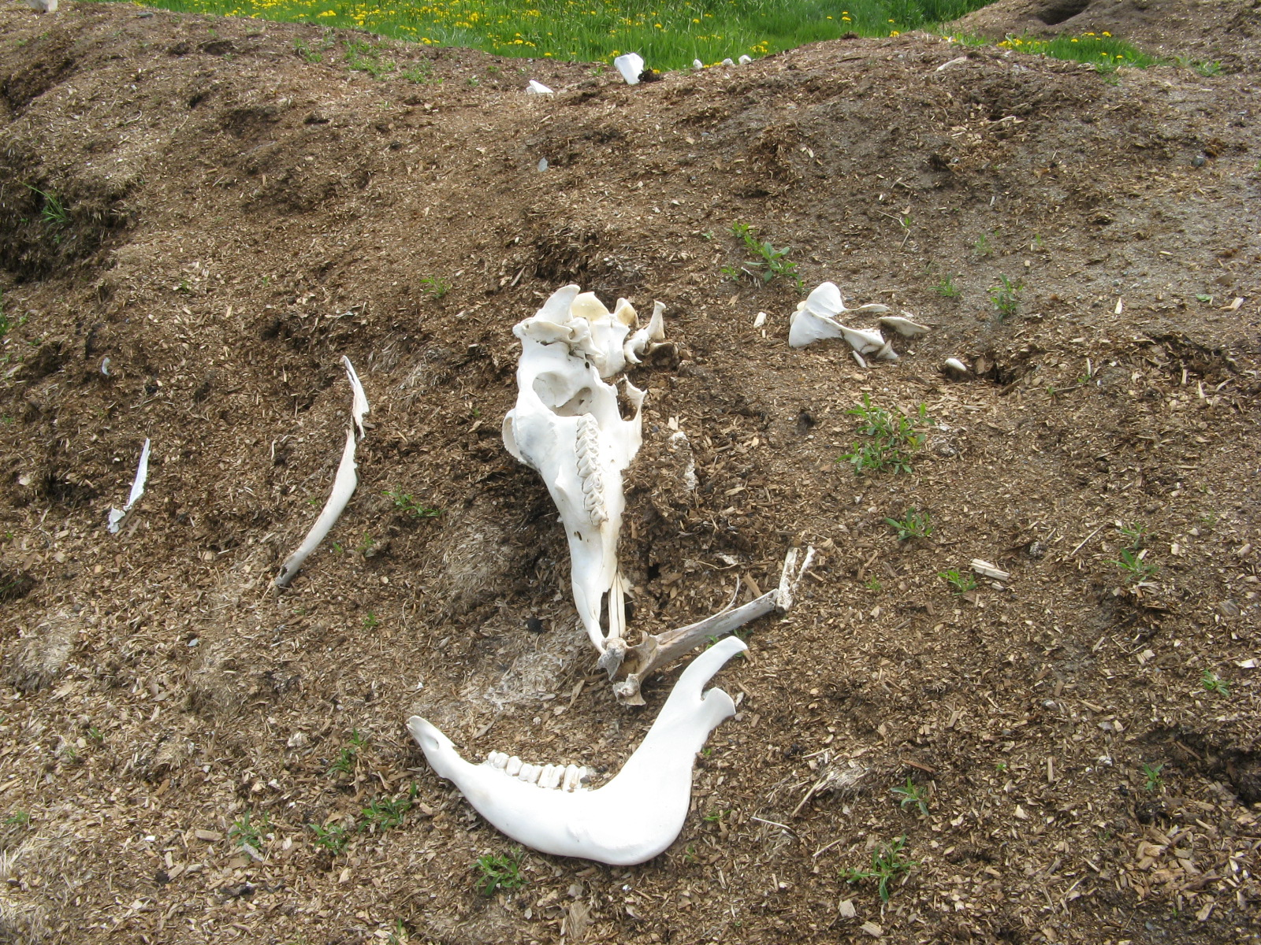
The larger bones are often difficult to completely compost without some mechanical size reduction. Dairy farm, Clinton, Maine
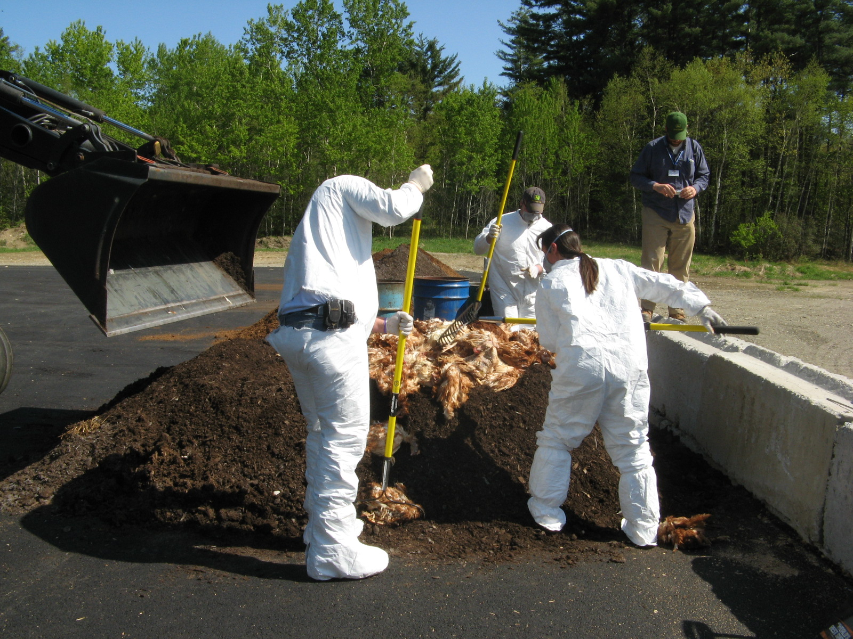
Students actively learning how to properly construct a compost pile for routine and catastrophic mortality management. University of Maine Experimental Farm: Highmoor Farm. Monmouth Maine

