Daily Bulldog

Local food producers look toward the Internet
By Ben Hanstein • Oct 10th, 2008 • Category: Features, News
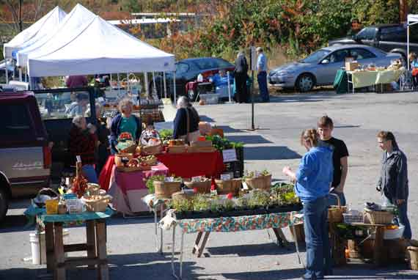
FARMINGTON - Farmers may soon have a new way to sell their products, as a local organization is helping develop an online site to market fresh greens, local meats and a variety of other foods.
Western Mountains Alliance is sponsoring a pair of informational meetings later this month to gather feedback and answer questions about the project. On Nov. 15, the creator of the original online farmers’ market, Abby Holm of the New Hampshire “Local Foods Plymouth” site, will be taking part in a conference on local foods and the world market. WMA, a community development organization serving four counties, is also sponsoring that event.

Local food, such as this delicious Cheese and Sour Cherry Tort made by Longfellow’s Creamery at Second Chance Farm in Avon, may soon be available online.
An example of a site dedicated toward the same of local food can be found here.
“The hope is to start with some nonperishable,” WMA’s Tricia Cook said, “syrups, jams and jellies, that sort of thing, and move into the growing season with greens and meats.”
The goal is simple; give farmers, who may not have the time or ability to create an online presence, a place to advertise and sell their goods. Cook said that the project is still under development, but she did give a possible example. Farmers would create a list of produce and send it to the Web site Monday morning. The Web site would run those listings through Tuesday, giving people the opportunity to add items to their “shopping cart,” similar to amazon.com and other sale sites. The site would then stop taking orders, giving the farmers Wednesday to compile the ordered items and bring them to central distribution points. The customers could then come in Thursday, pick up their box and leave.
This is not the first interaction between WMA and local farmers. The alliance, along with the Healthy Community Coalition and a number of local businesses and farmers, has released three annual directories for local farms and farm markets. Those booklets, which list addresses and contact information for 83 local farms, are available throughout the county.
The booklet is the third edition of the directory, which Western Mountains Alliance has produced with the assistance of a number of other agencies.
Several details with the plan still need to be ironed out, of course. Cook said that the organizers are considering what sort of place could serve as a distribution center. They’re currently looking at small stores throughout the region, which have space and refrigeration units, as a possibility. The “pick up day” could also draw some business to those places.
Then there’s the issue of transportation.
“If a farmer has an order for five pounds of tomatoes,” Cook wonders, “does it make sense for him to drive from, say, Anson to Farmington? Or does it make more sense to have someone going around picking these orders up?”
In any case, Cook said, the plan is to make the transition of products from the farmers to the public as easy as possible. The project is being financed through a $10,000 grant from the Sustainable Agriculture Research & Education, which itself is supported by the United States Department of Agriculture. That money will be used to buy the Web site template from Holm and pay for the set up costs and advertising. That may be augmented by a fee from farmers using the service.
“There probably will be a small fee,” Cook said, “we aren’t really sure at this point.”
Those interested in the project are being asked to attend one of two informational hearings. The first will be on Oct. 21, at 4 p.m. in Room 123 of the Olsen Student Center at the University of Maine at Farmington. The second will be on Oct. 22, at 8 a.m. in Room A of the Skowhegan Community Center. Those with questions can call Tricia Cook at 778-3885.
All local farmers are welcome. Cook also said that WMA was hopeful that some food entrepreneurs would also show up.

