- Daily Bulldog

Online farmer’s market hopes to open next week
By Ben Hanstein • Mar 27th, 2009 • Category: Features, News
FARMINGTON - Farmers will soon have access to a new venue to sell their products, as the Western Maine Market hopes to go online for a trial run next week.
WesternMaineMarket.com is a community venture designed to offer an online marketplace for local farmers. The idea is simple; a website offering the means for people to purchase products online from a number of local farms and businesses. After ordering, customers wait until the pick-up day and swing by a central distribution point to get their order.
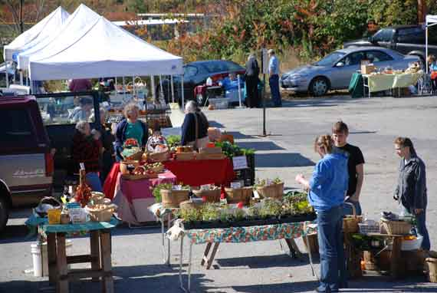
Like this, only online.
The program’s benefits are twofold. It gives farmers, who may not have the time or ability to create an online presence, a place to advertise and sell their goods. It also gives customers, who can’t always make it to the farms or farmer’s market, the ability to purchase locally-grown food easily, from the comfort of home.
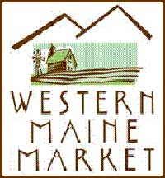The site is based off of a similar program run out of Plymouth, N.H., and it’s being implemented by Western Mountains Alliance, a community development organization serving four counties, the Northeast Sustainable Agriculture Research and Education, as well as lots and lots of volunteers.
“We run on volunteers from the community,” WMA’s Tricia Cook said. “We have a terrific advisory board.”
Cook said that the April 3 opening date for WesternMaineMarket.com is contingent upon the site being ready to go. Without the capacity for a trial run, known as a “beta,” the market’s organizers are going to start with a limited number of nonperishable products and move slowly.
“It’s totally exceeded our hopes and goals,” Cook said of the program, “but people are going to need to be patient with us as we start off.”
The market opens Friday afternoons, and remains open until Monday morning. While open, customers can browse through the offerings of the vendors, adding items to their “shopping carts” and paying for them online. Then, after the site has closed and the orders have been received and been filled, people can pick up their purchases Tuesday afternoon. Organizers say people should arrive at the distribution center with a bag to carry their purchases.
Currently, Cook says, Trantens Grocery on Main Street in Farmington is the distribution center for the program. Later, organizers are interested in looking to involve the local farmer’s market.
So far, 14 vendors have signed up for the program, offering mostly nonperishable goods such as jams, dry herb mixes, vinagers, frozen meats, candy and maple syrup products. Some milk and cheese will also be available, but Cook said that organizers want to make certain that all the kinks in the new program are worked out before offering large amounts of perishable goods.
“We’re definitely learning as we go,” she said. “Buyers, farmers, everyone is going to have to learn how this works.”
This is not the first interaction between WMA and local farmers. The alliance, along with the Healthy Community Coalition and a number of local businesses and farmers, has released three annual directories for local farms and farm markets. Those booklets, which list addresses and contact information for 83 local farms, are available throughout the county.
Cook hopes that people will check out the site, and be understanding if it takes some time to get everything running smoothly. They are also looking for a little help; the market is seeking donations of six bushel baskets and three 40 to 60-quart coolers to hold farmers’ products. If you can help with baskets and/or coolers, please call Mary at 778-4695. Organizers will pick the items up.

