
Ann Bryant, Staff Writer
FARMINGTON — The online Western Maine Market now offers home delivery of locally produced items.
Starting with this Friday's market, customers can simply indicate on their order page that they would like home delivery, said Deborah Chadbourne, a vendor who has volunteered to provide the delivery for the Western Mountains Alliance market.
There is a small charge of $3 for deliveries in Farmington, $5 to Wilton, Temple, Strong, Kingfield, New Vineyard, Industry or New Sharon or $10 for delivery to Rangeley, Oquossoc, Carrabassett Valley, Livermore, Livermore Falls, Jay, Chesterville, Vienna and Norridgewock.
"We hope to encourage more people to make use of this opportunity to purchase local products even if they can't get out," Chadbourne said.
Whether they can't participate due to work or the pickup times do not work for them or they are elderly... whatever the reason, she sees the deliveries as part of providing good service that will give local vendors more customers.
While the online market, started last April, has continued to do well there has been a slight slow down this fall, she said. Chadbourne is a small farm home gardener who brings produce and cut flowers, berries and soon mushrooms to the local farmers market.
As the year-round market continues, the Alliance hopes that local farmers will grow more root vegetables, said Tricia Cook, who began the online market.
Customers can place orders until Thursday for either pickup at Tranten's Market in Farmington on Friday afternoons or at the Farmer's Market now held on Saturday mornings at the West Farmington Grange Hall.
Home delivery of items is available either Friday or Saturday afternoon and many products can be delivered at other times and days, Chadbourne said.
Once the new semester begins, an Alliance intern from the University of Maine at Farmington will begin an effort to research and coordinate a network of people living in towns outside the local area who want to purchase items from the online market, said Cook. If the intern can connect interested people in towns such as Kingfield or Rangeley, deliveries could be made on a larger basis, she said.
A variety of items from fresh meat, to vegetables,
baked goods or maple syrup is available to order online at www.westernmainemarket.com
For more information about home deliveries, contact
Chadbourne by email at dchadbou@sprynet.com or call her at
857-225-1199.
abryant@sunjournal.com

Farmers’ online market to make house calls
By Bobbie Hanstein • Dec 29th, 2009 • Category: Features
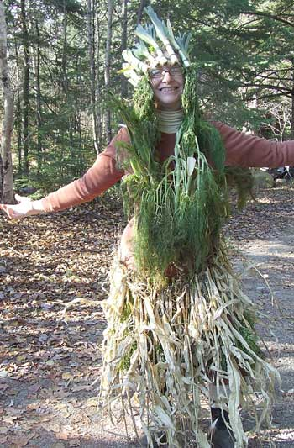
FARMINGTON - Beginning this weekend, delivery is available for those who order from the online local farmers’ Western Maine Market.
The market’s new delivery service is in response to some customers not being able to make the two pick-up times offered on Saturday mornings from 10 to noon at the Grange Hall on Bridge Street in West Farmington or Friday afternoons from 4 to 6 p.m. at Tranten’s Market on Main Street in Farmington. Those pick-up times will continue.
Deborah Chadbourne, will probably not be wearing her Halloween veggie queen costume when she makes the deliveries on orders coming though the online Western Maine Market.
The online market, which began operation in April and a program of the Western Maine Alliance, offers a wide variety of locally produced food and handmade gift items from several local area farms. The online store is open from Saturday afternoons through Thursday afternoons here.
Deborah Chadbourne of Rasmussen Farm in Freeman Township, said she volunteered to make the deliveries throughout Franklin County.
“I heard from a lot of people who couldn’t make the pick-up times,” she said. “This is the only way I could think of to make it easier for people.”
She noted that some people who expressed interest in the market but couldn’t were elderly, or don’t have transportation, while others are too busy to make the specific pick-up times.
Overall, the market is doing well with three new vendors joining the group in October. A slowdown of goods in winter is to be expected due to the seasonal availability of the products, but handmade gifts items and other year-round products have kept things busy. More than 650 people are receiving the market’s online newsletter each week, Chadbourne said.
With the new delivery service, comes interest in large orders. The Oquossic Market and Farmer’s Wife store have both asked about the possibility of making large orders and getting it delivered so they can carry many of the locally-produced goods in their stores.
“It would be great to give the Rangeley area access to locally produced goods,” Chadbourne said.
A small fee of $3 for Farmington area deliveries, $5 for area towns and $10 to the furthest reaches of Franklin County, will be charged at the time of delivery. Chadbourne, who is voluntarily driving her own gas efficient, hybrid Prius to make the deliveries, said the fee may be reduced or waived if the delivery stop is on her way to another delivery.
Although busy farming most of the year, Chadbourne with David Rasmussen grow raspberries, blueberries, various veggies, greens, herbs, fruit, edible and cut flowers and more, she has made time for deliveries.
The timing of the delivery will be dependent on the items’ availability at the time of the call. All products can be delivered Friday or Saturday afternoon. Some items such as honey or other products in stock and ready to go can be delivered immediately while others, such as the freshly baked goods that are ready at regularly scheduled times.
If you would like to take advantage of the delivery service, make a note this in the comments section when ordering online here. Email dchadbou@sprynet.com or call Chadbourne at 1-857-225-1199 to see what other times the products you want may be available.

