NCR-SARE Farmer Rancher Grant Program

Final Report
.

1. PROJECT IDENTIFICATION
- Name Providence Farms, LLC
- Address 932 Road X, Bladen, NE 68928
- Phone 402-756-1094 (home) 402-469-6784 (cellular)
- Project Title Cover Crop Water Usage and Affect on Yield in No-Till Dryland
Cropping Systems

- Project Number FNC07-653
- Project Duration 2007-2009
- Date of Report 12/30/2009

2. PROJECT BACKGROUND
Providence Farms, LLC is the joint farming venture of the Brian Berns and Keith Berns families of Bladen, Nebraska. Brian and Keith, along with their families, farm over 2,000 acres in south central Nebraska. The farm ground is about 1/3 pivot irrigated and 2/3 dryland and has been under continuous no-till production for 10-15 years.

Irrigated rotations consist primarily of corn and soybeans with an occasional cropping of irrigated wheat followed by a cash double crop. Dryland rotations are mainly corn-corn-soybeans-wheat-covercrop. A small cow-calf herd of around 45 cows is also maintained on the farm.

We have been no-tilling for 20 years and have been 100% continuous no-till for 10 years now (with the exception of 100 acres of ridge-till gravity irrigated ground). We are strong believers in no-till and are very active in the promotion of no-till farming.

3. PROJECT DESCRIPTION AND RESULTS
Our main goal was to look at how cover crops would work in the Midwest and, particularly, how they would affect a dryland cropping system. The first question and major concern any dryland farmer has about cover crops is: “How much water will a cover crop use?” This project attempted to answer this question regarding the use of cover crops in a dryland no-till cropping system.

A secondary goal was to look at how cover crops might effect the yield of the next crop. We recorded the yield of corn that was planted into different cover crop plots and analyzed this data to determine if cover crops had any affect on yield.

PROCESS:
- Select cover crops to be tested and order seed – Completed: May 2008
We consulted with a number of cover crop “experts” to determine what species to use and what mixtures to consider. Factors that were considered in the selection of cover crops were: [a] cost of seed (needs to be economically feasible), [b] ease of seeding (needs to be able to be seeded with existing equipment) [c] variety (include broadleaves, grasses, legumes, and mixtures) and [d] life span (choose some crop that winter kill and some that over-winter). Cover crops that were used included broadleaves, grasses, legumes, and mixtures. The following table shows crops that were used in this project:
Legumes  - Soybeans  - Lentils  - Vetch – common  - Red Clover  - Alfalfa  Grasses  - Milo  - Sudan  - Millet  - Winter Barley  - Wheat  Other  - Sunflowers | Mixes  Brassica Mix: Graza fodder radish, T-Raptor (rape x turnip), Hunter (rape x turnip), Barkant turnip, Barabas turnip, Rival turnip, Rangiora forage rape, Winfred forage (rape x kale)  Grass Mix: milo, sorghum sudan, pearl millet, proso millet, German millet  Legume Mix: Soybeans, mung beans, lentils, common vetch, alfalfa, red clover  Mix #1: milo, sorghum sudan, pearl millet, proso millet, German millet, Soybeans, mung beans, lentils, common vetch, alfalfa, red clover, oil seed radish, dwarf essex rape, Ethiopian cabbage, specialty brassica’s, sunflowers  Mix #2: sorghum sudan, pearl millet, German millet, lentils, common vetch, oil seed radish, dwarf essex rape, Ethiopian cabbage, specialty brassica’s | Brassicas  - Oil Seed Radish  - Turnips  - Dwarf Essex Rape  - Ethiopian Cabbage  - Specialty Brassicas  - Graza fodder radish  - T-Raptor (rape x turnip)  - Hunter (rape x turnip)  - Winfred (rape x kale)  - Barkant turnip  - Barabas turnip  - Rival turnip  - Rangiora forage rape

- Seed cover crops after wheat harvest – Completed: July 20, 2008
A 20 foot strip of each selected cover crop was seeded into wheat stubble using a 10’ rented no-till drill. A burn-down herbicide was applied prior to seeding. In addition, 50 acres of mix #2 listed above was planted on the same field to be used for grazing trials. This 50 acres was planted with a John Deere 1560 drill.

- Install soil moisture sensors and data loggers – Completed: August 2008
Sensors and data loggers were be installed at 12”, 24” and 36” depths. UNL Extension and Natural Resource District personnel were utilized to ensure proper installation.

- Read soil moisture sensors on a regular basis – August 2008 – November 2009
Sensors were read on a weekly basis from August through November. Data loggers were downloaded to a computer at the end of November.

- Host Cover Crop Field Day - Completed: September 2008
A field day was hosted to show area producers the growth of the different cover crops and discuss preliminary data on cover crop water usage. More details on this field day are found later in this report.

- Record corn yield in each cover crop plot – Completed: November 2009
Corn yields were recorded from several of the individual cover crop plots as well as 2 of the cover crop mix plots. Results are found later in this report.

- Publish and share cover crop water use and yield results - Ongoing
Information gathered from this project has been shared with thousand of people as will be detailed later in this report.

PEOPLE
Many people were involved in making this project a success.

Person | Agency | Role
Jenny Reese | UNL Extension | Helped install moisture sensors. Promotion and registration assistance at field day.
Darrel Anderson | Little Blue NRD | Helped install moisture sensors. Promotion of field day.
Dewey Linnamen | UNL Extension | Promotion and registration assistance at field day.
Paul Jasa | UNL Extension –No-till expert | Speaker at and sponsor of field day.
Dr. Ray Ward | Ward Laboratories | Speaker at and sponsor of field day.
Brad Young | Prairie States Seed | Supplier of seed, speaker at field day.
Nebraska Environmental Trust, No-till on the Plains, Krull Agency, Little Blue NRD, UNL Extension, Prairieland RCD, Pioneer Seed, Norder Ag Supply, NRCS |  | Sponsorship and promotion of field day

RESULTS
The late summer and early fall of 2008 was a very wet year for us which somewhat skewed a moisture use study, but the charts were generated some useful data. The results of our moisture use study were very interesting. In summary:
- Cover crop mixes showed far less water use than did heavy use crops such as sunflowers and soybeans.
- Cover crop mix water use charts looked very similar to the water use chart for wheat stubble alone.
- Some monoculture cover crops did show much water use but these tended to be crops that had limited growth.

An appendix of moisture use charts is found at the end of this report for further study.

Yield test results were interesting as well. We planted corn into all of the cover crop plots. We hand harvested 1/1000 of an acre (2 rows x 8.5’) in 4 different areas in 3 monoculture plots, 2 mix plots and the wheat stubble. We then weighed the ears that were harvested and calculated yield from these weights (Our thanks to Paul Jasa, UNL Extension, for his assistance in this). Yield results are found in the following table:
Cover Plot 2008 | 2009 Corn Yield
Sunflowers | 131.4
Soybeans | 134.3
Oil Seed Radish | 128.9
Wheat Stubble | 131.4
Mix #1 | 140.0
Mix #2 (higher seeding rate) | 154.3

This yield data was very interesting. In summary:
- Corn planted into cover crop mixes yielded significantly better than corn planted into plain wheat stubble or a monoculture cover crop.
- Corn planted into a monoculture cover crop mixes did not yield significantly less than corn planted into plain wheat stubble.
Based on these numbers we believe that cover crop mixes are beneficial to yield of the next crop. With this being said however, we acknowledge that these results are from one trial in one year. We think that this question of yield response to cover crop mixes needs to be studied further.

DISCUSSION
We learned many things from this grant. The following is a list of the most important things:

- Cover crop mixes showed far less water use than did heavy use crops such as sunflowers and soybeans.
- Cover crop mix water use charts looked very similar to the water use chart for wheat stubble alone.
- Some monoculture cover crops did show much water use but these tended to be crops that had limited growth.
- Corn planted into cover crop mixes yielded significantly better than corn planted into plain wheat stubble or a monoculture cover crop.
- Corn planted into a monoculture cover crop mixes did not yield significantly less than corn planted into plain wheat stubble.
- There are many biological benefits of having a growing cover crop but these are difficult to see, measure and quantify.
- Cover crop mixes are an excellent way to provide high quality late fall and winter supplemental grazing for livestock.
- Cover crop mixes should include a balance of grasses, legumes, and brassicas.
- Cover crop mixes with good legume growth can produce a significant amount of nitrogen when planted after wheat stubble.
- There is a great deal of farmer interest in the growth and use of cover crops.
The results of this project have made us firm believers in cover crops and we will plant every acre of our dryland wheat stubble to a cover crop mix. We will continue to experiment with different mixes, seeding rates, plant species, etc.. We also hope to continue to monitor water usage of cover crops and also measure yield in the crop following our cover crops.

OUTREACH
We have spoken nearly 25 times and shared our research project results with over 1500 people from across the Midwest. We have hosted two different on-farm field days where people could see, touch and feel our cover crop plots. In addition, we have been interviewed by numerous magazines and newspapers and have had our cover crop research project featured in several articles with others forthcoming. Publications include: Successful Farmer, Nebraska Farmer, The Furrow, and The Leading Edge, Hastings Tribune, and the Blue Hill Leader.

We also designed and published a website for our project and our research findings. www.notillcovercrops.com has numerous photos of our cover crop plots and our data findings. To date over 2600 people have visited this website to view our project results.

Date | Event | Location | Number of People
Fall 2008 | Cover Crop Test Plot Field Day | Cover Crop Plots – Bladen, NE | 125
Fall 2008 | Cover Crop Test Plot Field Day for NRCS, crop scouts, and other “experts” | Cover Crop Plots – Bladen, NE | 25
Winter 2009 | No-till On The Plains Winter Conference | Salina, KS | 400
Winter 2009 | Little Blue NRD No-till meeting | Fairbury, NE | 40
Winter 2009 | Upper Big Blue NRD No-till meetings | Hastings, Wilber, Fullerton | 250
Winter 2009 | Nebraska Grain Sorghum Producer Meetings | Wilber, Franklin, Deshler | 120
Winter 2009 | No-till On The Plains Winter Meetings | 6 locations throughout north east Kansas | 240
Summer 2009 | Tour stop for farmer group from Argentina | Cover Crop Plots – Bladen, NE | 40
Fall 2009 | Cover Crop Test Plot Field Day | Cover Crop Plots – Bladen, NE | 150
Fall 2009 | Nebraska Agri-business Crop Advisor Update meetings | Lincoln and Grand Island, NE | 120
Fall 2009 | Panhandle No-till Winter Meeting | Gering, NE | 75
Fall 2009 – Winter 2010 | Nebraska Sustainable Ag Conferences | Ogallala and Lincoln, NE | 80
Winter 2010 | No-till On The Plains AIM Conference | Salina, KS | 150
Fall 2008 – Ongoing | Website of Project Information | www.notillcovercrops.com | 2600+

Appendix A

Charts of Moisture Usage from Cover Crop Plots

August – November 2008

Data Collected from Watermark Soil Sensors and Data Loggers

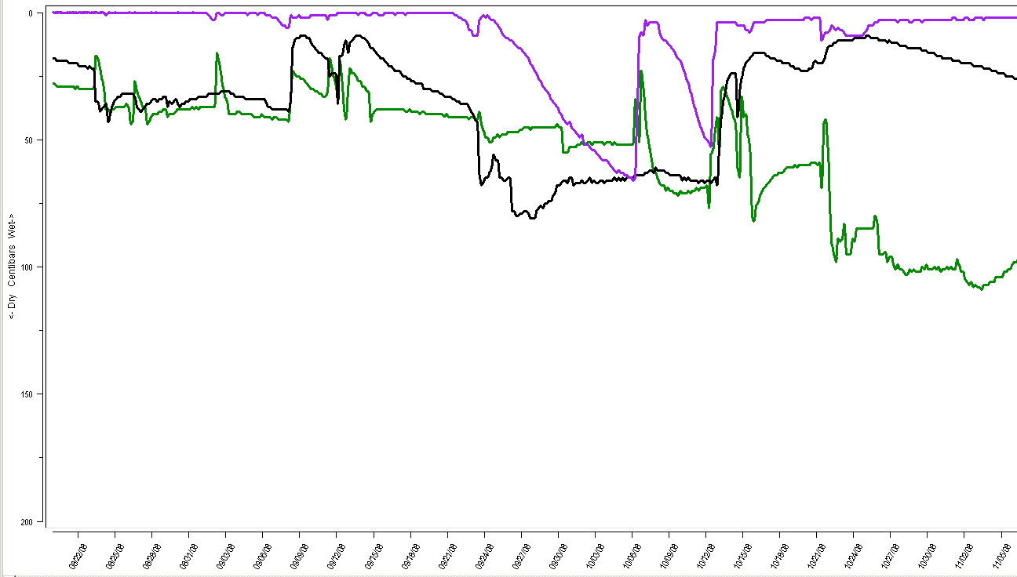 Aug 19th………………………..Sept 15th………………...Oct. 12……………………………..Nov. 5

Wheat Stubble  Relative Growth: 1 2 3 4 5 6 7 8 9 10  Seed Cost (acre): $0 $4 $8 $12 $16 $20 $24 | Notes: Some volunteer growth contributed to some water use. | 1 ft  2 ft  3 ft

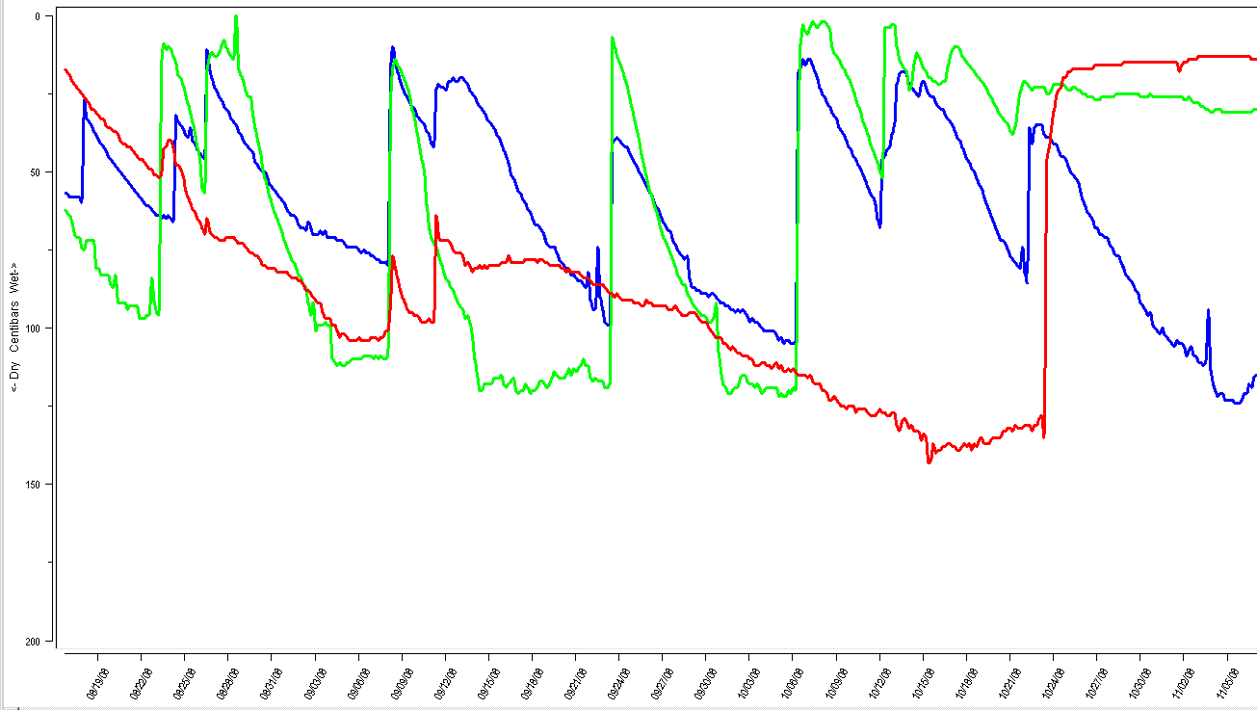
Aug 19th………………………..Sept 15th………………...Oct. 12……………………………..Nov. 5

Sunflowers  Relative Growth: 1 2 3 4 5 6 7 8 9 10  Seed Cost (acre): $0 $4 $8 $12 $16 $20 $24 | Notes: Excellent growth – heavy water user. Heads formed and some viable seed produced – no volunteer problems the next year. Semi-frost tolerant. Seeding rate: 25#/acre. Find bin-run seed to make cheaper. | 1 ft  2 ft  3 ft
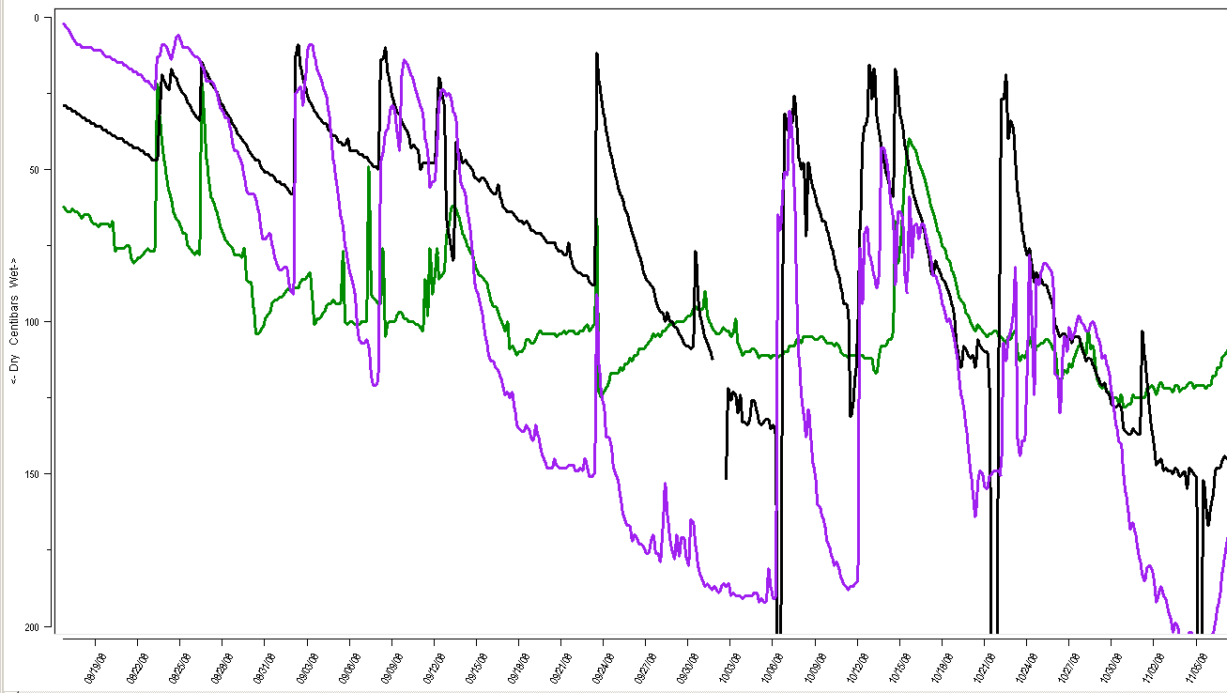
Aug 19th………………………..Sept 15th………………...Oct. 12……………………………..Nov. 5

Soybeans  Relative Growth: 1 2 3 4 5 6 7 8 9 10  Seed Cost (acre): $0 $4 $8 $12 $16 $20 $24 | Notes: Quick emergence, good growth and heaviest water usage. Nodulated well and produced 70-80# N (Ray Ward estimate). Group 3 bean set pods and made seed (not desirable for cover crop). May have made 15 bu if harvested. Seeding rate: 50#/acre | 1 ft  2 ft  3 ft
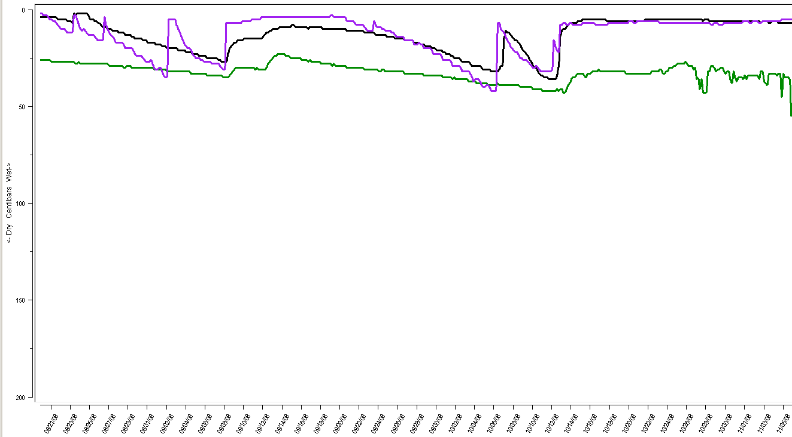 Aug 19th………………………..Sept 15th………………...Oct. 12……………………………..Nov. 5

Mix #1: milo, sorghum sudan, pearl millet, soybeans, mung beans, lentils, common vetch, alfalfa, red clover, oil seed radish, dwarf essex rape, Ethiopian cabbage, specialty brassica’s, sunflowers  Relative Growth: 1 2 3 4 5 6 7 8 9 10  Seed Cost (acre): $0 $4 $8 $12 $16 $20 $24 | Notes: Wide variety of species. Good growth with relatively little water usage. Legumes in mix were nodulating well and producing some nitrogen (not measured). Some species froze early while others grew well into November. Seeding rate: 25# | 1 ft  2 ft  3 ft
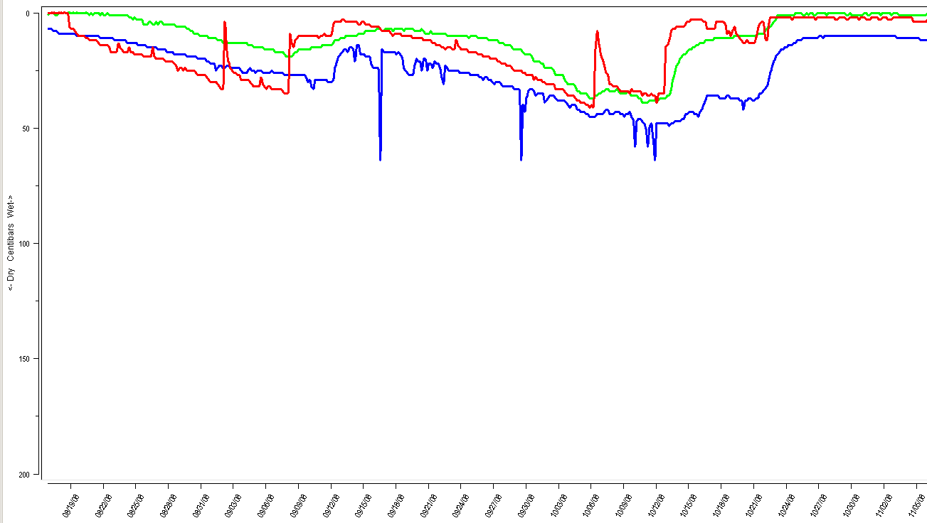
Aug 19th………………………..Sept 15th………………...Oct. 12……………………………..Nov. 5

Mix #2: sorghum sudan, pearl millet, German millet, lentils, common vetch, oil seed radish, dwarf essex rape, Ethiopian cabbage, specialty brassica’s Relative Growth: 1 2 3 4 5 6 7 8 9 10  Seed Cost (acre): $0 $4 $8 $12 $16 $20 $24 | Notes: Wide variety of species. Good growth with relatively little water usage. Legumes in mix were nodulating well and producing some nitrogen (not measured). Some species froze early while others grew well into November. Seeding rate: 25# | 1 ft  2 ft  3 ft

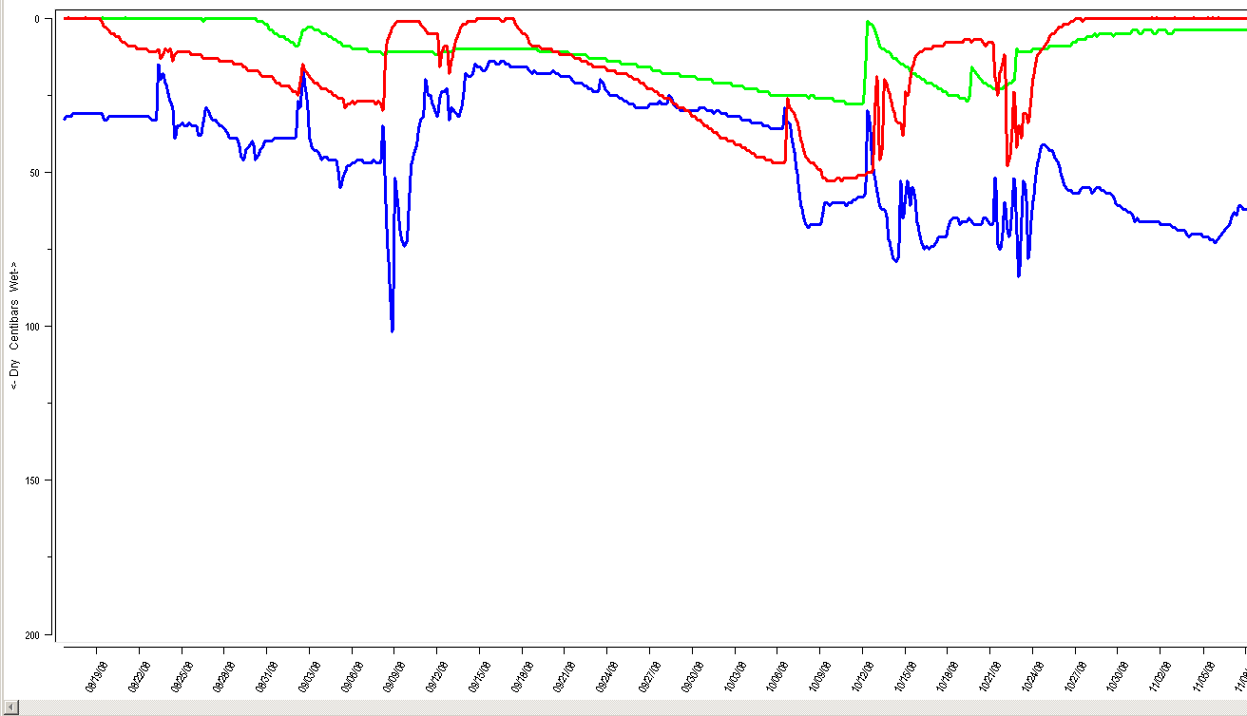 Aug 19th………………………..Sept 15th………………...Oct. 12……………………………..Nov. 5

Milo  Relative Growth: 1 2 3 4 5 6 7 8 9 10  Seed Cost (acre): $0 $4 $8 $12 $16 $20 $24 | Notes: Limited growth because of limited N. Few heads formed. Good residue production. Not frost tolerant. Seeding rate: 8#/acre. Find bin-run seed to make cheaper. | 1 ft  2 ft  3 ft

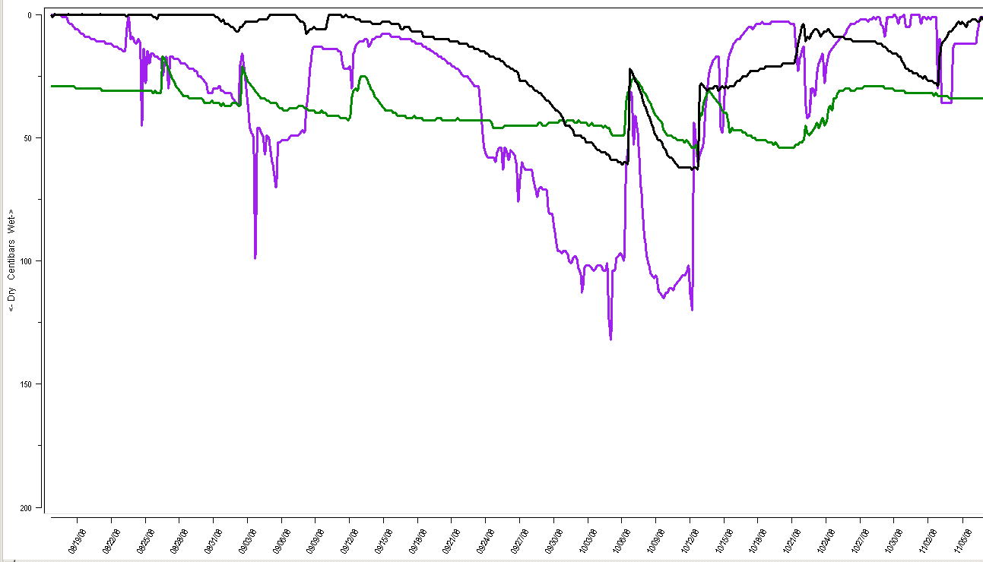
Aug 19th………………………..Sept 15th………………...Oct. 12……………………………..Nov. 5

Sorghum Sudan  Relative Growth: 1 2 3 4 5 6 7 8 9 10  Seed Cost (acre): $0 $4 $8 $12 $16 $20 $24 | Notes: Best grass we tested. Growth was somewhat limited because of lack of nitrogen. Not tolerant to frost. Seeding rate was approximately 15 # acre. Produced heads but not much viable seed before killing frost. | 1 ft  2 ft  3 ft

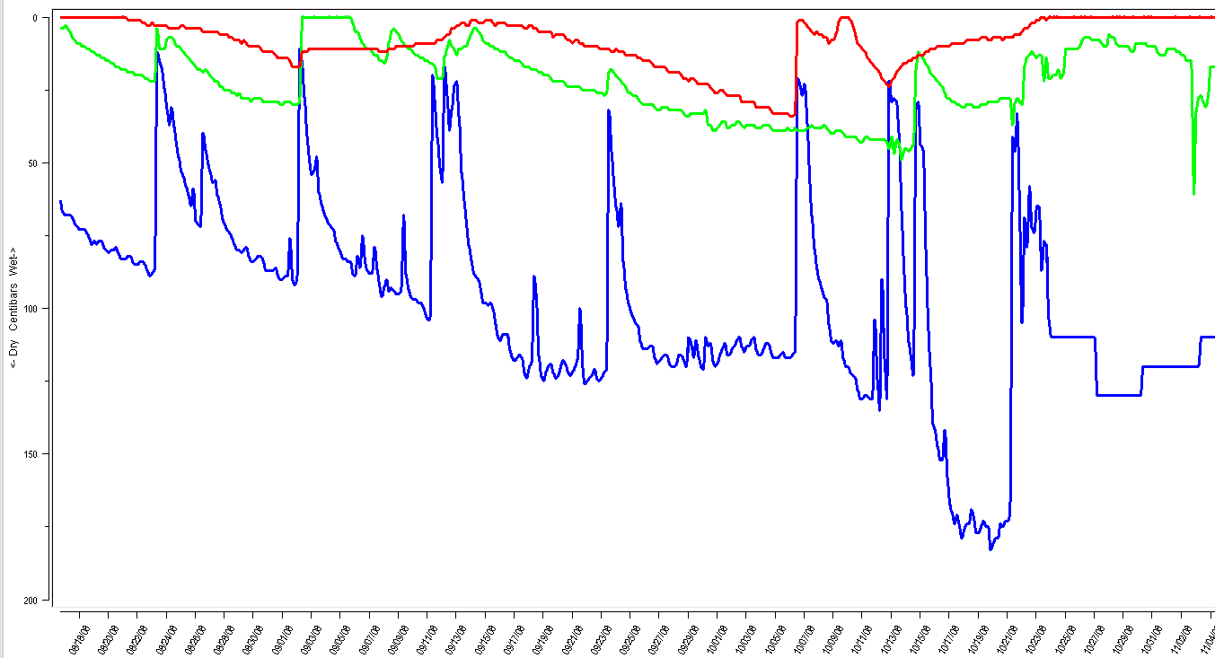 Aug 19th………………………..Sept 15th………………...Oct. 12……………………………..Nov. 5

Proso millet  Relative Growth: 1 2 3 4 5 6 7 8 9 10  Seed Cost (acre): $0 $4 $8 $12 $16 $20 $24 | Notes: Short growing millet. Makes seed heads and viable seed. Not good for grazing cattle on. | 1 ft  2 ft  3 ft

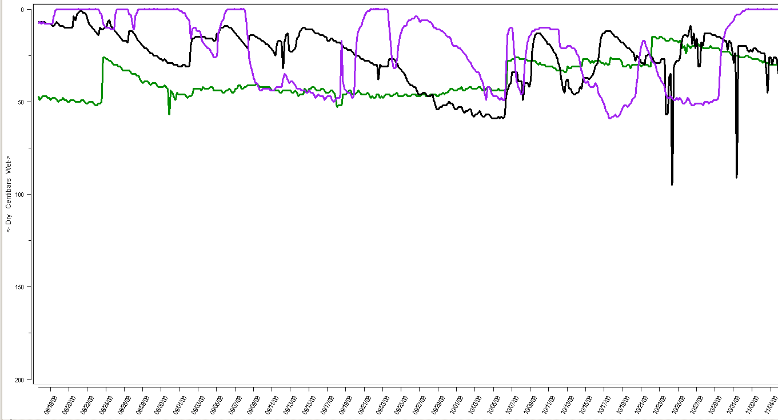 Aug 19th………………………..Sept 15th………………...Oct. 12……………………………..Nov. 5

German millet  Relative Growth: 1 2 3 4 5 6 7 8 9 10  Seed Cost (acre): $0 $4 $8 $12 $16 $20 $24 | Notes: Growth was limited because of lack of nitrogen. Not tolerant to frost. Seeding rate was approximately 15 # acre. Produced viable seed before killing frost. | 1 ft  2 ft  3 ft

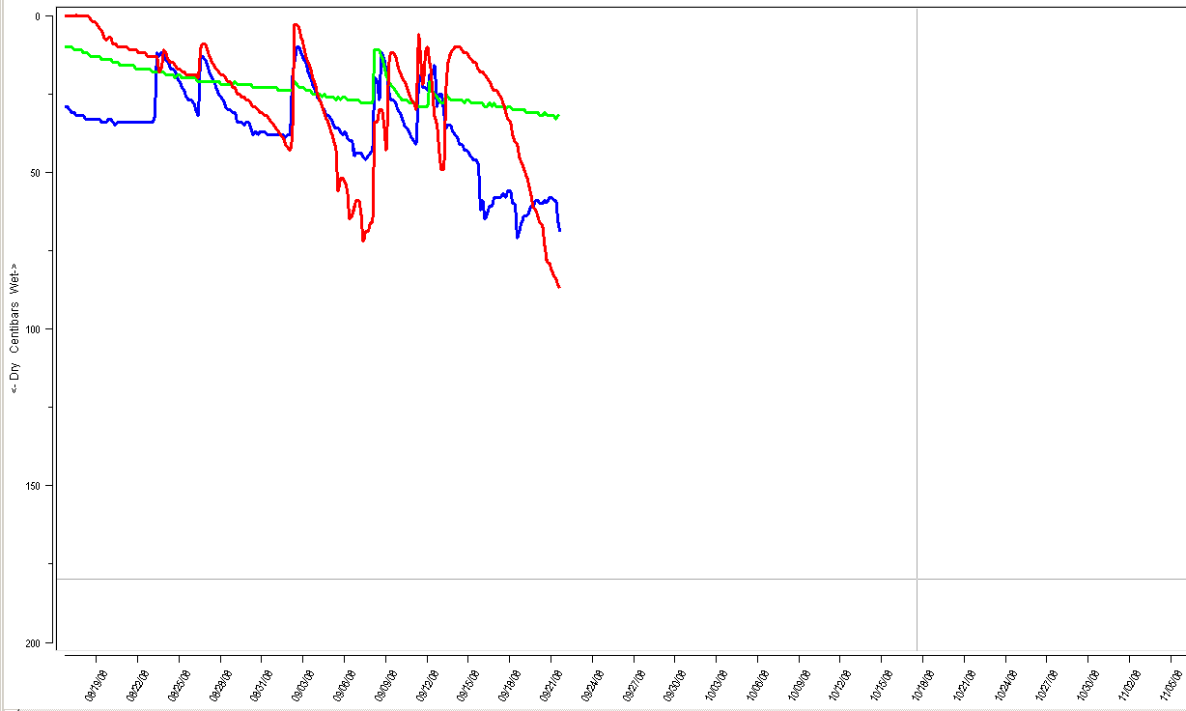 Aug 19th………………………..Sept 15th………………...Oct. 12……………………………..Nov. 5

Indianhead Lentils  Relative Growth: 1 2 3 4 5 6 7 8 9 10  Seed Cost (acre): $0 $4 $8 $12 $16 $20 $24 | Notes: Cows were out and broke sensor wires in Sept. Very frost tolerant – green well into November. Nodulated well and produced 60-70# N (Ray Ward estimate). Seeding rate: 20#/acre. Low growing, viney – liked to climb stubble. Not as aggressive as vetch. | 1 ft  2 ft  3 ft
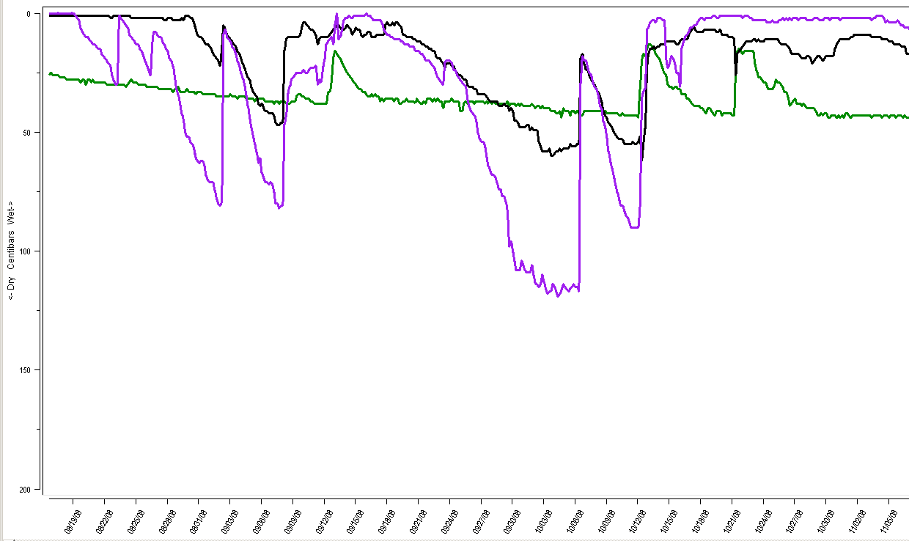 Aug 19th………………………..Sept 15th………………...Oct. 12……………………………..Nov. 5

Dwarf Essex rape (Canola)  Relative Growth: 1 2 3 4 5 6 7 8 9 10  Seed Cost (acre): $0 $4 $8 $12 $16 $20 $24 | Notes: Growth was limited because of lack of nitrogen. Very tolerant to frost. Seeding rate was approximately 10 # acre. We will use canola in the future because it is very similar but cheaper seed. | 1 ft  2 ft  3 ft
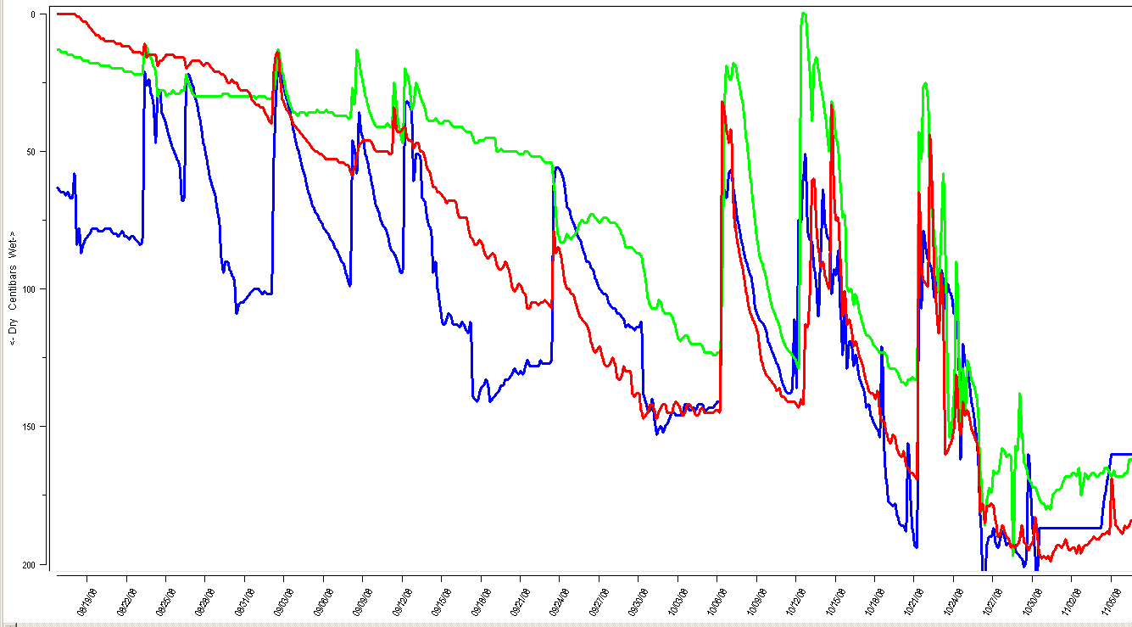 Aug 19th………………………..Sept 15th………………...Oct. 12……………………………..Nov. 5

Common vetch  Relative Growth: 1 2 3 4 5 6 7 8 9 10  Seed Cost (acre): $0 $4 $8 $12 $16 $20 $24 | Notes: Very frost tolerant – green well into November – notice late season water use on chart. Nodulated well and produced 70-80# N (Ray Ward estimate). Seeding rate: 20#/acre. Low growing, viney – liked to climb stubble. Slow emerging but grew well as days got shorter and temps got cooler. | 1 ft  2 ft  3 ft
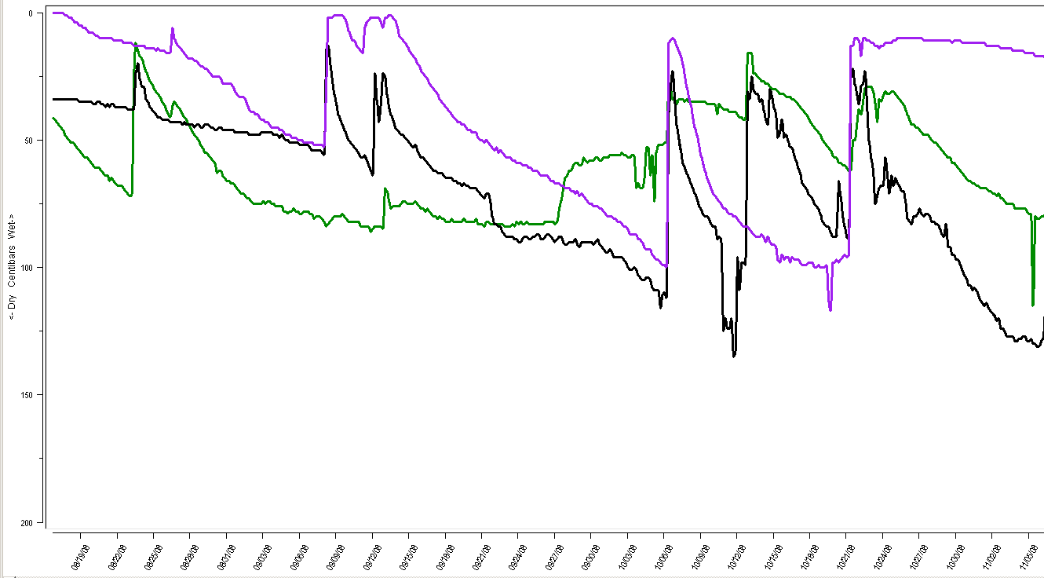 Aug 19th………………………..Sept 15th………………...Oct. 12……………………………..Nov. 5

Mung Beans  Relative Growth: 1 2 3 4 5 6 7 8 9 10  Seed Cost (acre): $0 $4 $8 $12 $16 $20 $24 | Notes: Very fast emergence and early growth. Growth was limited because we did not have proper inoculant. Very susceptible to first frost. Seeding rate was approximately 40 # acre. | 1 ft  2 ft  3 ft
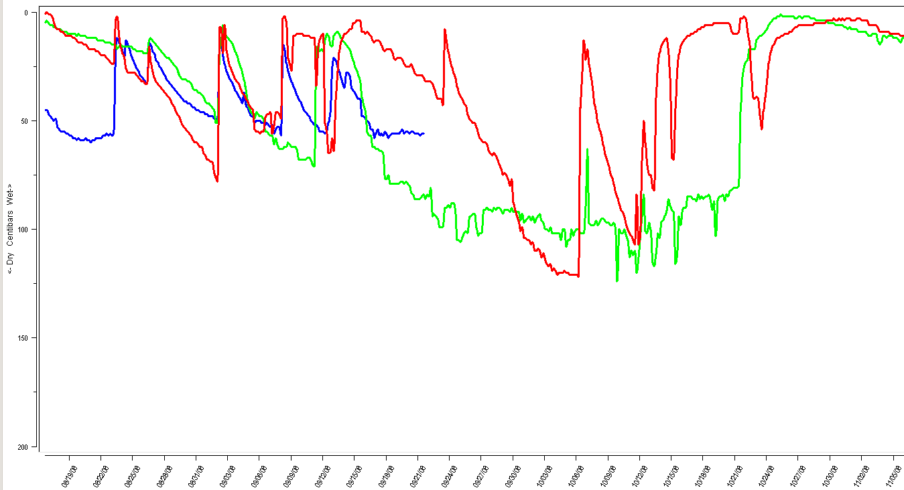 Aug 19th………………………..Sept 15th………………...Oct. 12……………………………..Nov. 5

Oil Seed Radish  Relative Growth: 1 2 3 4 5 6 7 8 9 10  Seed Cost (acre): $0 $4 $8 $12 $16 $20 $24 | Notes: Limited growth because of lack of N. Very frost tolerant – green well into November. Do not recommend brassicas by themselves. Seeding rate: 6#/acre. | 1 ft  2 ft  3 ft
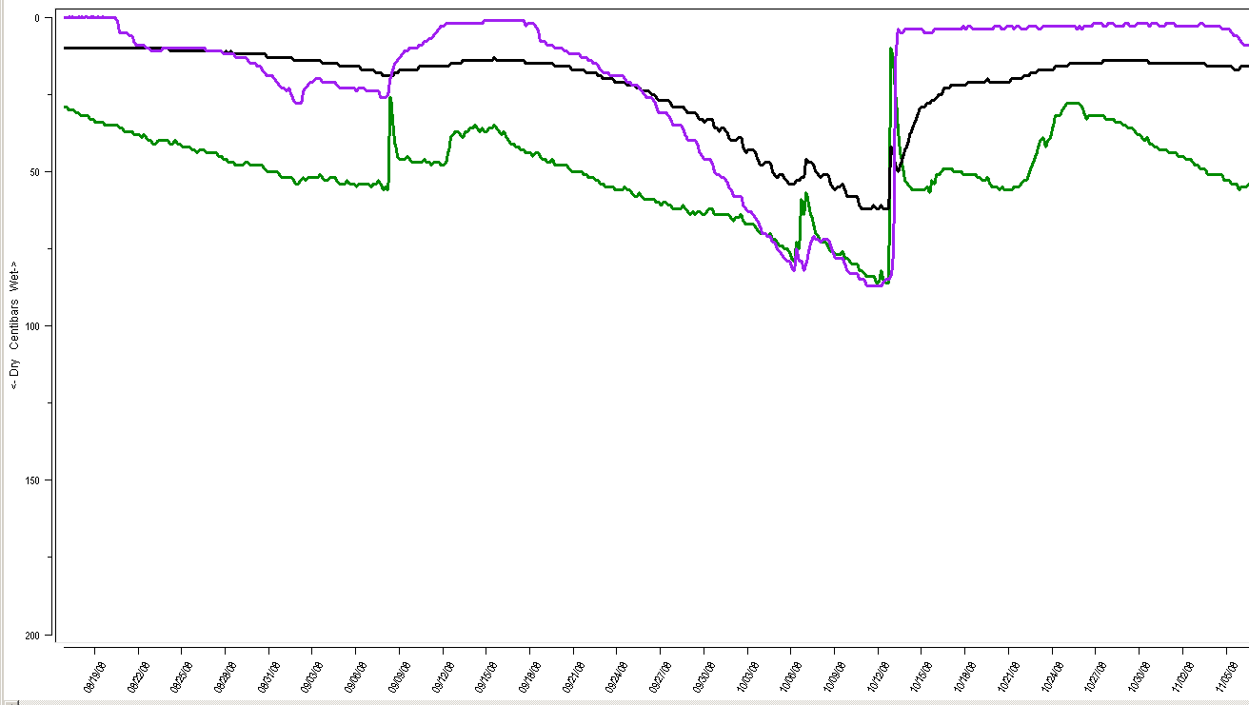 Aug 19th………………………..Sept 15th………………...Oct. 12……………………………..Nov. 5

Winter Barley  Relative Growth: 1 2 3 4 5 6 7 8 9 10  Seed Cost (acre): $0 $4 $8 $12 $16 $20 $24 | Notes: Not a lot of fall growth. Fairly shallow rooted and limited water use. Seeding rate was approximately 1.5 bu/acre. | 1 ft  2 ft  3 ft
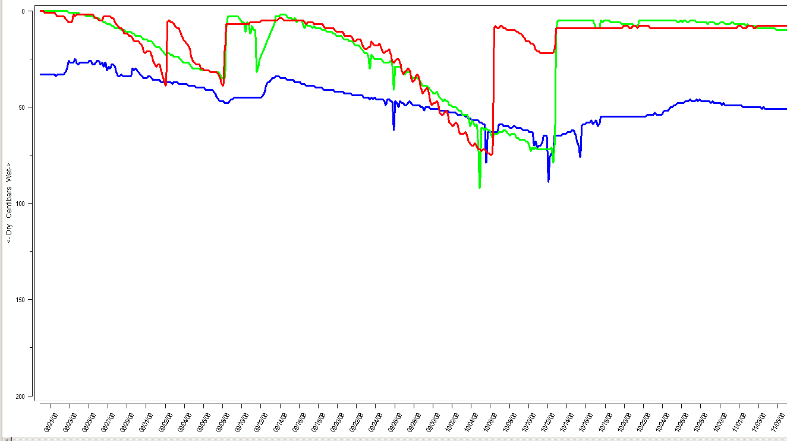 Aug 19th………………………..Sept 15th………………...Oct. 12……………………………..Nov. 5

Ethiopian Cabbage  Relative Growth: 1 2 3 4 5 6 7 8 9 10  Seed Cost (acre): $0 $4 $8 $12 $16 $20 $24 | Notes: Limited growth because of lack of N. Great root system. Very frost tolerant – green well into November. Stalks still standing when harvesting corn in Nov. Seeding rate: 5#/acre. | 1 ft  2 ft  3 ft
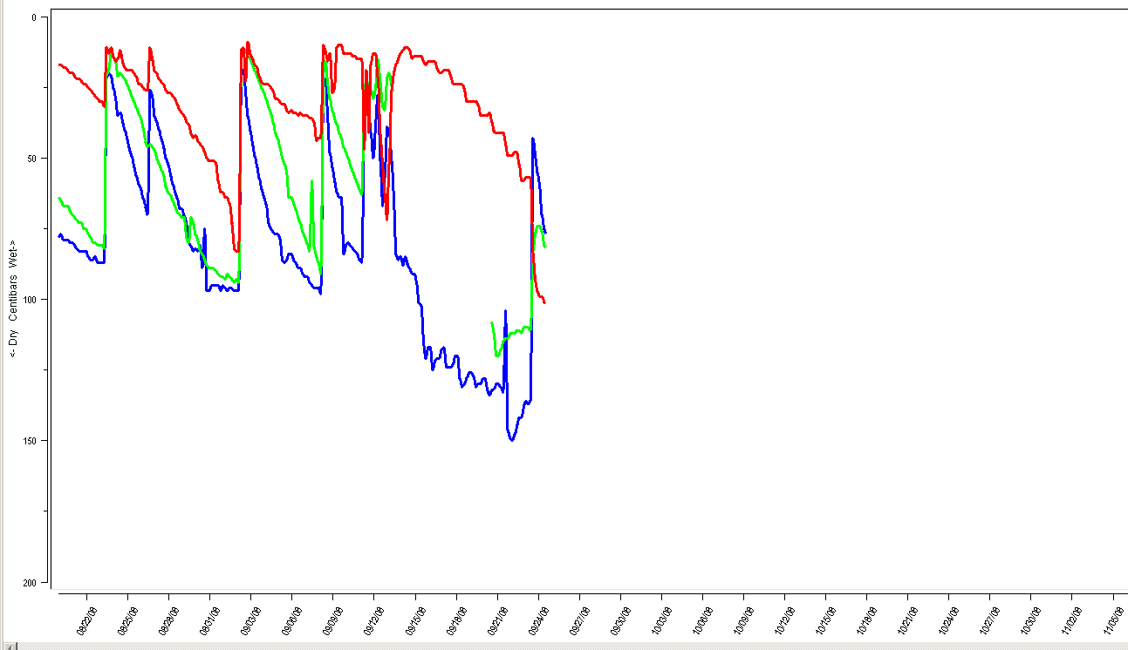 Aug 19th………………………..Sept 15th………………...Oct. 12……………………………..Nov. 5

Brassica Mix  Relative Growth: 1 2 3 4 5 6 7 8 9 10  Seed Cost (acre): $0 $4 $8 $12 $16 $20 $24 | Notes: Sensors stopped working in Sept. Limited growth because of lack of N. Very frost tolerant – green well into November. Do not recommend brassicas by themselves. Seeding rate: 6#/acre. | 1 ft  2 ft  3 ft

