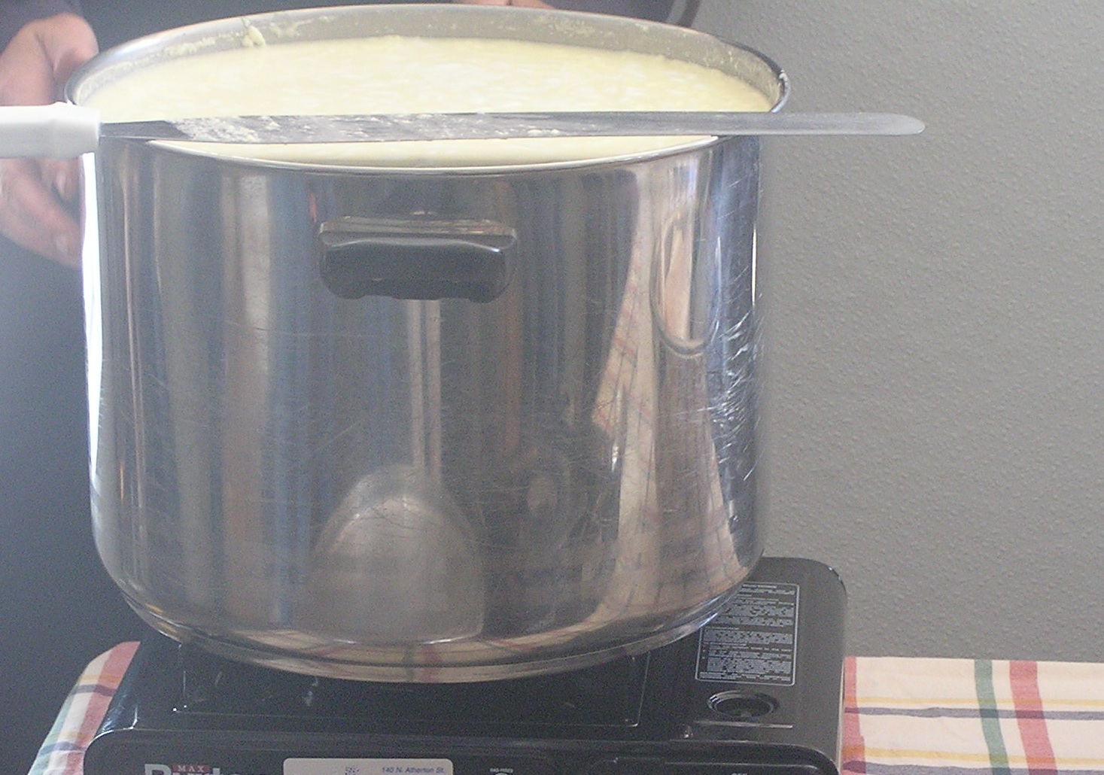

Home Cheesemaking:
Hands-On Workshop for Beginners

Date: Friday, October 2
Time: 10:00am - 4:00pm (includes lunch)
Location: Quiet Creek Herb Farm, Brookville, JEFFERSON Co.
Cost: $50 PASA Members, $75 all others

Learn to make fresh, homemade cheese and yogurt!
Get a start on incorporating value-added dairy into your farm business!

Perfect for the beginning cheesemaker, this daylong intensive covers the basics for making cheese with just a few ingredients and your kitchen stove. Make hard and soft cheeses from start to finish:

Yogurt Cheddar Mozzerella
Ricotta Fromagina

Learn about smoking and adding herbs to cheeses, as well as proper sanitation and storage methods. Take home starter culture and learn where to source materials as you expand your cheesemaking horizons!

For more information and to register for this event, visit www.pasafarming.org,
or call (814) 349- 9856.

