PRESS RELEASE
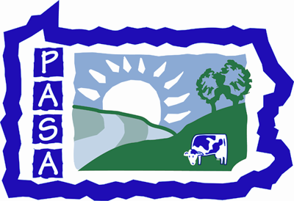
Pennsylvania Association for Sustainable Agriculture
PO Box 419, Millheim, PA, 16854
Contact: Rachel Schaal
Office: 814-349-9856 ext 205
Email: Rachel@pasafarming.org
Fax-814-349-9840
www.pasafarming.org

From Grass to Butter & Ice Cream:
An Educational Dairy Farm
Wednesday, June 24, 2009
10:00am – 3:00pm (lunch provided)
The Lands at Hillside Farms
Shavertown, LUZERNE County

Cost: $15 PASA members, $25 all others
Lunch included

Shavertown, PA – On Wednesday, June 24, the Pennsylvania Association for Sustainable Agriculture (PASA) will offer a program on From Grass to Butter & Ice Cream: An Educational Dairy Farm at The Lands at Hillside Farms in Shavertown. The event will run from 10:00am-3:00pm (lunch is included) and costs $15 for PASA members and $25 for all others. Tour the Hillside Farms dairy processing facility, including a behind the scenes look at ice cream production and milk bottling, discuss developing and marketing value-added dairy for revenue stream diversification, and learn about the rotational grazing plan being implemented this year.

The Lands at Hillside Farms is a nonprofit, farm-based educational organization located on a historic 19th century dairy farm. They milk approximately 60 Jerseys and Holsteins, bottle their milk on the farm, and make butter and ice cream. The Lands at Hillside Farms is the only fluid milk processor in Luzerne County, with most of their "Hillside Gold" milk & value-added products sold on-farm at the Dairy Store, in business for over 30 years.

Don’t miss this excellent opportunity to share resources and learn from the pros. To register for the event, visit http://pasafarming.org/our-work/educational-outreach or contact PASA at 814-349-9856.

