PRESS RELEASE
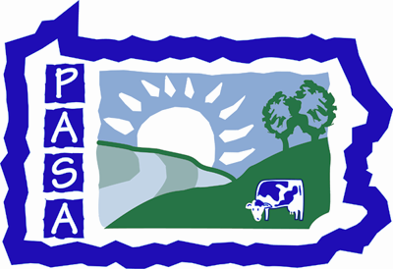
Pennsylvania Association for Sustainable Agriculture
PO Box 419, Millheim, PA, 16854
Contact: Rachel Schaal
Office: 814-349-9856 ext 205
Email: Rachel@pasafarming.org
Fax-814-349-9840
www.pasafarming.org

Adding Value to Dairy: Ideas for Expanding Markets
Wednesday, August 12, 2009
10:00am – 3:00pm (lunch provided)
Milky Way Farm
Troy, BRADFORD County

Troy, PA – On Wednesday, August 12, the Pennsylvania Association for Sustainable Agriculture (PASA) will offer a program on Adding Value to Diary: Ideas for Expanding Markets at Milky Way Farm in Troy. The event will run from 10:00am-3:00pm (lunch is included) and costs $15 for PASA members and $25 for all others. Innovation and balance are key to the success of this 4th generation family farm. When school's in session, Penn College of Technology cafeteria purchases Milky Way milk and chocolate milk, while in off times the milk is turned into chocolate milk, heavy cream, butter, cheese, and ice cream. We'll tour the milking barn, processing areas, restaurant, and enjoy a home-cooked local foods lunch. Then we'll take a pasture walk and discuss fencing, watering, nutrition, pasture maintenance, and controlled grazing, including grazing standing green corn. Milky Way has a closed herd developed from over 18 years of cross breeding seven pure dairy breeds specifically for characteristics necessary for grass-based dairy.

Don’t miss this excellent opportunity. To register for the event, visit http://pasafarming.org/our-work/educational-outreach or contact PASA at 814-349-9856.

