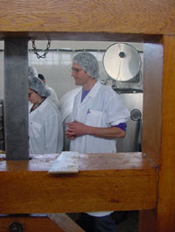

Advanced Cheesemaking with Peter Dixon
Date: Tuesday to Thursday, August 18-20
Time: 9:00 am - 5:00pm (each day)
Location: Hidden Hills Jerseys ~ Everett, Bedford County
Cost: $300 PASA Members, $375 all others (lunch will be provided)

Are you an established cheesemaker?

Take advantage of this hands-on practicum, designed specifically to help you improve your skills and expand your product line.

* Choosing starters and ripening cultures
* Cheese chemistry and groupings
* Conditions and techniques for successful affinage,
* Ripening biology
* Facility design
* Equipment
* Business planning & operations
* Marketing

Get constructive feedback on your cheeses and sample and critique classmates' cheeses during a facilitated tasting.

For more information including daily agendas, directions, and a list of convenient lodgings this event, visit www.pasafarming.org,
or call Rachel at (814) 349- 9856

