About The Small Farm Initiative
The primary goal of the SFI is to establish small farms producing for regional markets using purchase of development rights (PDR) to reduce land costs, improve farm profitability, and preserve farmland in a near-urban setting. Ann Arbor Township, with its proximity to the City of Ann Arbor and its ample open space and farmland, is an ideal location for this initiative. Support for the project is provided by a three-year grant from the Sustainable Agriculture Research and Education (SARE) program.
--------------------------------------------
To participate in the Small Farm Initiative or to find out more information, contact Barry Lonik, SFI Project coordinator:
Phone: (734) 223-2321
Email: blonik13@aol.com
Website: http://aatwp.org/smallfarms.htm

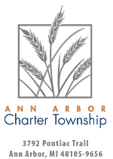

Ann Arbor townshiP Small Farm Initiative (SFI)
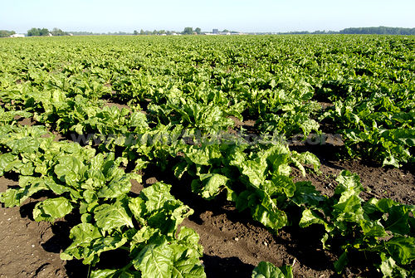

Linking producers, landowners, and markets

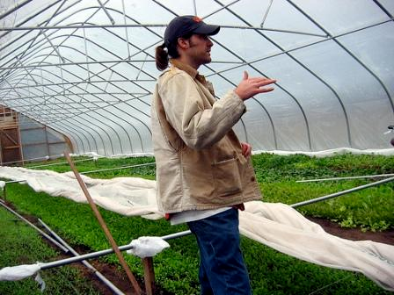
Producers
One of the biggest impediments to establishing a new farm operation is the cost of land. This is especially true in the Ann Arbor area, where development pressure has traditionally made land prices so high as to preclude purchase for farming.
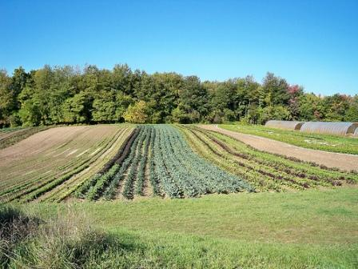
The Small Farm Initiative assists beginning farmers in two primary ways:
- Finding smaller plots of land (one to 20 acres) on which a farming enterprise could operate, more likely on a lease arrangement.
- Purchasing development rights on larger parcels (20 acres and greater) so that land can be purchased at its agricultural value instead of its development value.
Landowners
Many small farm properties or plots within them are idle, often for lack of knowing where or how to find people to work them. The Small Farm Initiative can help landowners find prospective farmers, provide sample leases and assist in establishing and maintaining a lesser-lessee relationship. In addition, Ann Arbor Township has a dedicated fund to purchase development rights (PDR) on qualified properties. If development rights are to be purchased, management plans to sustain and improve environmental quality and natural resources will be developed to coincide with agricultural pursuits.

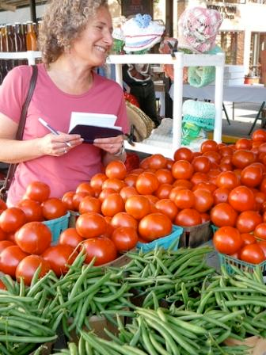
Markets
The demand for local produce in the Ann Arbor area exceeds the supply, and demand continues to grow. The Small Farms Initiative has developed contacts that can get produce to these and other markets:
- Farmer's markets
- Community Supported Agriculture (where consumers purchase an annual share of food produced on a farm)
- Natural foods grocery stores
- Restaurants
- Institutions such as hospitals, public schools and university dormitories.

