1. Project Name and contact information
Pasturing Hogs on Field Peas and Barley
FNE 09-674
Hanne Orm Tierney
74 Dogtown Road
Palmyra Maine 04965
207-487-5945
Hanne@cornerstonefarm.us

2. Goals

This project had three primary goals. Firstly, the project was designed to determine if it is reasonable to allow hogs to hog down field pea and barley pasture to replace 50% of the feed ration while maintaining proper growth. Secondly, it sought to determine if the fat from the hogs would contain healthier fat for the consumer and, thirdly if the volume of fat was significantly smaller, which would decrease slaughter costs.

3. Farm Profile

Cornerstone farm is located in Palmyra, Maine on 40 acres of land, half of which is in pasture. Cornerstone farm produces approximately 150 pigs from farrow to finish each year with the number increasing each of the last six years. The sows all farrow inside and are moved outside with their piglets to pastures or paddocks through out the year. Our pigs our raised on pasture seasonally and many are supplemented with silage through the winter. The farm is designed to allow hogs to express their natural instincts as much as possible.

4. Participants

Rick Kersbergen and Tom Malloy both from Maine co-operative extension have assisted in this project. They have helped with adviCe: on writing of the grant, planting of crops, lab selection, and culminating the data. They also supplied the scales for this project. Nell Baldwin, Jennifer Drew, and Chris Gomes all planted seed, feed and cared for pigs, and took weekly samples and measurements. Hanne Tierney organized the project, participated in all of the above mentioned tasks, and prepared this paper.

Project activities

The sows were turned out on 1 acre pasture lot to turn the soil as soon as the frost was out of the ground. As they completed the 1st acre we moved them to the next and planted the first. They were slower at this then we had anticipated, so by the time we came to the following acres we hired another farmer in to plow the following acres. We planted each acre with a total of 5 acres in succession plantings with 50lb of field pea seed and 50lbs of barley seed, with a hand held broadcast seeder. We incorporated seed with our team of working steers with a basic drag behind them. We received heavy rain after several plantings which at first helped with seed to soil contact in early plantings but hindered us being able to completely incorporate the seed in later plantings. Two litters of pigs were selected one (group S) of 14 piglets, and one (group A) of 6 piglets. Each group was ear tagged in the order in which they were caught not considering size or gender, then each litter was split into the even numbers (to become the experimental hogs) and the odd numbers (to become the control hogs). hogs were all grown on average pasture with grain until the field peas and barley were ready to graze. These Hogs were put out on June 25th 2009 with the hogs being 15 weeks of age as the 1st field peas started to flower, and the barley was pre-milk stage. We weighted each hog individually as they were unloaded off the trailer into the field pea and barley pasture (the experimental pasture). On the same day we weighed and unloaded the control group onto fresh average pasture (mainly timothy and orchard grass). On this day the rationed also changed. The control group was feed twice as much grain as the experimental group from here on out. Thursday was designated as SARE day and we weighed the hogs every Thursday for the rest of the experiment. We moved the hogs to the next pasture after the pasture they were on seemed to no longer have viable forage, either from the hogs consuming it all or the forage senescing. A total of five acres of field peas and barley were hogged down for the experiment. The forages for the both the control pasture and the forages from the experimental pastures were each sampled every Thursday and sent in for analysis at Dairy One Forage Testing Lab in Ithaca NY.

The five largest (by live weight) hogs were selected from each group for the first slaughter. The smaller five continued with the experiment for an additional month. We had one pig from each group cut exactly the same way as a pig from the second group thus we could compare the cuts from each group to the cuts from the second group. We also recorded fat weights as well as primal cut weights. Thus it could be determines if one group had a smaller hanging weight did it also produce less meat or was the difference only fat based. One month later the second group of hogs were brought to slaughter and cut in similar fashion.

For the final comparison, the data was separated from the hogs 4 groups each containing 5 hogs. The larger experimental and the larger control hogs were the first two groups and that smaller from each experimental and control for the 2nd two groups. We took small samples from both the lief lard and the back fat from each pig and mixed it with the fat from the other hogs in its group of 5. We then sent that fat in for sampling (Medallions Lab Minneapolis, MI) to determine any heath benefits to the consumer of the experiment.

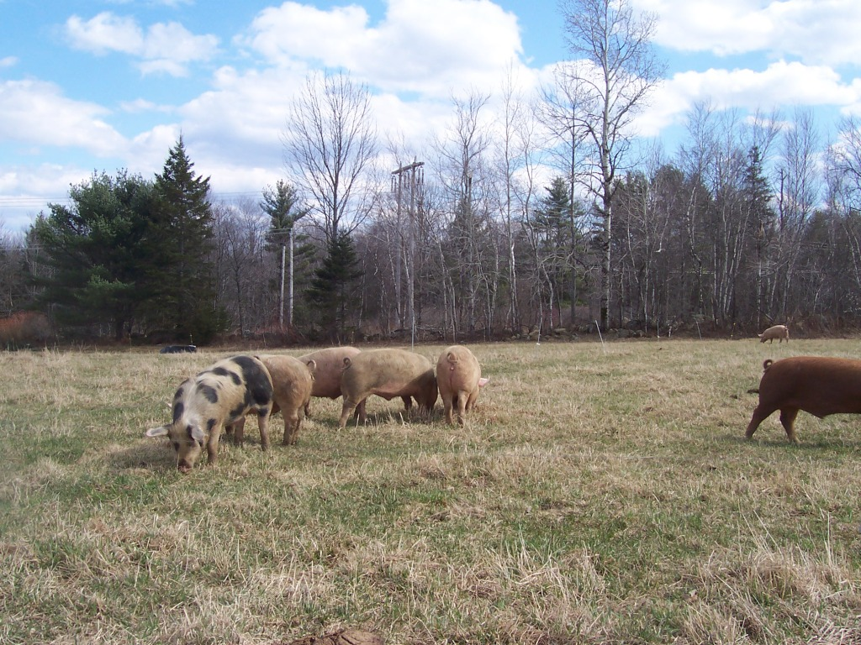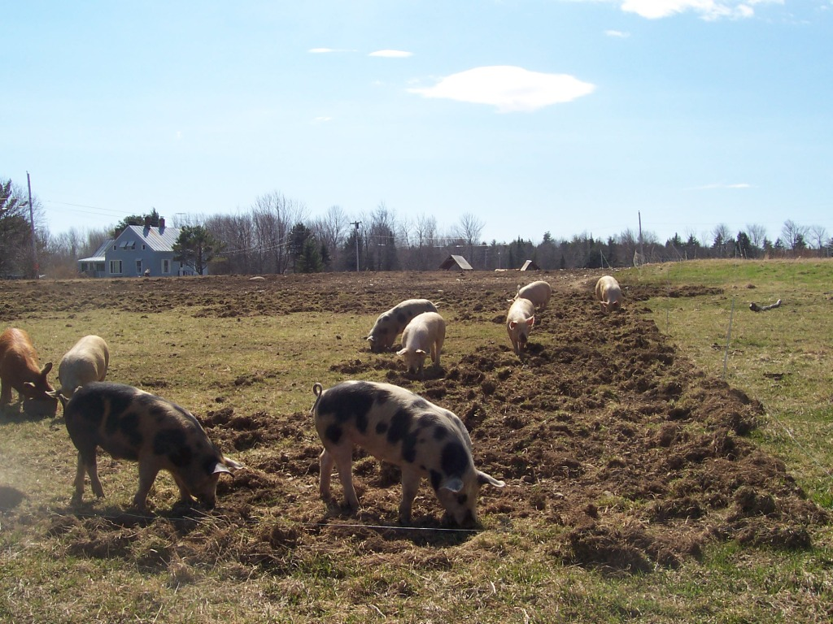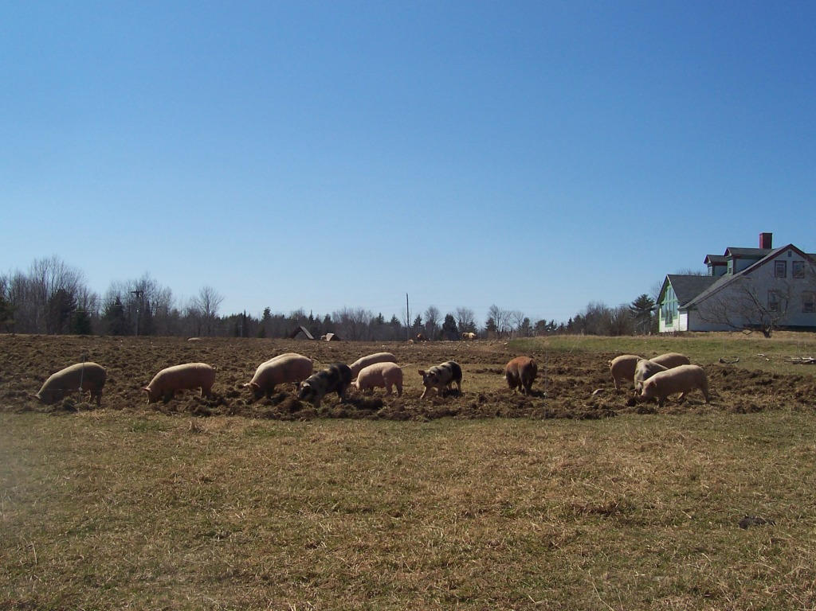

The three pictures are of the same pasture along the line of the fence. These pictures show how the hogs tilled.

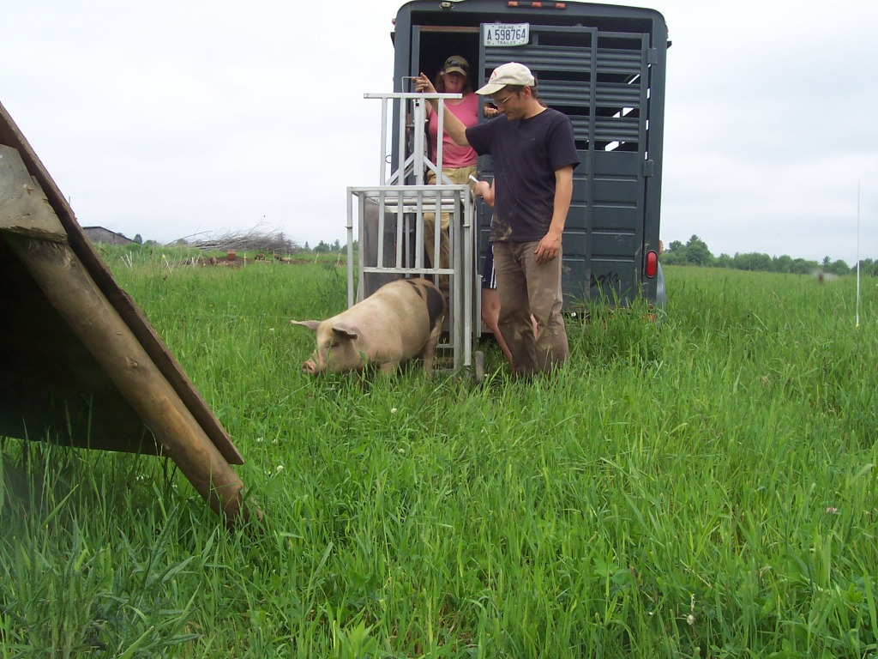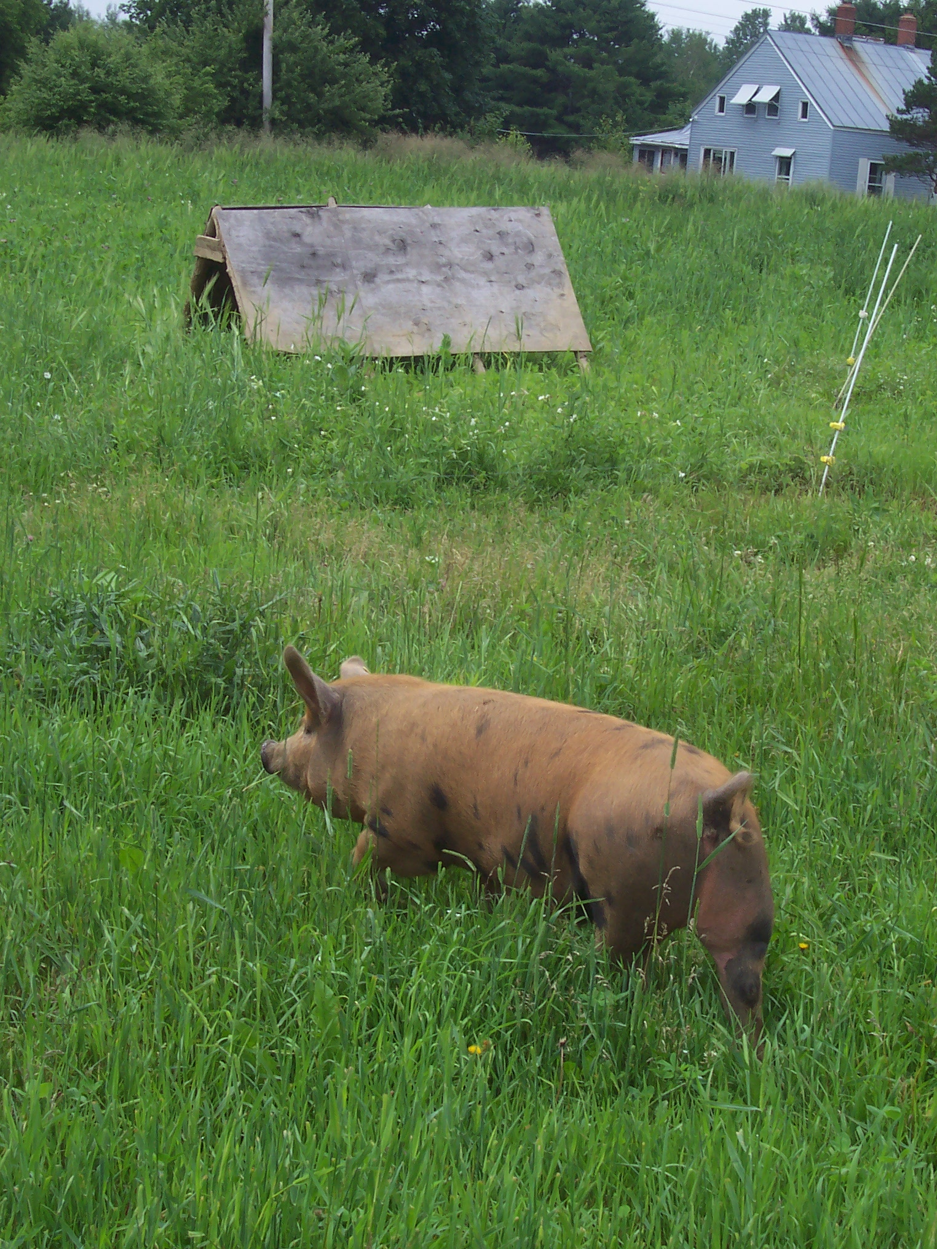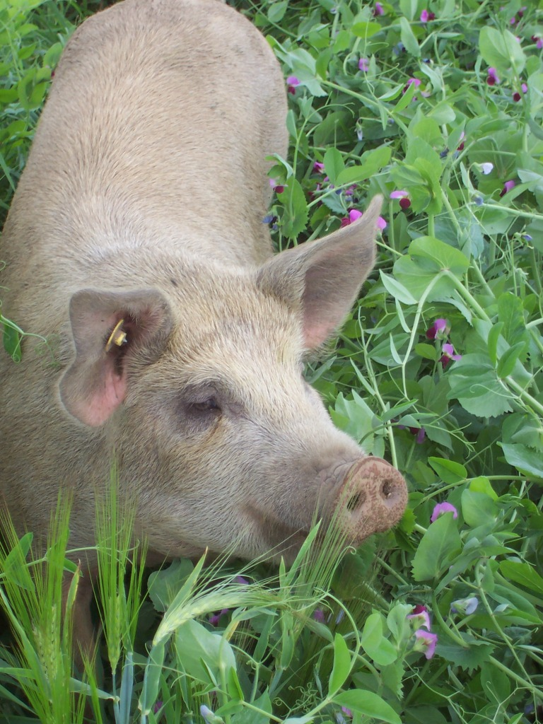
Cornerstone Farm team weighing a hog Control hog on control pasture Experimental hog on Field Peas

6. Results

The Forages

The forage samples collected every week from both the experimental (field pea and barley) and control (grass) pastures were sent to a lab (Dairy One, Ithaca NY) to be tested. The TDN % varied throughout the project, ranging between 56% and 66%. There was no apparent difference between the control and the experimental pasture; the experimental dropping below the control periodically through the season. Similarly, there was no apparent correlation between the TDN % and the growth of the hogs in either the experimental or the control group (Fig. 2).

Figure 1 Total digestive nutrients (TDN) for the experimental and control pastures throughout 12 weeks of the study

The Animal

The Data from each group (the experimental and the control) were split into two different groups. The five largest hog from each group and the five smallest hogs from each group represented the 4 groups. The five larger hogs were slaughtered one month before the five smaller hogs in each group. In the graph 2 it is seen that the top five from each group grew at very similar rates. When the project began all twenty pigs were in the same 20 pig group , as they were all pigs from two litters and the genetics were very similar. Both litters had the same boar sire and each litter and the sows were sisters form the same litter. The initial differences may be attributed to difference in pecking order (which pigs were able to compete for feed most efficiently). If that were true it would follow that the top five from the control group when separated from the group of twenty to be part of a group of 10 would continue to have similar growth. It would also follow that the top experimental 5 which previously had similar weights to the bottom 5 control hogs were suddenly at the advantage in competition for feed, thus possibly explaining the sharp initial growth of those individuals rather than the change of forage (figure 2). As the low groups still were in groups with 5 more dominate pigs thus it would follow they their growth did not adjust sharply. The low five experimental pigs had more notable increase in their growth when there social hierarchy changed rather than the feed values. The grain in the experimental group was more limited as we gave them only 50% of the grain ration that is recommended for hogs of this age and size, thus with competition the larger hogs may have been eating their full ration allowing the smaller group to fight over the remaining grain making them depend more on the forages for nutrients more than the larger experimental hogs. Unfortunately observing social behaviors and hierarchy was beyond the scope of this project.
Figure 2. The weights of the four different sample groups throughout the summer.
The Meat

The meat weights were examined as total hanging weights, total non-fatty meats (loin, tenderloin, ham, shoulder, and ribs), fatty meats (Boston butt and bacon), and fat and organs (lief lard, fat back, and organs all not usually consumed by Cornerstone farms’ customers) to enable the fat quantities to be compared, as well as the actual usable meat between the different groups. The total non-fatty meats, the fatty meats, and the fat/organs were then analyzed as a percentage of hanging weight (Fig 3).

Figure 3. Meat categories compared as a percentage of hanging weight between the four sample groups.

The actual weights of the total non-fatty and the fatty meat were compared between the experimental and control groups using the Mann-Whitney U-test. There was no significant difference between the 5 larger hogs of the control and the 5 larger hogs of experimental (p>.05) which coincides with what was observed with their growth weights (Fig 2). There is a significant difference between the smaller groups in overall meat weights (p<.05) as well as the hanging weights (p=.01). This difference could be from insufficient feed intake or other factors such as runty pigs or feed competition hierarchy.

Table 1. Mean values (± SE) for the overall meat weights and the hanging weights for the …
 |  | All (n=10) | High (n=5) | Low (n=5)
Total non-fatty and fatty meats
 | Control | 76 ± 3 | 83 ± 4 | 71 ± 5
 | Experiment | 67 ± 4 | 88 ± 6 | 57 ± 2
 | p-value | 0.30 | 0.48 | 0.04*
Hanging Weight
 | Control | 167 ± 6 | 160 ± 7 | 174 ± 4
 | Experiment | 142 ± 9 | 161 ± 14 | 122 ± 3
 | p-value | 0.05* | 1.00 | 0.01*

The Fat

The fat as a percentage of hanging weight was seen to be very similar between all of the groups (Fig 4); therefore, the fat quantity did not affect the hanging weight.

In the results from the Medallion lab in Minneapolis, MI it was found that none of the fats either form the experimental or control group contained Omega III fatty acids.

All the fat from each of the four groups were sent in together, each sample contained 10 equal (by weight) pieces of fat, pieces of lief lard and pieces of fat back. The pieces were thought to be 100% fat without visual presence of tissue or skin. The control pigs had a higher average percentage of fat than the experimental group. Of the fat that was in the samples the control group had higher percentages of saturated, monounsaturated, and trans fats. The experimental hogs had a higher percentage of cis-cis polyunsaturated fat than the control group.
Figure 4. The amount of each type of fat present in the samples tested
7. Conditions

The summer of 2009 was an extremely wet season. Although the fields in which the peas and barley were grown all drained well, there may have been decreased growth due to the lack of sunshine. On the positive side there was so much rain that the seeds that failed to have soil contact did not desiccate and did germinate later for a second growth of forage.

8. Economics

During the 12-weeks that the hogs were of forage fed, the control group consumed 2454 lbs of grain costing $319.02; and the experimental group was fed 1227lb of grain costing $159.51. The slaughter costs for both control groups were $1623.32 and the combined experimental groups slaughter costs were $1439.47. Unlike the control group, the experimental group required seed, which cost $147.50 for both the field pea seed and the barley seed. The total control group costs were $1942.34 and the experimental groups total cost were $1746.25. The average meat per hog from the control group was 129.82lbs, as compared to 109.65lbs in the experimental group. Thus, the control group cost $1.50/lb to feed and slaughter while the experimental group cost $1.59/lb to feed and slaughter (Chart 2).
 | Total $ for grain | Total slaughter cost | Seed cost | Average Cost/ Hog | Average meat / Hog | Average cost/ lb of meat
Control pigs | $319.02 | $1,623.32 | $0.00 | $194.23 | 129.83 lbs | $1.50
Experimental | $159.51 | $1,439.24 | $147.50 | $174.63 | 109.66 lbs | $1.59

Chart 2 Summary of costs for the experimental and control groups
9. Assessment

The choice of variety of forage seems critical. It must both have a high level of protein to support the rapid growth of a monogastric animal like a hog, as well as provide large amount of energy to fuel that growth. The forage also needs to be suited to the seasons, the field pea and barley combination senesced too quickly towards the end of the study not allowing for enough hogging down of the crops. It would also seem more sustainable if the forage varieties were perennials rather than the annuals that were used here, thus not requiring the frequent tilling of the soil and frequent plantings. A perennial mix including a palatable legume would be preferred.

It also appears that the stocking densities may have been too low. To have more complete hogging down it would appear that one needs more than 10 hogs /acre per rotation or smaller areas.

10. Implementation

The practices as described in the methods section (Section 5) will not be used exactly as they were written on Cornerstone Farm. Forage may be planted in the spring, however, to cover open areas to supplement growing feeder hogs. Cornerstone Farm is more likely to continue a search for a more appropriate forage mix (likely to include perennials) in order to more completely meet the needs of our monogastric friends (☺).. As a follow up to this project we allowed the gestating sows on our farm to hog down the field pea barley fields after the experimental pigs had been slaughtered. This fall the farm had its most prolific farrowing season ever. The question could be asked whether or not the field pea and barley diet may have caused this.

11. Outreach

Cornerstone Farm hosted a pasture walk on July 17th. The walk was well attended (25 people) and the group walked through the pastures of both the experimental and control groups and discussed the goals, the scope, and the initial data that had been collected. There was opportunity to ask questions and discuss both the SARE project and raising hogs in general. There are more outreach projects to come; including but not limited to presenting at the MOFGA sponsored Farmer to Farmer Conference in November of 2010, as well as an article in MGFN newsletter.

12. Report Summary
The purpose of this study was to investigate the possibility of replacing 50 % of the hogs diet with fresh field pea and barley pasture. Twenty hogs were split up into a control group and an experimental group and turned out on separate pastures; the control on grass pasture while being fed 100% of the normal grain ration and the experimental on field peas and barley while being fed 50% of the normal grain ration. The hogs were weighed weekly. After slaughter, meat and fat weights between the two groups were compared. No significant differences were found with the exception of the smallest five hogs in the experimental group, which grew significantly less than the five smallest in the control group. The meats and fats as a percentage of total hanging weights were very similar throughout both groups. There is room for much improvement in this study. Were this study to be taken further it should adopt a method of decreasing competition between hogs for the grain that was given, especially in the experimental group. Also different forages should be selected for different seasons, so that each season has forage that usually thrive in these climates during these seasons. It would also be helpful for management techniques for those forages to be perennials rather than annuals to decrease the tilling that is need to maintain soil quality.

