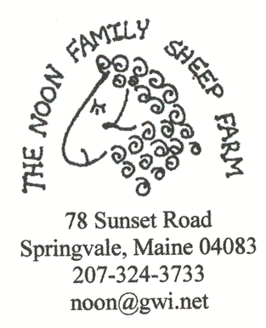
FNE04-527: Measuring the Effectiveness of Treating Lambs with Garlic at Various Rates for Internal Parasites Using the FAMACHA© System

Project Leader: Jean Noon
Address: 78 Sunset Road, Springvale, Maine 04083
Telephone: 207-324-3733 Best time to call: 6:00-9:00 PM
noon@gwi.net
www.jeannoon.com

Northeast Sustainable Agriculture Research and Education Program
Farmer/Grower Grant Report

Goals

To design and implement a controlled experiment that would use the FAMACHA© System to study the parasite rise in lambs and measure the effectiveness of various dosages of garlic juice to determine the optimum worming rate. This process would at the same time identify the naturally genetic resistant lambs for breeding stock replacements and reinforce my findings that garlic is effective from my 2003 SARE project.

Farm Profile

The Noon Family Sheep Farm is a Maine Organic Farmers and Gardeners Association (MOFGA) certified organic sheep farm. We winter about 60 ewes and have been raising sheep since 1970. Our original sheep were purchased indirectly from the UVM flock dispersal. Since then the flock has evolved into a mix of Columbia-Rambouillet-Leicester-Suffolk-Island etc. bloodlines including colored and white wool brood ewes. We direct market lamb sausage and shish kebabs at select fairs and festivals through our food booth and also sell hay, yarn, sheepskins, wool, and lamb at the farm. Our raw wool is sold to hand spinners and to Green Mountain Spinnery and is marketed as Maine Organic Yarn. Most of the year this is a part-time operation, the exceptions being during the fairs, lambing, and during haying season.

We own ~75 acres that we purchased in 1974 and lease an additional 30 acres of hay land. We have about 8.5 acres of pasture, and about 15 acres of our own hay land that we rotate the sheep onto after haying. The balance of our land is managed forest and wetland. Our fencing is mostly electric, permanent and portable. We maintain a permanent wooden handling facility with pens, a chute and gates to handle the sheep. The sheep harvest most of the second and third crop of hay directly. The 30 acres of hay from neighbor’s land is partially sold in the field to support machinery and operating costs.

Participants:

Dr. Tom Settlemire
21 Lisbon Falls Road
Brunswick, Maine 04011
207-729-9748
Katahdin Hair Sheep Project (SARE)
E-mail: ctsettle@suscom-maine.net

Bill Noon, Preston Noon, Aaron Noon – Farm Help

Mike Bukowski-Thall DVM
Down Maine Veterinary Clinic – Veterinarian consultant
Sanford, Maine 04073

Rick Kersbergen
Extension Educator
University of Maine Cooperative Extension
922 Waterville Rd
Waldo, Maine 04915
richardk@umext.maine.edu

Eric Sideman
Technical Advisor
Maine Organic Farmers and Gardeners Association
P.O. Box 170
Unity, Maine 04988

Diane Schivera M.A.T.
Assistant Director of Technical Services
Maine Organic Farmers and Gardeners Service, MOFGA
294 Crosby Brook Rd.
PO Box 170 Unity, ME 04988
207-568-4142
FAX: 568-4141
www.mofga.org

Project Activities
2004
In 2004 I had 72 lambs between Feb. 7th and March 14th. These were sorted by random sample into three groups. The idea was to treat each group at a different concentration of Garlic Barrier as need was determined through FAMACHA scoring.

The FAMACHA© System.
This is a system that uses a visual observation of the redness of the interior of the eyelid using a specially developed eye color chart to determine the degree of infection due to Haemonchus Contortus. H. Contortus is a blood-sucking parasite that causes anemia in sheep that is observable in the color of the inner eyelid tissue. H.Contortus is the most damaging parasite to sheep and goats and has developed resistance to commercial anthelmetics (wormers) in many areas and particularly in Africa.
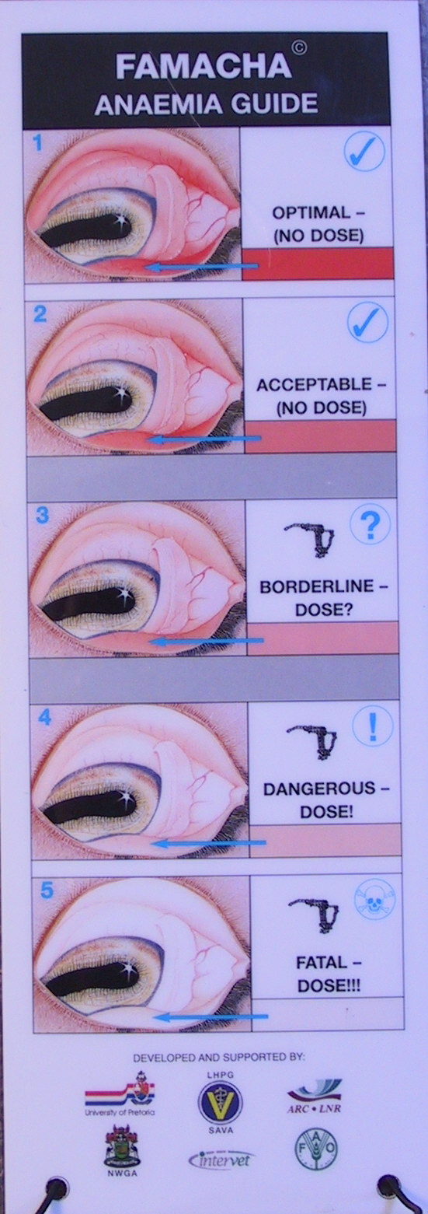
The FAMACHA© system was developed in Africa. I had the opportunity to attend a training session for the use of the FAMACHA© system and am excited by how simple and quick it is for determining infections as opposed to the fecal samples. Unfortunately the FAMACHA© developers have attached the requirement of training with a licensed Veterinarian to being able to access the system and the color card. I think it should be a priority for various sheep, goat association and the Extension Service to make this training available to all small ruminant growers. I found the color card somewhat cumbersome as it is large (4½x12”) and difficult to hold while holding a sheep. I am usually working alone. The card is also prone to fading and needs to be protected from sunlight as much as possible. For this reason I took my eye chart to the local paint store and matched the three top levels with paint chips and fabricated my own portable color card that is on an elastic neck cord. Level one (the reddest) indicates high resilience(or lowest infection), level two indicates good resilience and level three (lighter pink) indicates a need for treatment, level four is indicative of a dangerous level of infection. There are actually five levels and five is very light, almost white and considered fatal. I decided to record the FAMACHA© level on each sheep and lamb when I checked them. Levels one and two would not be treated and level three or worse would be treated.

Understanding and zoning in on the conditions that effect the life cycle of any pest is key to overcoming its damage with organic management. H. Contortus parasites have a complex life cycle.

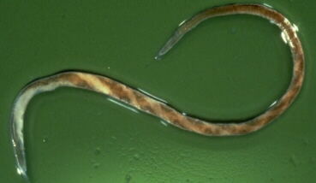
Haemonchus Contortus Simplified Life Cycle (H. Contortus, Strongylid Nemotode)
Photo by Ed Munn
The Barberpole worm
I have spent considerable time researching Haemonchus Contortus and a “google” search brings up 67,000 references. Needless to say there are contradictions in the data, and the workings of this parasite are still not completely understood. What follows is a short summary compiled from my research.

Eggs are shed in the feces of the ewes during the fourth or morula stage of H. Contortus development. One H. contortus morula stage female may pass as many as 10,000 eggs per day under favorable conditions, so one sheep can pass as many as 30,000,000 eggs per day. Some eggs also appear to be able to survive in hypobiosis (an arrested state similar to hibernation) on the pasture for over a year. This means that one winter is not enough to completely clean a pasture.
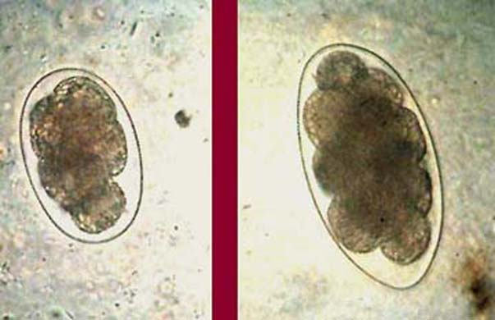
Warm, wet conditions are necessary for the eggs to hatch into larvae. If the weather is too hot or variable, the eggs will hatch quickly and the larvae will die. If the weather is too cold the eggs will not hatch. First stage Larvae(L1) develop from eggs in manure in 4-6 days of damp 75-85 degree weather and hatch to feed on microorganisms in the feces.

H. Contortus Eggs vary in size
After a molt, second stage larvae (L2) also feed on microorganisms but they must have contact with soil as well as favorable conditions. This is good news because it means that the parasites cannot become infective in the barn where the lambs and sheep live on a bedding pack that insulates the larvae from the soil.
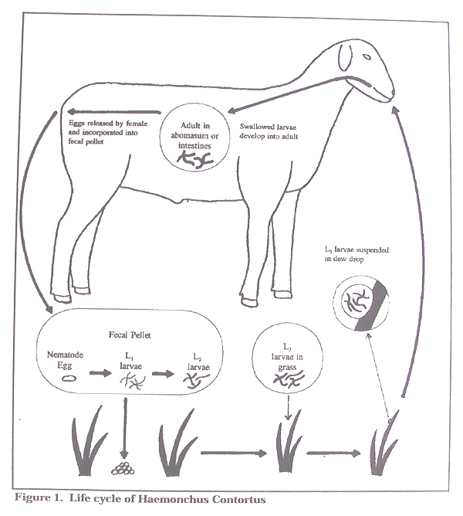
The average length of this stage (L2) is about 21 days. They then become third stage larvae (L3) that are active and infective. Research has shown that L3 larvae can survive over 15 years of being frozen in liquid nitrogen, however those conditions do not exist outside a laboratory and the larvae rarely survive more that a week in the field. Moisture and warmth are necessary for the infective third stage larvae to move from the manure and soil onto the grass, where they are consumed by the sheep eating the grass. When conditions are dry, the larvae are unable to migrate up the grass and will die. They also do not survive long in strong sunlight or high heat.

Chart from Texas Ag Extension Service Texas A&M University L-5095

Variable weather has a large influence on the survival and development of the parasite on pasture. Short pasture conditions may lead to more severe internal parasite infestations because more infective larvae are normally found on the lower parts of the plants near the soil surface where the moisture is retained. L3 larvae do not survive in hay and the stubble exposes them to the sun and dries out effectively decreasing the parasite population. Sheep are short grazers, they eat the grass to the ground. Sheep could be confined until the dew or rain has evaporated before they are allowed to graze to help minimize infection. Thousands of parasites may infect a sheep with low resistance. Sheep with high resistance do not carry high populations of H. Contortus. Some sheep have resilience to H.Contortus, this means that they are able to thrive while carrying a high infection of the parasites.
Ingested larvae in the third stage (L3) lodge in the stomach glands until external conditions are favorably warm and wet are favorable and they molt again into fourth(L4) morula stage adults and attach to the wall of the abomasum where they suck blood to nourish the development of their eggs. When conditions are not favorable the morula stage H. Contortus are able to survive in hypobiosis (an inhibited state) without taxing the sheep or shedding eggs. This is important because the sheep do not exhibit any indication of infection while they may be carrying a large population of parasites. There is some speculation that hypobiotic parasites are not affected by treatments. Morula stage parasites can suck more blood than the sheep can replace resulting in severe anemia. This anemia may develop quickly and cause acute symptoms and death before the animals can be treated. When conditions are favorable more and more stomach worms reach the adult stages and there is an enormous increase in egg shedding, pasture contamination, and anemia.

The cycle repeats.

The variability of the length of the life cycle, and its optimal conditions are the most challenging aspects of understanding and overcoming the Haemonchus Contortus.

Project Activities continue...

FAMACHA© System parasite load scores of all the sheep were measured and recorded in late April and early May as lambs were weaned (usually weaning is done in two or three periods determined by the ages of the lambs). None of the lambs showed any infection as the bedding pack does not provide contact for the parasites with the soil.

May 1st 2004 all lambs were weaned by removing ewes from the barn and moving them to the dry lot to dry off. Lambs remained in the barn and continued on their diet of organic grain and hay. May 6th I drenched all the ewes with 2 oz. of 1:3 garlic water. I did this as a precaution, hoping it might affect any hypobiotic parasites. I think it would be better to FAMACHA check them and isolate the level 3 and higher to fecal test and treat until they were clean. It may not be necessary to treat the level 1 and level 2 sheep at all. May 13th ewes had moved out to permanent pasture and lambs were moved to the dry lot. Lambs continued to have free choice organic grain, hay, salt - mineral mix and water and were given access to pasture. The lambs pasture is adjacent to the dry lot barn and is fenced with temporary electric fencing. Around May 19th the lambs began to eat grass on the pasture. Having learned so much about the life cycle of H. Contortus, I decided to be very careful about the lamb pasture. I purchased two rolls of flexinet and began to practice strip grazing with my lambs. This involves moving the fence forward daily onto new grass and moving a back fence as well to keep them off the grazed areas. (see the photo in management calendar section) I had put up a perimeter fence that I did not need and was in the way when I hayed. I have found that the lambs do not consume very much grass at first and prefer it to be short. I have time to hay the first crop off of most of that field before it is needed for pasture. This is an added defense against any parasites that may have survived the winter as hypobiotic eggs in the soil. The ewes never had access to the lamb pasture in the spring, but do graze there in the late fall.

Results from this grazing strategy were encouraging with a very low number of infections in lambs. This was a good thing for the flock but a bad thing for the experiment. Of all those lambs and frequent scoring, only six exhibited level three FAMACHA© scores of infection and those not appear until September. The sample size however, was too small to be a significant test, and the response to the garlic was mixed and inconsistent. I decided that the dosages in the experiment were low.

Taking and testing individual fecal samples is time consuming. I got to the point in 2003 where I could collect about eight lamb samples in about an hour by myself. That includes penning, weighing, preparing the lab equipment, collecting samples and recording sample and ear tag numbers. The lab work for eight samples of preparing the slides, examining with a microscope, calculating, and entering results took an additional hour. That works out to about 15 minutes a lamb for each sampling session. I am able to pen, check, and record using the FAMACHA© system about 25 sheep or lambs an hour without any help.

Being able to monitor parasite loads quickly, economically and conveniently is an important portion of best management in raising organic lambs and sheep. Keeping records of FAMACHA© scores over time will help identify resistant sheep and also identify critical time periods for infection. Learning which sheep are naturally resistant and selecting breeding stock for that trait should reduce the need for treatments within the flock over time. This is one of the goals of the Katahdin Sheep Project which I believe can be applied to any breed of sheep or goat. One of my surprises has been that most of my flock is naturally resistant under good management so selecting is not difficult. Only a small percentage are effected by H. Contortus.

Good pasture management is key to successful organic sheep production. I continue to record, update and improve my management calendar which is geared toward weaning before the pasture season. I share this with interested parties as a portion of my outreach. The calendar begins in September because that is when I breed. I breed in September so the lambs can be weaned from the ewes just as the pasture becomes ready for grazing in May. The lambs do not graze with the ewes.

My farm calendar is determined by the grass growth cycle.
The Noon Family Sheep Farm Organic Management Calendar

Sept. 1-- Ewes checked using FAMACHA system and dosed with garlic juice if needed. Records kept of ewes that need treatment. Clean ewes are turned into a third crop hay field for flushing (Very clean of parasites). Infected ewes are fecal tested, treated and isolated in a pen until they recover to protect the pasture from the H. Contortus eggs they are shedding. This may take continual treatment and repeated testing for a couple of weeks. If improvement is not evident cull immediately or treat with Ivormectin and mark to cull.
Sept. 20— I take FAMACHA© scores. Ewes sorted into groups, Rams are introduced to the flock(s). I usually have 2 rams and separate the group’s pastures. Ewe lambs sometimes have their own ram. Rams are selected with resilience if possible. I am also looking for twins, nice wool and good growth / carcass.
Nov. 10—Rams are removed from the flock. This puts the last possible lambs by April first. This is another opportunity to take FAMACHA© scores (mine have all been 1 & 2 for 2 years as this is after the frost and unfavorable conditions for parasites).
Nov. 15 (or when the ground freezes, pasture gets too short, and ewes begin to eat hay)--Ewes are brought into the open barn off pasture and are fed hay and have access to heated water (and salt/mineral).
Dec. 20--Ewes and ewe lambs start to get supplemental organic grain, gradually increasing from 1/10 pound to ½ pound per head over a week or two.
Dec.-Jan.--Sheep are shorn. At shearing FAMACHA© scores are taken and feet are trimmed. I shear before lambing for cleaner wool, more space, dryer sheep, so I can see their udders, and because they are more careful to lamb out of the wind in our open 2 sided barn. They do require more feed and I am careful to keep their weights up, sorting thin ones together to feed extra. Sheep are penned in flock groups of less then 20 to minimize the risk of hernias from pushing at grain time. (Without the wool they are less padded) Ewe lambs are kept in their own group the bred ones are sorted out when they start to bag up for special treatment. Six or seven lambing pens (4’ x 4’) are set up. Two of the pens have stanchions in their gates to assist with grafting orphan lambs.
Feb. 5-10--Lambs start to be born. Ewes have their lambs in the flock group and are then moved into a lambing pen for two to three days. Next they are moved into a larger pen with up to five other ewes with lambs for a few days before joining the major groups of lambed out ewes. Lambs are given free choice grain and hay in a creep feeder. All sheep have access to water, shelter and trace mineral sheep (selenium) salt all year. The pens are all built out of movable wood gates that are adjusted continually as the populations and needs for space shift. The manure pack is left building up in the barn under the sheep for the entire winter. This provides a barrier from the soil and H. Contortus is unable to spread from the ewes to the lambs.
April 1--All lambs have been born. Ewes with Feb. lambs are taken off grain and are fed only hay in early April. Lambs have access to a creep pen (that is enlarged as lambs grow) with grain and hay.
April 25 to 30--Feb. and early March lambs are weaned. Any one or combination of factors such as poor nutrition, concurrent disease, stress, overstocking, or pregnancy/lactation can cause a loss of immunity to parasites. It is well established that ewes lose much of their protective immunity around the time of lambing (-2 to +8 weeks) causing the number of parasites to increase. This phenomenon, known as the peri-parturient rise (PPR) is an important part of the Haemonchus Contortus cycle. It has been documented that most ewes actually self cure without treatment from PPR infections. I think that the winter lambing period on the bed pack helps to minimize PPR’s risk to lambs, but I have seen resistance lost in thin ewes as the weather warms up. Weaning is stressful and parasite conditions are improving. Resistance is compromised by the stress. Ewes are removed from lambs and dried off. Water and hay are withheld for a feeding. Lambs never go on grass with ewes. Ewes feet trimmed, FAMACHA checked, treated and recorded for parasite infection. Any ewes that FAMACHA check 3 or worse get isolated and treated until they are FAMACHA 2 or better. This is important so that they can be monitored and so that they are not contaminating the pasture with eggs. All sheep are walked through a zinc footbath once a day until they go out to the pasture.
May 10-- Ewes are moved to permanent pasture. They are given a full feeding of good hay just before being turned out to reduce the digestive shock of the change in diet. They are rotated very early in the season and then allowed several pasture sections as the grass growth slows. Ewes are also rotated onto hay land after harvest of first crop to help break the parasite cycle. Because of the lay of my land and fencing, my ewe pasture rotation is not quite up to my recommendation. As is the case for most parasitic diseases, haemonchosis is most severe in young animals during their first and second years on pasture as they have not developed resistance. Yearlings need to be watched carefully. Weaned lambs are moved into the dry lot with free choice grain, hay and access to winter cleaned, ungrazed pasture. Lambs’ access to grass
is moved every day by “strip grazing” with portable fence. The lambs never go on ground that the ewes have been on (since November). Most of the lamb pasture is mowed for hay in early June before their “strip” moves up to it. When the lambs are still small it takes a few weeks before they begin to eat much grass and I provide them with free choice hay and limited grain of one pound/head while they become accustomed to the new grass diet. Once the lambs have moved out of the big barn the manure is removed and composted for the summer to be spread in the fall.
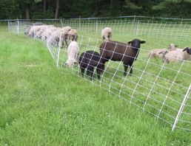
May-Sept A section of Flexinet is moved out on new grass ahead of lambs about 10-24” a day or twice a day as they began to eat more as they grow. Another section is moved up behind the lambs the same distance providing a strip of 12-15 feet between sections for the lambs to romp. This worked well for 70 lambs. As lambs reach finish grade they are retained for replacement or sent to the butcher. I sort out finished lambs every two to three weeks. They usually weigh between 90-105 pounds. I have a permanent sorting set up made of wooden pens with a squeeze and a narrow chute that makes checking sheep and treating feet and using FAMACHA system to check for parasites quite quick and easy. Ewe lamb replacements are moved to a separate pasture and taken off grain as they reach finish. My first trip to the butcher is in mid May. Sheep and lambs have access to water, shade, feed and salt mineral mix year round. Rams are housed separately accept during breeding season.

It is important to remember that the average period of H. Contortus from the egg stage to infective stage is 21 days on the pasture. Rotations should ideally allow more that 25 days of pasture rest before re-grazing during warm and wet periods. Adult sheep should be moved to new clean grass every 15 days during the warm season.
Project Activities continue...
We had an exceptionally cold, bare winter in 2003-2004 and I think that there was a very low survival rate of the parasite eggs on the pasture. In keeping with my results from 2003, I saw no evidence of parasites during May. We had a lot of rain, about three weeks of it in May and early June. On June 1st I noticed evidence of foot rot in the lambs, caused by the wet conditions, and started to treat them using a foot bath of Copper Sulfate solution. I switched to Zinc after a couple of weeks because a few lambs were appearing sick and I thought it might be copper poisoning. During the summer I had several lamb deaths and finally with help from Dr. Bukowski-Thall, and the Veterinary Lab at UNH had an autopsy preformed. The results determined that the lambs had White Muscle Disease which is a selenium deficiency. That was corrected with injections of BO-SE.

Ewes also exhibited foot rot and needed treatment. In early June two yearling ewes developed bottle jaw which is an indication of parasite infection. They were treated with 2 oz. of 1:3 garlic water and recovered. Individual lamb weights and FAMACHA© system parasite load scores were measured and recorded on July 13. Most of the pasture the lambs were moved onto was 2nd crop hay land having been harvested once in June. Total number of lambs included in the test at that time was 55. There was no evidence of any parasite infection. My 2003 data indicated no infection rise until the middle of August, and the life cycle of H. Contortus seems to need more that 20 days for the infective stage to develop on the pasture. I continued to check lambs every 10 days through July and then in August checked the 8/1, 8/7, and 8/16 with no evidence of parasites.
I took several fecal samples during this period. The weather was quite cool possibly reducing the viability of the parasites. On 8/16 the ewe lambs were separated from the ram lambs and moved onto a pasture that had been infected by grazing adult rams. There is a theory that exposure is necessary for resistance to develop.

Because of my findings in 2004 I requested and was granted an extension for 2005 and I wrote an interim report.

2005
In 2005 64 lambs were born in Feb and March. During 2005 I used FAMACHA© System on the ewes before I drenched and included them in the test. I also checked their eyelids when they lambed as there is a documented rise in parasite infection at that time. I found that there was no indication of infection at lambing and that is probably due to the Feb.-March low temperature here in Southern Maine.

I had seven yearling ewes who exhibited symptoms of infection at weaning in late April. I believe that this was due to PPR and the stress of weaning and of having their grain eliminated before weaning to try to help them dry off. In the future I will pay special attention to the yearlings that lamb and postpone weaning a few weeks to be sure they are mostly dried off naturally. Temperatures rise in April so parasites are more likely to come out of their hypobiotic state. The ewes became quite sick and I decided to dose them twice a day for four days. Four survived, (one slipped her wool), and another died and I treated two with Ivormectin and later culled them when they were clear of the medication and had gained back enough weight to slaughter. (not organic and low natural resistance). Other factors or infections could have contributed to their lack of resilience. It is very important to keep ewes with an indication of high infection isolated off the pasture and in a pen so that the high numbers of eggs that they are shedding do not contaminate the pasture grass. I used a dosage of 2 oz. at 1:3 Garlic Barrier to Water, twice a day for 4 days.

During the summer and fall I checked FAMACHA© on the flock frequently. The last scores were taken on November 21 and all the ewes and lambs scored 1 and 2 indicating that the parasites had gone into hypobiosis. I will continue to keep records of the scores. I will be particularly noting the ewes with infections of 3 or worse as those are the ewes with less resilience or natural resistance to the parasites.

Since the publication of my 2003 results, I have been responding to a continuous stream of emails asking about my research. One question I have been asked is about treatment for mites. I think it is quite possible that the garlic treatment would be an effective treatment, perhaps a drench and a surface spray at shearing. I shear in the winter before lambing and am going to study this in the future. About 5% of my ewes exhibit wool pulling, but I have been unable to diagnose mites.

RESULTS

2004
My plan was to treat lambs when they exhibited a FAMACHA© system grade of 3 (borderline 5,000+EPG) or greater (worse) they will be assigned to and treated at one of three dosages of garlic juice: Group 1@ ½ tsp.; Group2 @ 1 tsp.; Group 3 @ 1½ tsp. Groups were assigned by random sampling.

In 2004 the parasite numbers in lambs did not rise until the warm weather in September and after lambs were exposed to infected pasture. By September 15 all of my market lambs have been sold so the sample size only consists of replacement ewe lambs. It does not appear that my dosages were strong enough to counteract the rise during those optimal (for parasites) conditions.

On September 17th I had 5 ewe lambs that looked like grade 3s. I took their fecal samples and counted eggs, treated them by group and re-sampled on 9/21;

Treatment ewe # 9/17/04 9/21/04 10/05/04 10/08/04
3 | 404 | 4300 | 3400
2 | 414 | 2250 | 3550
1 | 415 | 4150 | 4500
2 | 425 | 7600 | 9800 | 19250 | 10050
2 | 432 | 2650 | 950
1 | 433 |  |  | 4850
Treatment Group #1 was dosed with ½ teaspoon of Garlic Concentrate.
Treatment Group #2 was dosed with 1 teaspoon of Garlic Concentrate.
Treatment Group #3 was dosed with 1½ teaspoon of Garlic Concentrate.

By the 10/05 flock check the only ewe lambs who appeared to be 3 or 4 were # 425 and # 433(who did not show up earlier and was not very infected. She is not on the graph with only one test)

On 10/5 only #425 tested at 19250 eggs per gram. This is a very dangerous level so I treated her with 3 tsp. garlic and on 10/8 her count was down to 10050. I treated her again but did not have a chance to test later. #425s dramatic parasite rise would indicate to me a very low resistance. By 11/09 she checked at a 2 and also at 12/17. She did not exhibit a poor score during 2005. Perhaps she was able to develop natural resistance.

A count of less than 5,000 eggs per gram is not considered detrimental to production.

On 11/9/04 and 12/17/04 I checked all 52 of my ewes and 17 ewe lambs and recorded their eye scores. Two looked like 3 scores and were treated and tested but did not show any H. Contortus eggs in samples and # 425 looked like a 2 and was clean as well. By then we had had many frosts and the daily temperature was usually below 40.

There are still questions...I decided that the dosage was still a bit low and that I would continue the experiment at 1:3 garlic to water in a 2 oz dosage. Because the test group and the random sample were so small I decided that I would be better off sticking with one dosage and expanding the experiment to the entire flock for 2005.

2005

These ewes scored 3 or worse on the FAMACHA scale. 313 was a two year old and the others yearlings. TI indicates ewes treated with Ivormectin (and Culled in August). I have become quicker to use Ivormectin when infections are truly severe and don’t show response to the Garlic. I decided that due to the lack of numbers in the sample I should standardize my dosage. Somewhat arbitrarily and for simplicity, I decided on a ratio of 1:3 concentrated Garlic Barrier to water.

I was surprised that # 425 did not score as infected again.
Ewe # | 17-Apr | 18 | 20
313 | 7700 | 7750 | 16600
401 | 9100 | 8900 | 10900
406 |  | 19200 | 19350
408 | 12300 | 8100 | 49700 |  | TI wool slipped
415 | 8550 | 20950 | 17050
432 | 8700 | 10200 | 13400
436 | 9250 |  |  |  | died
443 |  | 22000 | 23100 |  | TI
#408 became sick again in October, slipped her wool again but did not show significant parasites. I did treat her with garlic for several days and she recovered. I was surprised by the death of # 436. She did not lamb and may have died from some other condition.

Once again the results were mixed and the sample too small to be significant. This also could be an indication of the peri-parturient rise “PPR” or “Spring Rise” when the parasites come out of hypobiosis and become active with the rise in temperature. I have reviewed the weather and there were a few days in April that were unseasonably warm in 2005.

I kept checking the lambs through out the summer. The ewes appeared healthy. They are pastured for the summer away from the barn and it is a major job to get them in to the sorting pens through the fences before September. In September I finished harvesting my second crop of Hay and brought them in to FAMACHA check and do a final cull. Most of the ewes FAMACHA checked at 1 or 2 scores. I tested and treated 5 ewes who looked marginally 3 but tested out less that 500EPG. I did not test those again. It is quite easy to score eyes as worse than they are on the FAMACHA scale.

ewe# | 9/14/2005 | 9/15/2005
247 | 50
256 | 1900 | 850
306 | 450
313 | 1650 | 1150
322 | 100
429 | 34550 | 22200
443 | 18900 | 20900
906 | 200
911 | 150

Only # 429 and # 443 had dangerous infections. Response was again mixed. Several of these sheep I FAMACHA scored at #3 while their egg counts were very low so were probably #2s.

Only the four ewes who were measured twice show on the graph. None of the 2005 lambs ever FAMACHA scored 3. On October 10 all of the ewes were 1s and 2s as well, indicating the onset of parasite hypobiosis or resistance of the ewes. It was interesting that the egg counts changed in 24 hours.

CONDITIONS

My results indicate that hard winters, careful management, and strip grazing can effectively minimize parasite infections from H. Contortus in lambs and sheep. Other Factors such as mineral (selenium) deficiencies, foot rot, weaning stress, etc. also influence the susceptibility of sheep and lambs to parasites. Spending enough time (labor) diagnosing potential infections at critical stages of the growing season seems to be key to catching infections early. Late April and mid September are dangerous periods on my farm with my management.

Sheep are unpleasant to handle when they are wet.

I have found that garlic treatment does affect most parasite infections most of the time. Garlic has high sulphur content and may be more of a prevention or prophylaxis treatment. It may be that the antibiotic properties of the garlic affect other health issues and help boost the immune system in sheep so that they resist the parasites. It may be that the parasites that are infecting the sheep let go and are shed when the have contact with garlic in the gut. It appears that repeated dosages are effective in difficult cases. I have read about speculation that garlic does not prevent the production of eggs but prevents eggs from developing into larvae. But my research indicates that garlic does affect the numbers of eggs being shed. It is clear that there is a need for more research.

I have not been able to observe any side effects to high dosages of garlic juice.

ECONOMICS

By using the FAMACHA© system to determine which lambs (or sheep) need testing and treatment, the time and cost involved is greatly diminished in comparison to fecal count testing and treating every animal as I did in 2003. The proper sheep handling equipment is needed unless one has a lot of help. With my handling pens I can FAMACHA score 50-60 lambs in about an hour and a half by myself. I could do that many in less half the time with a helper to keep the records. It is helpful (and interesting) to have the knowledge and ability to take fecal samples and do fecal counts when questions of infection arise.

By determining infection and only treating those sheep that require it saves a lot of money in treatments. This more than compensates for the labor costs even if using conventional chemicals. There is also the problem of parasites having the ability to develop resistance to chemicals. Parasites may be able to develop resistance to the garlic.

ASSESSMENT

By understanding the life cycle of the H. Contortus parasite and living in a somewhat hostile (cold) region there are strong possibilities that management and selection are the best organic tools to overcome parasites. Eggs need an average of 3 weeks of optimum warm damp conditions to hatch into infective larvae so pastures should be rotated every 2 weeks and may need to rest 4 or more weeks during the hot wet summer weather before being re-grazed. Very careful pasture management is necessary to successfully raise organic lambs and keep breeding stock healthy. Lambs do not become infected in the barn on bedding pack because the eggs and Larvae need contact with the soil to reach an infective stage. Keeping lambs separate from ewes on their own clean pasture reduces their exposure to parasites. Ewes develop resistance to parasites with age.

- Individual sheep have widely varied infections that are due to inherited and acquired resistance to parasites and other factors including age, exposure, grazing habits, nutrition, stress, arrested development (hypobiosis), and PPR (peri-parturant relaxation of hypobiosis at lambing). Sheep do self cure from PPR unless compromised by other conditions. I did see a rise of infection in some ewes during stress at weaning. Delaying pasture turnout in the spring until after the self cure may be advantageous to avoid contamination. There has been evidence collected that suggests that traditional chemical anthelmetics are not effective on parasites in a hypobiotic state so garlic may not be either.

- My data suggests that my lambs were not infected from the winter bedding pack and only developed slight infections after being on pasture for over three weeks. Composting the bed pack manure reduces viable eggs in the manure through high temperature.

- The greatest rise in infection did not occur in lambs or ewes until almost 12 weeks on pasture. This infection is apparently the result of larvae that hatch from eggs that survive on the pasture over winter or carried to pasture by ewes. It could also be caused by eggs picked up and carried by feet onto the pasture. Using a zinc foot bath before releasing onto pasture should help clean feet.

- Here in Maine we are fortunate to have cold enough and long enough winters to effectively decrease the viability of eggs on pasture even when they are in hypobiosis. We also have very few days where the low temperature is above 70 degrees.

- April, May, August and September are critical months (particularly if it is hot and wet… so maybe July as well) Sheep may need to be monitored weekly for H. Contortus as infections can increase rapidly. Keeping highly infected ewes off pasture will decrease the potential parasite load of the pasture.

- Garlic treatment does work as long as infections are not too severe or less than 10,000 eggs per gram. I have success with Garlic Barrier concentrate mixed 1:3 with water and dosed at two ounces/sheep, one ounce/lamb(under 100 Lbs.) More severe infections appear to require repeated dosages. I have dosed ewes twice a day for up to five days.

- Particular sheep do not respond as well as others. It is surprising how low the percentage of parasite susceptible ewes in my flock is. This is encouraging for the possibility of selectively eliminating (culling) genetic susceptibility to parasites from the flock. Rams and replacement ewes should be selected for parasite resistance. Through record keeping of FAMACHA scores resistant lambs and sheep can be identified for selection. Critical time periods can be determined so that management can focus on those periods.

- FAMACHA is a lot easier than fecal samples. However, egg counts need to be made to really know what the levels of infection are when a problem is identified. Sheep with resilience may not be identified with FAMACHA as they are able to thrive while carrying high infections. (another can of worms)

ADOPTION

I intend to continue to use and study the effects of garlic juice on internal parasites in my flock. I will try to determine which sheep are resistant to keep for replacements. I will try to determine more closely when the critical time periods for infection and treatment occur. I am also interested in garlic’s possible effect on external parasites. I am thankful for the tool of the FAMACHA system for infection determination.

OUTREACH

I held a MOFGA small farm field day July 2004 that was attended by Maine Sheep Breeders and MOFGA folks. I published and article in The Maine Sheep Breeder in 2004 and the management calendar in 2005 which is on their web site. I published an article in The Shepherd Magazine. There was an article in the winter 2005 issue of The Maine Organic Farmer and Gardener it is posted on the MOFGA web site. I attended the SARE Conference in Burlington in the Fall of 2004 with a poster presentation (and had a terrific time!). I presented at the annual MOFGA Farmer to Farmer Conference in Bar Harbor in 2004.

I am planning to write an update for The Shepherd and follow up with Maine Sheep Breeders. I will also send an update to MOFGA. I will post this report on my website. www.jeannoon.com.

I continue to get requests for information through the internet and have an expanding file of emails. I maintain and update the organic management calendar as a file so that I can easily send it out when I receive an inquiry about my garlic/parasite research.

REPORT SUMMARY

Important results of my research:
- Awareness and understanding of parasite life cycles leads to better management practices.
- Very careful pasture management is vital for successfully raising healthy organic lambs on grass.
- April/May for ewes and August/September are critical months (particularly if it is hot and wet… so maybe July as well) sheep may need to be monitored weekly for H. contortus as infections can increase rapidly.
- Garlic treatment does work most of the time but appears less effective on extreme infections in some individuals so early diagnosis is important.
- FAMACHA is a lot easier than fecal samples.
- Replacement ewes and rams should be selected for parasite resistance.
- There is a need for more research.

Measuring the Effectiveness of Treating Lambs with Garlic at Various Rates for Internal Parasites using the FAMACHA© System

Project Leader: Jean Noon

The Noon Family Sheep Farm
Address: 78 Sunset Road
Springvale, Maine 04083

Telephone: 207-324-3733 Best time to call: 6:00-9:00 PM

E-mail address: noon@gwi.net

SARE Project Report / Grant Number FNE04-527

