1. Project name and contact information

Cover Crop Optimization For Sustainable Forage Systems On A Southern Dairy Farm
Producer Grant Project FS06 – 205

Neil R. Miller (World Hunger Relief, Inc.)
P.O. Box 639, Waco TX 76640
(254-799-5611) Fax (254-799-5611)
WHRIneil@hot.rr.com

2. Project activities (1/2 to 2 pages)

This study investigated the use of leguminous cover crops to supply nitrogen for subsequent grass hay/grazing crops.

Summer cover crop - winter pasture experiments: To provide nitrogen for cool-season grasses, a mixture of velvetbean (Mucuna pruriens) and lablab (Lablab purpureum) were planted at 7.5 lbs/acre and 65 lbs/acre respectively in May, 2006 and 2007 to serve as green manures. In 2006, the field was chisel plowed and disked before seeding 1-1.5in deep with a conventional grain drill. In 2007, plots were no-till planted by hand. Plots were 16 ft by 55 ft and arranged in randomized complete blocks with 3 replications. In both years, extremely dry conditions limited growth of the cover crops. In 2006 the area received 7.2 in. of rainfall during this May-September growing season versus a 12.3 in. historical average. Plots were watered with an overhead sprinkler once in June, but by mid-summer the velvetbean had died out and by September most of the lablab had died from moisture stress. In 2007, moisture was even more limiting, and the experiment was abandoned due to very poor cover crop establishment.

Plots were mowed in October, 2006, and the field was again chisel plowed and disked. Turkey manure (our historical fertility source for winter pasture) was added to one set of plots at the equivalent of 2.5 tons/acre. A nutrient analysis of this manure indicated plant-available nutrients were applied at the following rates: 79 lbs/acre N, 159 lbs/acre P₂O₅, and 159 lbs/acre K₂O. All plots were sown with a mixture of oats, triticale, and wheat at 20 lbs/acre each with a conventional grain drill at 1-1.5 in. depth.

In early February, 2007, three 1 m² portions of each plot were harvested by hand, at a 2-cm height. Samples were bagged and dried for weighing and forage analysis. The remaining plot area was mowed and removed, but not weighed. In April, 2007, plots were harvested again, this time with an 8 ft commercial haybine. The borders between plots were mowed and raked before harvest to avoid areas of inter-plot competition. Whole-plot wet weight yields were measured, and sub-samples were taken for forage analysis and calculation of dry-weight yields. Also at this date, one-ft. deep soil nitrate and ammonium samples were taken within each treatment.

Winter cover crop - summer pasture experiments: To provide nitrogen for warm-season forage grasses, a mixture of crimson clover and hairy vetch was planted at 10 lbs/acre and 20 lbs/acre respectively in October, 2006 and 2007. In 2006, the field was chisel plowed and disked before broadcasting seed with a hand-operated spinner-spreader. In 2007, this practice was repeated in one experiment, whereas in a second experiment the winter legumes were established by over-seeding directly in standing sorghum-sudangrass without any tillage. Plots were 24 ft by 50 ft and arranged in randomized complete blocks with 4 replications.

In both years, cover crop growth was slow through the winter, but by early spring stands of legumes dominated their respective plots. In April of each year all plots were mowed and tilled prior to sowing sorghum-sudangrass with a conventional grain drill at 1-1.5in depth. In year 1, only two treatments were included (cover crop/no cover crop), but in year 2, a fertilizer control was included in both experiments by spreading 200 lbs/acre 34-0-0. Yields and forage quality were measured in July and September using an 8 ft commercial haybine. The borders between plots were mowed and raked before harvest to avoid areas of inter-plot competition. Whole-plot wet weight yields were measured, and a sub-sample was taken for forage analysis and calculation of dry-weight yields.

In July, 2007 1-ft. deep soil samples were taken in each plot to measure soil nitrate and ammonium. Due to a lack of apparent correlation with treatments during this year, and due to dry conditions and the extreme difficulty of sampling, we chose not to sample soil nitrogen levels in the 2008 experiments. Due to drought stress during this season, forage plots were watered once with overhead sprinklers. Inconsistent distribution of water led to irregular growth and increased the overall variability in the experiment area.

Laboratory procedures: Forage sub-samples were sent to the Stephenville AgriLife Research Forage Laboratory where they were dried in forced-air ovens for 48 hrs at 55º C and weighed. The percent moisture loss from the green sub-samples to the dried sub-samples was used to correct the dry matter (DM) weight of the whole-plot samples and yields are reported as DM. These samples were then ground through a 2-mm screen. Ground samples were analyzed for acid detergent fiber (ADF) using methods developed by van Robertson and van Soest (1977) using an ANKOM 200 Fiber Analyzer (Ankom Technology, Macedon NY). Analysis for total N was carried out using an Elementar Vario Macro combustion analyzer (Elementar Americas, Inc., Mt. Laurel, NJ) using 0.2500 g (±.0010 g) samples. Nitrogen concentration was converted to crude protein (CP) by multiplying by a factor of 6.25, the ratio of CP to N found in most plant proteins.

3. Results (1/2 to 2 pages)

Summer cover crop - winter pasture experiments: In 2006-07 winter forage yields were increased significantly by both turkey manure and cover crop treatments (Figure 1) at both dates. These two treatments did not, however, differ from each other. Turkey manure also increased crude protein levels in forages harvested at both dates (Table 1). No significant differences were found in other forage quality measurements at either date.

As noted above, drought and near-drought conditions limited growth of the warm-season leguminous cover crops used in this experiment, and thus their ability to fix nitrogen was undoubtedly reduced. Soil nitrogen measurements did not detect significant differences between any treatments, though the precision of this measurement was rather low.

Winter cover crop - summer pasture experiments: The 2006-07 experiment produced dramatic results with winter cover crops increasing summer hay yields 65% in July and 41% in September as compared with yields of the control plots (Figure 2). Crude protein levels were not significantly different between treatments, but acid detergent fiber (ADF) was higher for the cover crop treatment. This finding was not expected, but very likely resulted from the dry growing conditions.
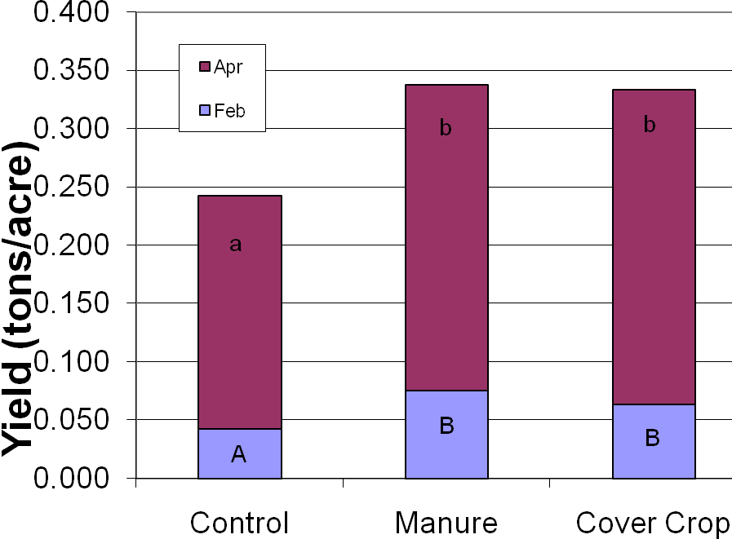
Table 1. Effects of manure and cover crops on winter forage quality, 2006-2007. ¹
 | Crude Protein (%DM) | Carbon (%DM) | Acid Detergent Fiber (%DM)
February Harvest
Control | 12.3 ª | 42.8ª | 22.3 ª
Manure | 13.6 ^{b} | 43.8 ª | 22.1 ª
Cover Crop | 12.7 ª | 43.7 ª | 20.6 ª
April Harvest
Control | 10.9 ª | 43.3 ª | 33.4 ª
Manure  Figure 1. Effects of manure and cover crops on winter forage yield, 2006-2007. Means with the same letter within harvest dates are not significantly different (P=0.05). | 12.4 ^{b} | 43.2 ª | 32.8 ª
Cover Crop | 11.2 ª | 43.1 ª | 33.2 ª
¹ Means with the same letter within harvest dates are not significantly different (P=0.05).

Table 2. Effects of cover crops on sorghum-sudangrass forage quality, 2006-2007. ¹
 | Crude Protein (%DM) | Carbon (%DM) | Acid Detergent Fiber (%DM)
July Harvest
Control | 5.7 ª | 44.2 ª | 43.2 ª
Cover Crop | 5.3 ª | 44.8 ^{b} | 48.6 ^{b}
September Harvest
Control | 7.3 ª | 45.6 ª | 43.7 ª
Cover Crop  Figure 2. Effects of cover crops on sorghum-sudangrass yield, 2006-2007. Means with the same letter within harvest dates are not significantly different (P=0.05). | 7.2 ª | 45.6 ª | 44.5 ^{b}
¹ Means with the same letter within harvest dates are not significantly different (P=0.05).

In the two 2007-08 experiments, dry weather limited 1st cutting sorghum-sudan yields (Figures 3 and 4), but the July harvest still showed a significant response to both cover crop (42% and 109% more than control) and fertilizer nitrogen (132% and176% more than control). Fertilized plots yielded 33% and 63% more than cover crop plots, but costs of this treatment were also higher (roughly $55/acre vs. $35-40/acre for cover crop seed). September yields were not significantly different in the no-till cover crop experiment, but the fertilizer treatment yielded roughly 24% more than cover crop and 28% more than control treatments in the tilled cover crop experiment.

Forage quality was also affected by fertility treatments in the 2007-08 experiments, though these results were not as consistent as yield effects. In the no-till cover crop experiment, crude protein levels were highest in the fertilizer treatment at both harvest dates (Table 3). In contrast, the tilled cover crop treatment produced sorghum-sudangrass with higher CP levels that either fertilizer or the no-fertilizer control. These differences would significantly impact animal development, especially in September when CP concentrations in the control were well below 6%, the minimum considered necessary for cattle maintenance. Minimum maintenance values are closer to 8% for dairy goats (NRC, 2007).
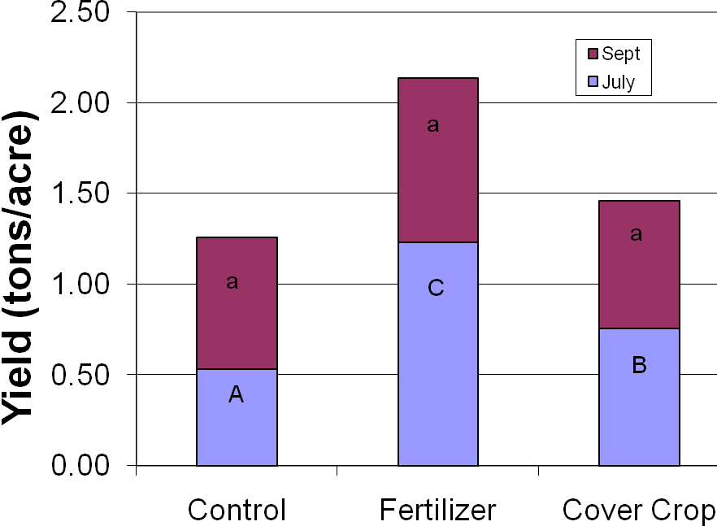
Table 3. Effects of no-till cover crops on sorghum-sudangrass forage quality, 2007-2008. ¹
 | Crude Protein (%DM) | Carbon (%DM)
July Harvest
Control | 6.7 ª | 45.5 ª
Fertilizer | 6.9 ^{b} | 45.8 ª
Cover Crop | 6.4 ª | 45.7 ª
September Harvest
Control | 5.8 ª | 45.5 ª
Fertilizer | 6.5 ^{b} | 45.6 ª
Cover Crop  Figure 3. Effects of no-till cover crops on sorghum-sudangrass yield, 2007-2008. Means with the same letter within harvest dates are not significantly different (P=0.05). | 6.1 ª | 45.7 ª
¹ Means with the same letter within harvest dates are not significantly different (P=0.05).

Table 4. Effects of tilled cover crops on sorghum-sudangrass forage quality, 2007-2008. ¹
 | Crude Protein (DM) | Carbon (DM)
July Harvest
Control | 6.9 ª | 45.9 ª
Fertilizer | 7.2 ª | 46.2 ª
Cover Crop | 7.9 ^{b} | 46.0 ª
September Harvest
Control | 5.4 ª | 45.3 ª
Fertilizer | 5.9 ª | 45.5 ª
Cover Crop | 6.5 ^{b} | 45.4 ª
¹ Means with the same letter within harvest dates are not significantly different (P=0.05).
Figure 4. Effects of tilled cover crops and fertilizer on sorghum-sudangrass yields, 2007-2008. Means with the same letter within harvest dates are not significantly different (P=0.05).

One visible difference in cover crop growth between these two experiments was that crimson clover predominated in the tilled cover crop plots, whereas hairy vetch seemed to compete more effectively in overseeded, no-till plots. It seems doubtful, however, that this difference explains the differences in CP response since this effect is nitrogen-related, and no paralell trend was observed in forage yield.

4. Future Work (no more than 1 page; less than one page is OK)

The response of summer forages to leguminous cover crops has raised considerable interest, both within our organization and on the part of other area farmers. However, we see need for some fine tuning of the system in order to maximize its effectiveness. First, optimizing the timing of cover crop seeding should result in higher nitrogen fixation and greater response of subsequent forage crops. Our observations in adjacent, non-experiment fields suggest that seeding in September rather than October may result in more legume growth going into the winter. However, erratic fall rain patterns may make early seeding more risky in some years (i.e. if early rains cause germination, but aren’t followed by enough moisture to sustain early growth). Self-reseeding may allow legumes to germinate on their own at times dictated by soil moisture or temperature seed bank is established in the soil. Managing self-reseeding legumes to not only produce soil-N but also allow time in late spring to set seed, is especially tricky for late-flowering species such as hairy vetch. Such determinations will undoubtedly take several years to understand more fully.

No-till seeding of leguminous cover crops into standing forages appears possible with the system studied, and will further increase the cost effectiveness and conservation-appropriateness of this approach. Further optimization of no-till seeding will involve timing of seeding (see above), timing of grazing, and selection of cover crop. Grazing should be early enough to allow hoof traffic to improve seed-soil contact and subsequent germination, but late enough that forage growth won’t unduly suppress cover crop establishment. Hairy vetch appeared to perform better than clover in the 2007-08 no-till experiment, but this observation should be confirmed with further experimentation, and other cover crop species might be included for screening.

We were disappointed in the performance of warm-season legumes as cover crops for winter forages. However, in the two seasons studied, dry summer weather severely limited cover-crop growth and may not have represented years with more “typical” spring rainfall. Had adequate moisture led to more vigorous growth of the cover crops, forage yield responses would have likely been much more pronounced. Forage protein levels would also be more likely to increase under such conditions. We are continuing to test lablab as a summer cover crop, but plan to seed somewhat earlier (e.g. April rather than May) in order to allow plants to become better established before the drier mid-summer months. As with the winter legumes, we are also testing no-till seeding methods.

5. Adoption (no more than 1 page; less than one page is OK)

We have already begun no-till seeding all our summer pasture fields with winter cover crops. In the 2008-2009 season, cover crop establishment was again spotty due to lack of rainfall. However, we remain optimistic that this practice will, in the long run, prove both practical and cost effective in non-drought years. Visitors to our farm, both workshop participants and neighboring producers, have had a chance to observe this system first hand. Interest grew exponentially with the increase in N fertilizer that occurred during this time period.

As noted above, summer legumes have been more difficult to develop, however we continue experimenting in the hopes of developing a summer legume-based cover crop system for our winter grass forages. Earlier seeding, more drought resistant species, and different systems for weed control all need to be studied before such a system will be viable.

6. Outreach (no more than 1 page; less than one page is OK)

Virtually all commercially-grown southern forage species for summer production (e.g. bermudagrass and sorghum-sudangrass) have a high nitrogen demand which is commonly met by the use of synthetic nitrogen fertilizers. With rising fertilizer prices and increasing environmental concerns, farmers are eager for alternatives. For organic producers, nitrogen management of hay and pasture species is even more challenging due to a lack of economical nitrogen fertilizers.

Following the initial year of promising results, we held a field day in September, 2008 in collaboration with Texas AgriLife Extension and Tarleton University. These results were also presented at the December, 2008 Educational Concerns for Hunger Organization conference in North Ft. Myers, FL. In the coming year, we intend to present our final report at the Texas Organic Farmers and Gardeners Association meetings as well as the Heart of Texas Fair and Rodeo.

We will also publish a promotional flier for distribution through AgriLife Extension programs, and we plan to publish results in a peer-reviewed professional journal with broader extension potential (Forage and Grazinglands http://www.plantmanagementnetwork.org/fg/ or Livestock Research for Rural Development http://www.lrrd.org/).

7. Summary (no more than ½ page and it is OK be shorter)

To test the effectiveness of leguminous cover crops in providing nitrogen for subsequent grass forages, four experiments were conducted over 2 growing seasons on our dairy farm in Central Texas. Legumes were seeded and allowed to grow to flowering before mowing and incorporation with tillage. Forages were seeded in replicated plots with no-fertilizer controls and manure or synthetic nitrogen fertilizers for comparison.

Results demonstrated that clover and hairy vetch cover crops are an agronomically effective source of nitrogen for production of sorghum-sudangrass in central Texas. Annual yields increased by 16-60% over no-fertilizer controls. Cover crops also competed favorably with other nitrogen sources including manure and synthetic fertilizers, though these comparisons were not as consistent from experiment to experiment. Cover crops raised the crude protein concentration of follow-up sorghum-sudangrass from 13-17%, a significant change for all types of ruminant production. Effects on other forage quality indicators were minimal. Use of warm-season leguminous cover crops for winter forage production produced significant, though less dramatic, yield results. No measurable effects were documented for forage quality.

Further optimization of both these systems should make them more economically and environmentally attractive to producers. With the price of nitrogen fertilizers having doubled in recent years, hay growers and graziers are finding this alternative an increasingly viable option. Since most synthetic nitrogen fertilizers are derived from fossil fuels, the use of leguminous cover crops also reduces our dependency on foreign oil as well as our carbon footprint.

Our thanks to Dr. S. Ray Smith, Univ. of Kentucky, Dr. Yoanna Newman, Univ. of Florida (Agronomy Department), Dr. Jim Muir of Texas AgriLife Research (A&M System), and Butch Tindall of the Homestead Heritage community.

WHRI trains individuals to work in sustainable agriculture in the United States and around the world. We operate a vegetable cooperative and a certified organic pecan orchard. Our livestock operations include a Grade-A goat dairy, as well as egg and meat production for sale in the local market.

Literature Cited

NRC, 2007. Nutrient requirements of small ruminants. National Research Council, The National Academies Press, Wash. D.C.
Robertson, J.B., Van Soest, P.J. 1977. Dietary fiber estimation in feed concentrate feedstuffs. J. Anim. Sci. 45 (Suppl. 1), 254.

