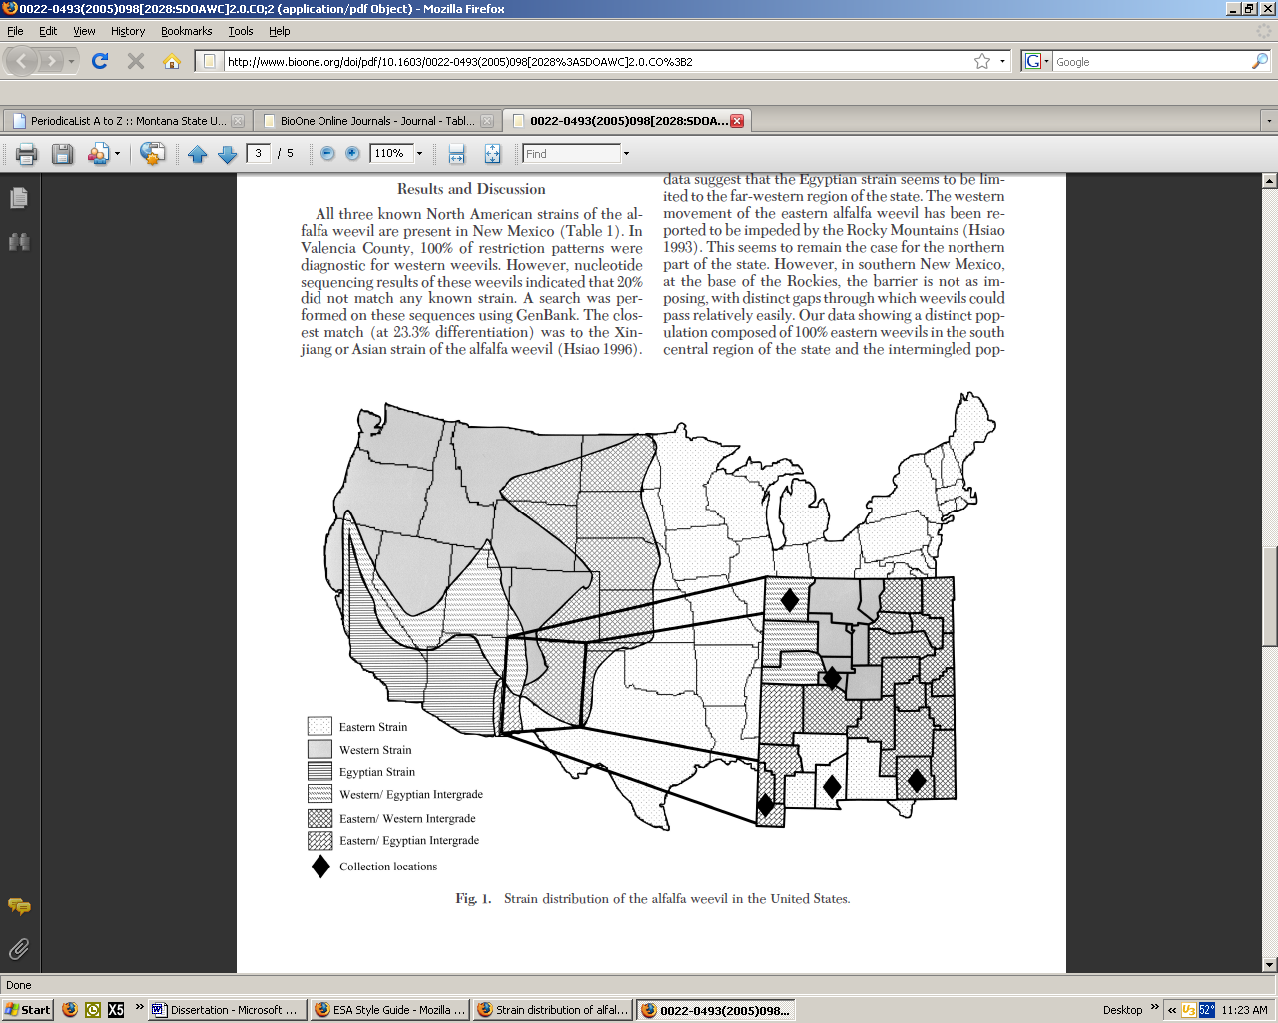
Fig. 1. Strain distribution of alfalfa weevil in the United States (adapted from Bundy et al. 2005)

