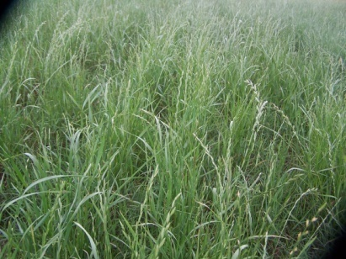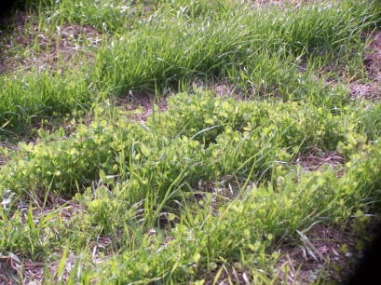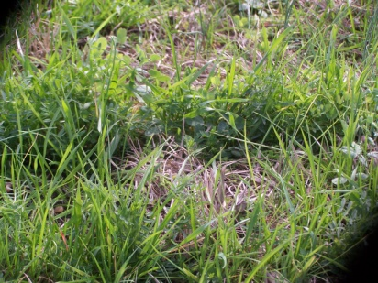
(a) Wheat/Rye (b) Wheat/Rye+Berseem clover (C) Wheat/Rye + Hairy vetch
+ berseem clover
Figure 3. Multi-cultural forage system during winter and spring, Tuskegee, AL

