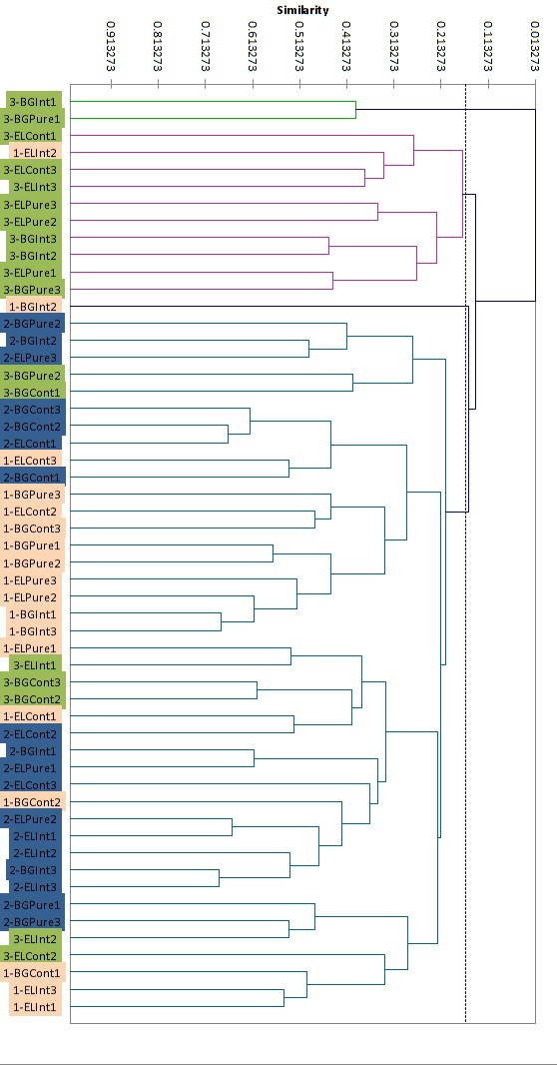
Figure 1: Cluster analysis of DGGE profiles from sites 1, 2, and 3. The horizontal axis represents similarity of the profiles to each other. Samples in orange are from site 1, blue are from site 2 and green are site 3.

