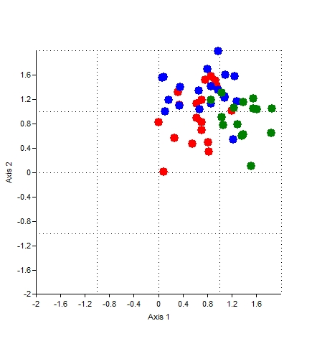
Figure 2: DCA of sites 1, 2 and 3 samples. Units are standard deviation of species turnover (s.d.). Site 1 is represented by red, site 2 by blue and site 3 by green dots. The spread of all samples was approximately 0 to 1.8 s.d. on the first axis and 0 to 1.8 s.d. on the second axis, indicating a monotonic curve for the data.

