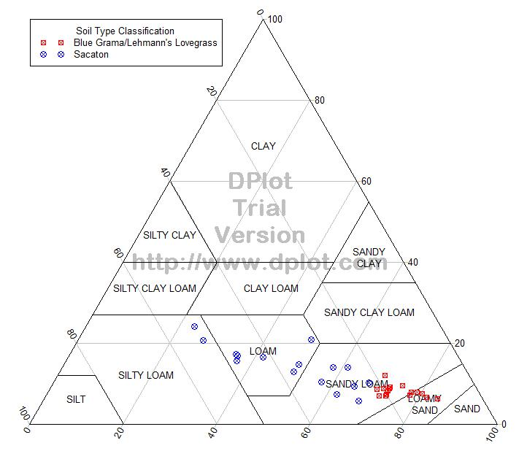
Figure 3: USDA soil classification ternary plot of the soils from all sites. Lehmann’s lovegrass/blue grama sites are represented by red squares. Data on sacaton plants, represented by blue circles, are also presented.

