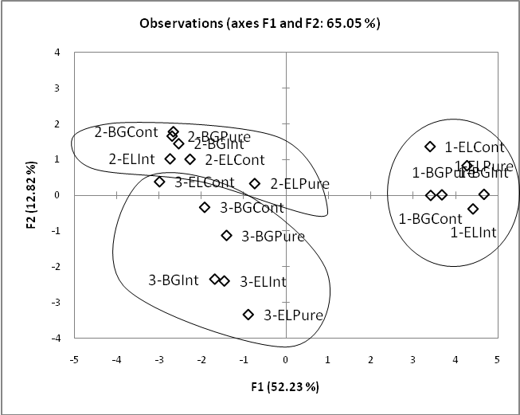
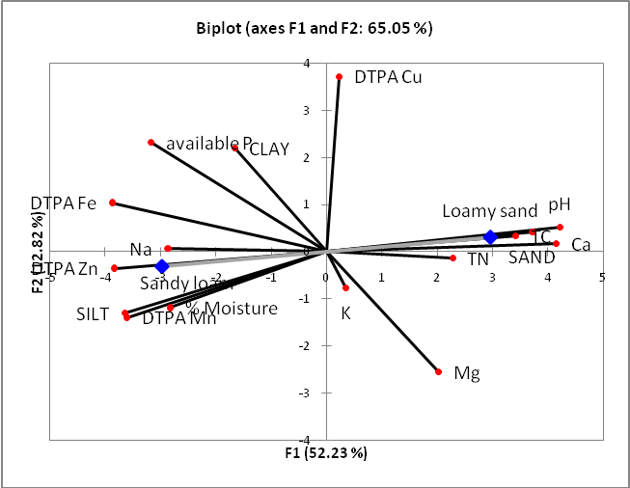
Figure 4: PCA analysis of soil data for all Lehmann’s lovegrass/blue grama sites. A.) Sample locations on the plot, showing grouping of samples by site. B.) Vector biplot of the variables tested. Chemical and physical characteristics in red and soil type in blue.

