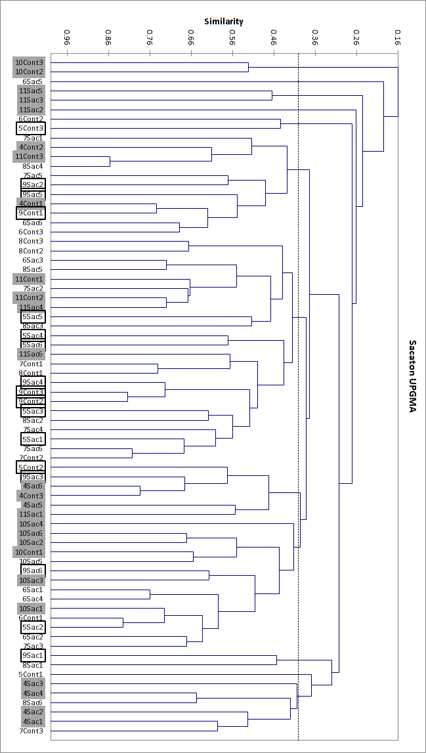

Figure 5: Cluster analysis of sacaton samples. Deep water samples are represented by gray shaded text, mid-level are black bordered and shallow samples are white.

