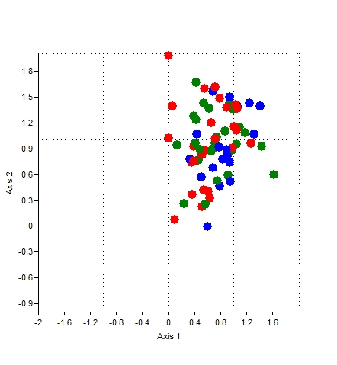

Figure 6: DCA of all sacaton sites (4-11). Shallow water table sites (6, 7, 8) are in green, mid-level (5, 9) are in blue, deep (4, 10, 11) are in red. Spread of the points is between approximately 0 and 1.6 on the first axis and 0 and 2 on the second axis.

