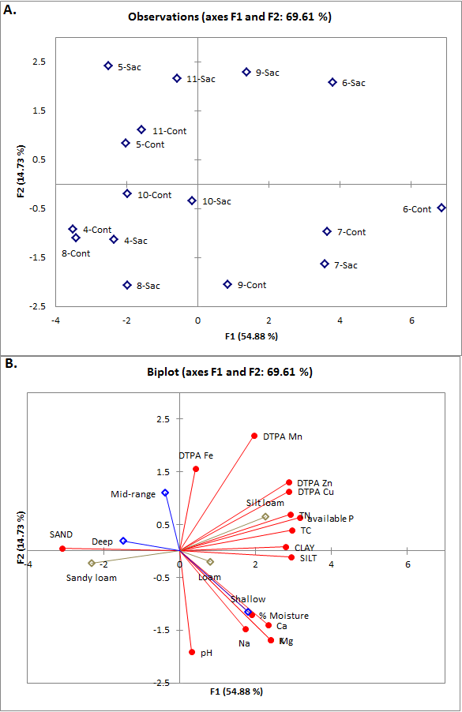

Figure 7: PCA analysis of soil data for all sacaton sites. A.) Sample locations on the plot, including sacaton (Sac) and bare ground control (Cont). B.) Vector biplot of the variables tested. Chemical and physical characteristics in red, water table in blue and soil type in gold.

