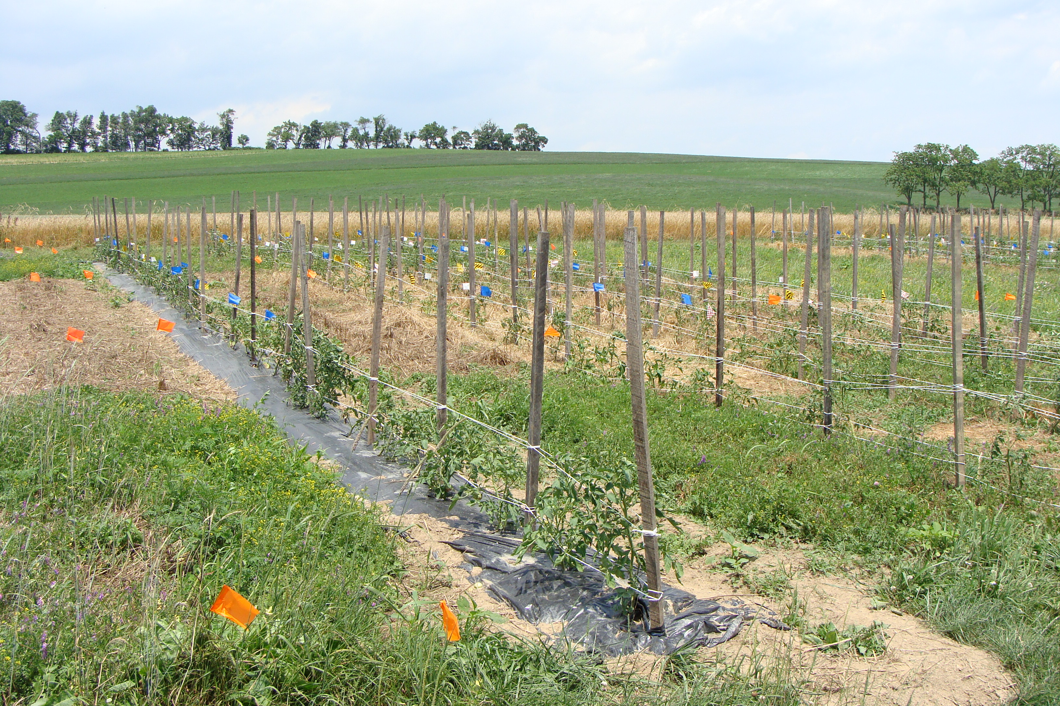
Cover crops from near to far: hairy vetch, rye-vetch mix, and rye.

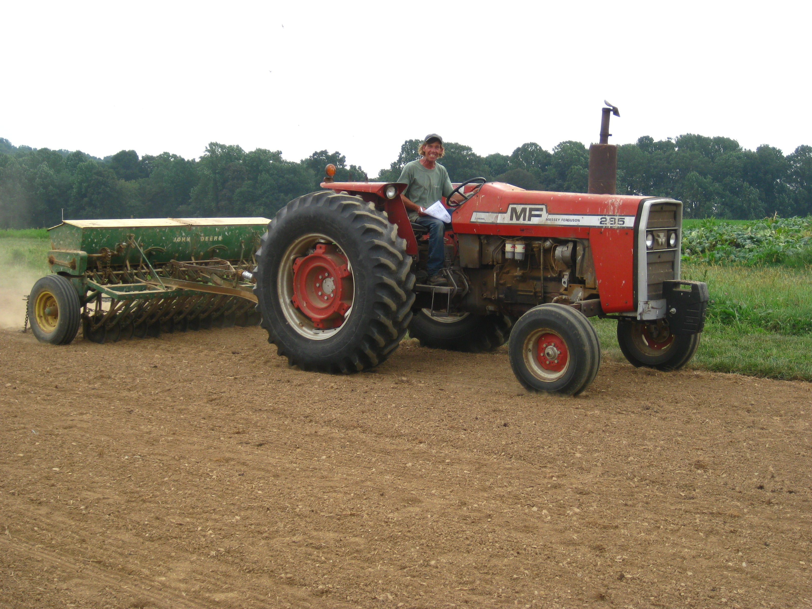
Farmer Randolph, a collaborating farmer, planting rye-vetch seed this September in preparation for the 2011 season.

Figure 1. Tomato yield in lbs/acre. This yield appears unnaturally high because we picked and weighed all the fruit on the plants, including half-rotten and unsellable fruit. Additionally, our season extended until almost October.
Figure 2. Percent soil moisture in the tomato plots. Moisture was calculated gravimetrically from 5 20-cm soil cores per plot collected bi-weekly and averaged.

Figure 3. Weed biomass assessed 4 and 8 weeks after planting in kg/ha. 0.5m2 quads were placed half in-row and half-between row to capture biomass; all weeds inside were dried and weighed.

