2010 Cover Crop Termination Study

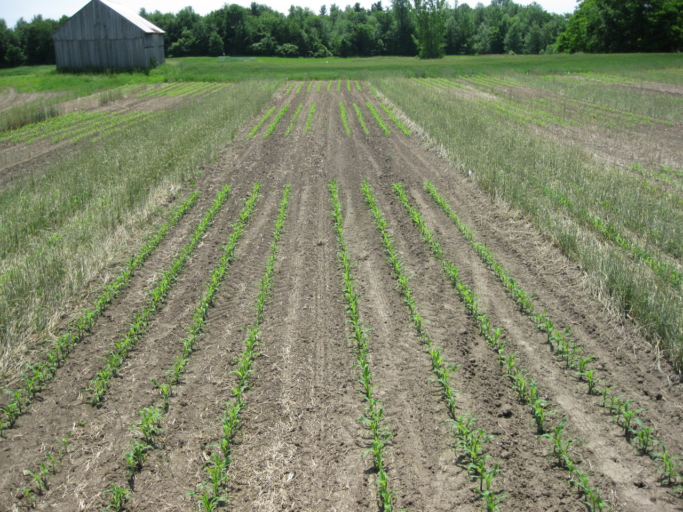
Figure 1. Cover crop termination study. From right to left: cover crop rolled and crimped, cover crop plowed down, no cover crop control. Planter type from front to back: zone-till planter, no-till planter, strip-till planter.

2010 Cover Crop Termination Study

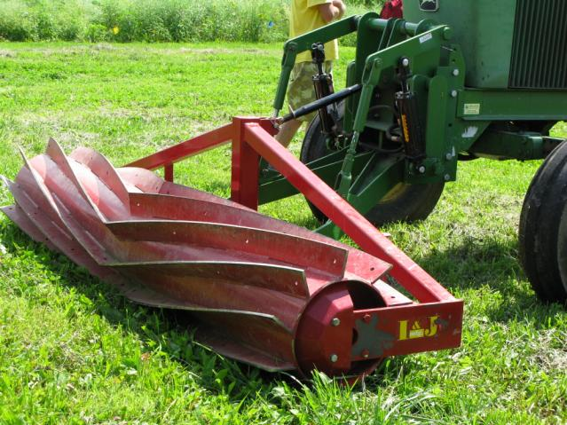
When a crop such as corn silage or sunflowers is harvested in the fall, the entire plant is removed, leaving the soil exposed through the winter. To alleviate problems associated with leaving soil bare, many farmers have started to plant cover crops following harvest. Cover crops can fill several positive roles in addition to protecting the soil from erosion. Cover crops scavenge excess soil nitrogen, keeping the nitrogen from potentially being lost through leaching, and can also reduce weed pressure in the spring, if they are terminated properly. Farmers would like to reap the most benefit from the cover crop while protecting corn silage yield and quality, therefore understanding what the best method for terminating the cover crop is of significant interest. As a part of this study, a unique termination strategy called “rolling and crimping” was demonstrated in both corn silage and sunflower systems (Figure 1). In order to properly utilize this technique the rye crop must be in the flowering stage before it is terminated. Once in the flowering stage, the rye is rolled down and the machine crimps the stems, killing the plant (Figure 2). The rolled cover crop acts as a mulch mat, suppressing weeds. The crop is then planted into the mat using a no-till, zone-till, or strip-till planter. This system has many advantages as it reduces costs associated with both weed control and tillage. However, this practice has not been evaluated in either corn silage or sunflower systems in New England. Therefore establishing best practices for timing and method of cover crop termination is critical to success of the establishment of this method in New England. In 2010, the University of Vermont Extension conducted the second year of an experiment to evaluate the impact of cover crop termination strategies on soil health, soil nitrogen dynamics, corn silage yield and quality. The goal is to document the positive and negative aspects of each strategy so farmers can decide the best way to terminate cover crops on their farm. It is important to remember that the data presented are from a single test at only one location. Cover crop data from additional tests in different locations and often over several years should be compared before you make conclusions.
Figure 1. Roller crimper.
Figure 2. Rye cover crop that has been rolled and crimped.

CULTURAL PRACTICES FOR COVER CROP TERMINATION
STRATEGIES IN SILAGE CORN

The experiment was conducted on a silt loam soil at Borderview Farm in Alburgh, VT with the previous crop being cereal rye. On October 10, 2009 the winter rye cover crop was seeded at a rate of 100 lbs/acre. Plots without cover crops served as controls. The plot design was randomized spilt block with four replications. The main plots were cover crop termination method: cover crop herbicide burn-down using 2 qts/acre of Roundup, cover crop plowed down with a moldboard plow, rolled and crimped cover crop, and a control with no cover crop. The split plots were planter types: no-till, zone-till, and strip till planters. The plot size was 10’ x 40’. In mid-April the soil was sampled to determine soil quality. Soil was sampled from multiple locations to a 6” depth using a trowel. Representative subsamples of soil were taken from four cover cropped plots, and four plots without cover crop, and sent to the Cornell Soil Health Lab for analysis. Soil quality was monitored to determine if a single season of cover cropping would improve soil health. Soil nitrates were measured weekly from the beginning of May until the end of June. Soil nitrate sampling was used to monitor the break-down of the cover crop and subsequent nitrogen release. Nitrate sampling was terminated once the corn was at the V6 stage (time of nitrogen topdress). Multiple soil samples to a depth of 12 inches were taken from each plot, composited, and the subsamples analyzed for soil nitrate-N. Prior to cover crop termination, a one-meter² sample of cover crop was taken to determine crop biomass and nitrogen content. In the spring of 2010, the cover crops were terminated with a burn-down herbicide (glyphosate (Roundup) at 2 qts/acre), plowing the cover crop into the soil, or by rolling and crimping the crop. After the cover crop was terminated, corn (var. Mycogen TMF2L418) was planted in the no-till treatment with a John Deere 1750 4-row planter, in the zone-till treatment with a White 6100 zone-till planter, and in the strip-till treatment with a Blujet Coulter Pro at 34,000 seeds to the acre. Starter fertilizer was applied at a rate of 200 lbs 10-20-20 to the acre. On July 10th, the corn plots were side-dressed with urea-nitrogen at the V6 growth stage. Fertilizer rates were determined with soil nitrate-N tests with applied rates for each treatment as follows: crimp = 130 lbs/ac, RR = 75 lbs/ac, till = 50 lbs/ac, control = 50 lbs/ac? The plots were harvested when the corn reached 35% whole plant dry matter or following a killing frost. The plots were harvested on October 11, 2010 with a John Deere 2 row chopper, and the forage wagon was weighed on a platform scale. A subsample was collected for moisture determination and quality analysis. Pertinent trial information is summarized in Table 1.

Table 1. Cover crop termination trial information.
Cover crop termination method | Cover crop termination date | Tillage type | Planter type | Corn planting date
No cover crop (control) |  | Plow & disk | No-till | 5/28/2010
No cover crop (control) |  | Plow & disk | Strip-till | 5/29/2010
No cover crop (control) |  | Plow & disk | Zone-till | 5/28/2010
Plow down | 5/13/2010 | Plow & disk | No-till | 5/28/2010
Plow down | 5/13/2010 | Plow & disk | Strip-till | 5/29/2010
Plow down | 5/13/2010 | Plow & disk | Zone-till | 5/28/2010
Herbicide burn-down | 5/11/2010 | None | No-till | 5/28/2010
Herbicide burn-down | 5/11/2010 | None | Strip-till | 5/29/2010
Herbicide burn-down | 5/11/2010 | None | Zone-till | 5/28/2010
Rolled and crimped | 5/27/2010 | None | No-till | 5/28/2010
Rolled and crimped | 5/27/2010 | None | Strip-till | 5/29/2010
Rolled and crimped | 5/27/2010 | None | Zone-till | 5/28/2010
*Nitrogen topdress rates were determined by soil nitrate-N testing just prior to corn growth stage V6.

PRESENTATION OF DATA
The impact of cover cropping on soil quality is reported in Table 2. The soil nitrate-N measured is reported in Table 3 and Figure 3. The impact of cover crop termination strategy on corn yield and quality is shown in Table 4 and Figure 4. Finally in Table 5 the impact of reduced tillage strategy is shown. Dry matter corn yields were calculated and then adjusted to 35% dry matter for the report. The numbers presented in the tables are of four replications. All data was analyzed using a mixed model analysis where replicates were considered random effects. The LSD procedure was used to separate cover crop termination means when the F-test was significant (P< 0.10).

RESULTS
Table 2. Impact of a single season of cover cropping on soil quality characteristics.
Treatment | Aggregate stability | Surface hardness | Subsurface hardness | Organic matter | Active carbon | Potentially mineralizable N | Root health rating
 | % | psi | psi | % | mg/kg | ug N g-1 d soil | (1-9)
Cover crop | 52.8* | 101 | 292 | 4.95 | 521* | 19.4 | 3.41
No cover crop | 47.7 | 107 | 261* | 4.58 | 441 | 17.1 | 3.23
LSD (0.10) | 3.23 | NS | 35.5 | NS | 54.4 | NS | NS
Mean | 50.2 | 103 | 279 | 4.76 | 481 | 18.2 | 3.32

Table 3. Impact of cover crop termination method on soil nitrate-N levels.
Cover crop termination method | Soil nitrate-N sample date
 | 5-May | 21-May | 26-May | 2-Jun | 9-Jun | 15-Jun | 22-Jun | 29-Jun
 | ------------------------------------------------ppm-----------------------------------------
No cover crop (control) | 5.73 | 10.2 | 8.51 | 12.9 | 9.98 | 11.6 | 14.2 | 15.2*
Crimp | 2.10 | 2.05 | 1.62 | 2.00 | 2.15 | 2.59 | 8.09 | 3.80
RR | 2.29 | 3.91 | 4.38 | 6.45 | 4.28 | 5.18 | 9.33 | 9.31
Tillage | 1.75 | 4.23 | 5.71 | 9.09 | 6.68 | 8.18 | 11.2 | 13.7*
LSD (0.10) | 0.572 | 2.30 | 1.85 | 2.08 | 2.35 | 2.24 | NS | 2.64
Mean | 2.97 | 5.09 | 5.06 | 7.60 | 5.77 | 6.87 | 10.7 | 10.5

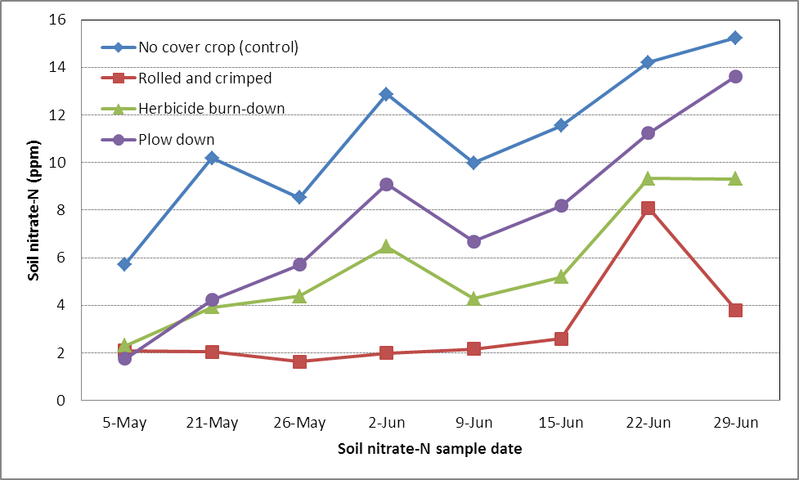
Figure 3. Soil nitrate-N of cover crop termination strategies from May to the end of June.

Table 4. Impact of cover crop termination strategies on silage corn yield and quality.
Termination strategy | Population | DM at harvest | Yield at 35% DM | Forage quality characteristics |  |  |  |  | Milk per
 |  |  |  | CP | ADF | NDF | dNDF | Nel | ton | acre
 | plants/ac | % | tons/ac | % | % | % | % | mcal/lb | ton | acre
No cover crop | 30000 | 29.3 | 19.1* | 8.96 | 24.2* | 41.1 | 57.9* | 0.75 | 2920* | 19500*
Rolled &  crimped | 28000 | 25.5 | 9.5 | 9.60 | 25.3* | 43.7 | 56.4 | 0.73 | 2800 | 9420
Herbicide  burn-down | 31400 | 31.4 | 17.0 | 8.66 | 22.9 | 39.0 | 58.4* | 0.76* | 2960* | 17600
Plow down | 29000 | 31.7 | 20.1* | 8.66 | 23.7 | 40.3 | 57.1 | 0.75* | 2910* | 20500*
LSD (0.10) | NS | 1.78 | 1.82 | 0.36 | 1.16 | 1.9 | 1.2 | 0.01 | 69.6 | 2020
Mean | 30000 | 29.5 | 16.4 | 8.97 | 24.0 | 41.0 | 57.4 | 0.75 | 2890 | 16800

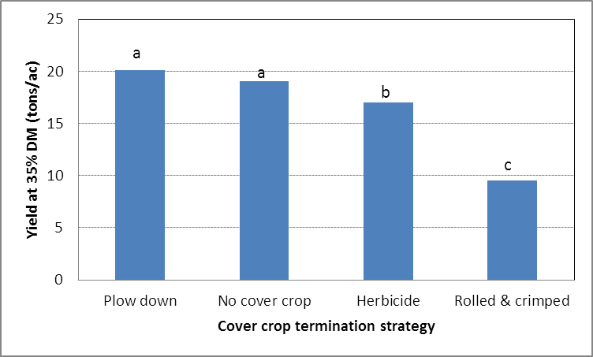
Figure 4. Impact of cover crop termination strategy on corn silage yield.
Treatments with the same letter did not differ statistically in yield.

Table 5. Impact of reduced tillage practices on silage corn yield and quality where the cover crop was terminated via herbicide burn down.
Reduced tillage practice | Dry matter | Yield at  35% DM | Forage quality characteristics |  |  |  |  | Milk per
Reduced tillage practice | Dry matter | Yield at  35% DM | CP | ADF | NDF | dNDF | Nel | ton | acre
Reduced tillage practice | % | ton/acre | % | % | % | % | mcal/lb
No-till | 30.8 | 16.7 | 8.68 | 24.2 | 40.8 | 57.3 | 0.75 | 2880 | 16900
Strip-till | 30.2 | 18.4 | 8.38 | 23.1 | 39.2 | 57.7 | 0.76 | 2940 | 18900
Zone-till | 33.3 | 16.0 | 8.92 | 21.3 | 37 | 60.1 | 0.78 | 3050 | 17100
LSD (0.10) | NS | NS | NS | NS | NS | 1.33 | NS | 96.6 | NS
Mean | 31.4 | 17.0 | 8.66 | 22.9 | 39 | 58.4 | 0.76 | 2960 | 17600

DISCUSSION
Overall, soil quality was improved by a single season of cover cropping. The cover crop improved aggregate stability and increased the amount of active carbon in the soil. It is promising to see that even a single season of cover cropping can provide immediate benefits to the soil. The control with no cover crop had a higher level of soil nitrate-N throughout the sampling period, although by the end of June, when corn exhibits the greatest nitrate demand, the cover crop plow down treatment had statistically similar soil nitrate-N levels. Silage corn yields were statistically similar for systems with plowed down cover crop and for the no cover crop control. This would indicate that while the plow down treatment did lag a bit in soil nitrate-N through the early season, when the corn needed nitrogen the most, the nitrogen from the plowed down rye cover crop biomass was available for the corn crop to take up. The rolled and crimped cover crop plots had the lowest amount of soil nitrate-N due to the high C:N ratio of the cover crop. This high ratio may have resulted in nitrogen being tied up as the cover crop was degraded, resulting in subsequent corn nitrogen deficiencies, as demonstrated by the increased amount of urea-N applied during sidedress and the lower corn yields. Additionally, the thick mulch from the rolled and crimped cover crop could have contributed to slower warming of the soil and nitrogen tie-up, and delayed corn development. Overall, cover cropping can have positive results on soil quality and plant yields. Additional studies need to be conducted to continue to understand how to reap the benefits of each termination strategy. Various reduced tillage planting practices produced statistically similar yields. No significance was detected between percent dry matter at harvest, yield, crude protein, ADF, NDF, or milk/acre for differing reduced tillage practices. Significance was determined at the 0.10 level of significance between dNDF and milk per ton with corn that had been zone-till planted out-performing the other forms of reduced tillage trialed.

