2010 Maine Corn Hybrid Performance Trial

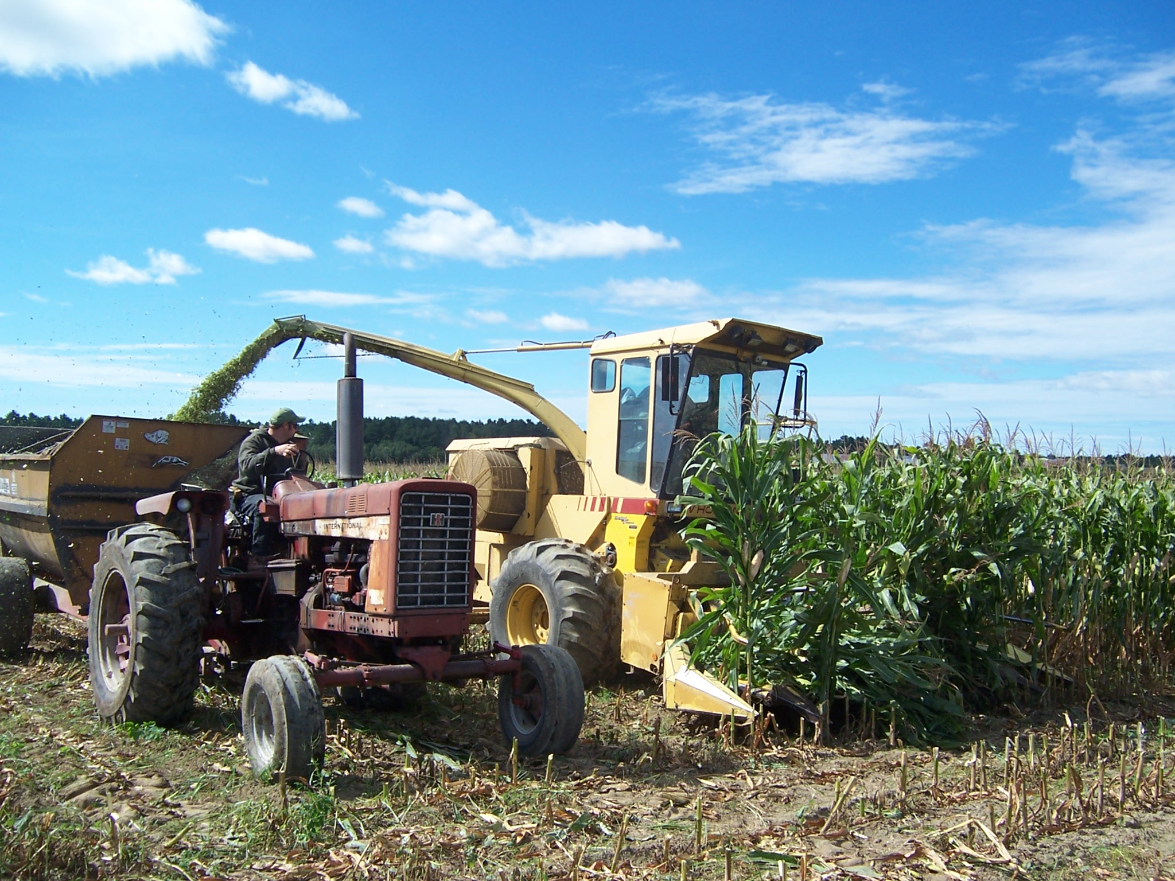

Funding provided by local seed companies, the University of Maine Cooperative Extension, and Northeast SARE (Project LNE09-287).

Special thanks to Dave Barker and the farm crew at Barker Farm for hosting the trial and helping with planting and harvesting.
Rick Kersbergen
richard.kersbergen@maine.edu

Caragh Fitzgerald
cfitzgerald@maine.edu




A Member of the University of Maine system

In 2010, the University of Maine Cooperative Extension repeated a hybrid corn evaluation program in cooperation with local seed dealers, Maine Farm Days and the Barker Farm who hosted the trial in Leeds, Maine.

The purpose of the program is to provide unbiased performance comparisons of hybrid corn available in the central Maine area. It is important to remember, however, that the data presented are from a single test at only one location. Hybrid performance data from additional tests in different locations, and often over several years, should be compared before you make conclusions.

Contacts for hybrid seed sources for 2010

Blue Seal
Michelle Bennett 1-800-734-1945 (207) 754-0764 mbennett@blueseal.com
DeKalb
Spencer Greatorex (207) 341-1375 svg1@adelphia.net
Dyna-gro
Alvin Winslow (207) 795 6640 (207) 740-0253 alvin.winslow@cpsagu.com
Garst
Lauchlin Titus (207) 314-2655 LTitus1@myfairpoint.net
Hyland
Alvin Winslow (207) 795 6640 (207) 740-0253 alvin.winslow@cpsagu.com
Masters Choice
Newman Gamage (207) 622-5009 (H) (207) 446-5620 (M)
Mycogen
Spencer Greatorex (207) 341-1375 svg1@adelphia.net
Alvin Winslow (207) 795 6640 (207)740-0253 alvin.winslow@cpsagu.com
NK Seeds
Spencer Greatorex (207) 341-1375 svg1@adelphia.net
Alvin Winslow (207) 795 6640 (207)740-0253 alvin.winslow@cpsagu.com
Nutridense
Alvin Winslow (207) 795 6640 (207) 740-0253 alvin.winslow@cpsagu.com
Seedway
Lauchlin Titus (207) 314-2655 LTitus1@myfairpoint.net

Note: Paris Farmers Union sells many of these hybrids. Contact is Tim Donovan 461-4641

TESTING PROCEDURE
The experiment was planted at the Barker Farm in Leeds on May 18, 2010, using a six-row corn planter. The predominant soil types were Swanton fine sandy loam, Scantic silt loam, and Agawam fine sandy loam. Three replications of 33 hybrids were planted in a randomized block design, and plots were 100 feet long. Hybrids used were nominated and donated by seed companies. The hybrids used had relative maturity days ranging from 69 to 103 (Table 1). We targeted a planting density of 32,000 plants/acre. Prior to planting, 12 yards of poultry manure per acre was spread and incorporated.

Results from a temperature sensor at the field edge were used to calculate growing degree days. Total growing degree days (86/50) for 2010 were 2120, higher than in previous years (1908 in 2009, 1840 in 2008, 2086 in 2007). The experiment was harvested on September 16. No killing frost had occurred by harvest time.

Table 1. Hybrids and relative maturity dates, 2010

Hybrid | Company | Relative Maturity
696 | Blue Seal | 69
789 | Blue Seal | 78
SW 1990 | Seedway | 80
MC 468 | Masters Choice | 82
N16M-3000GT | NK | 82
SW 2244RR | Seedway | 84
868 | Blue Seal | 86
D27GC19 | Dyna-Gro | 87
HL SR35 | Hyland | 88
DKC39-07 | DeKalb | 89
86K65 | Garst | 89
F2F297 | Mycogen | 89
TMF 2Q298 | Mycogen | 89
DKC40-22 | DeKalb | 90
MC 480 | Masters Choice | 90
SW 3008RRYGCRW | Seedway | 90
D32RR29 | Dyna-Gro | 92
MC 490 | Masters Choice | 94
N33R-GT/CB/LL | NK | 94
D34VN19 | Nutridense | 94
334 | Blue Seal | 95
DKC45-52 | DeKalb | 95
88E24 | Garst | 95
F2F383 | Mycogen | 95
CX1095 | Nutridense | 95
SW 3737bmr | Seedway | 96
HL SO47 | Hyland | 97
88B37 | Garst | 98
MC 515 | Masters Choice | 98
CX1000 | Nutridense | 100
DG 54T42 | Dyna-Gro | 101
HL SO58 | Hyland | 101
N49J-3000GT | NK | 103

Rainfall for 2010 as recorded by National Weather Service for May, June, and July at the Winthrop, Maine location is indicated in Table 2. Data for Augusta and September were not available at press time.
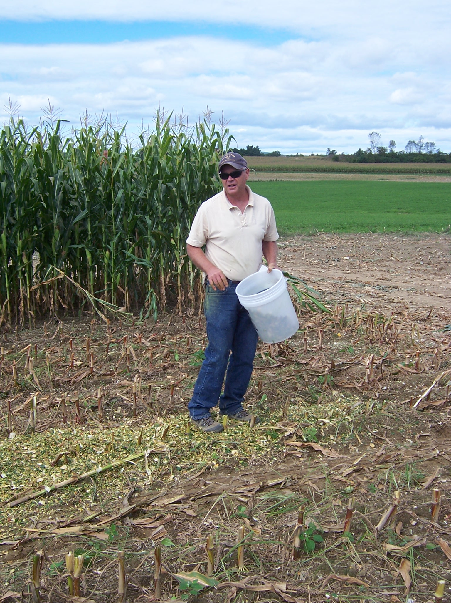
Table 2. Rainfall, Winthrop, Maine, 2010
Month | Rain, inches observed
May | 1.14
June | 5.98
July | 2.84

The plots were harvested using a six-row corn chopper with each plot loaded into a mixer wagon with scales. Grab samples from one replicate of each treatment were sent to the Dairy One laboratory in New York for immediate analysis for moisture and quality. Grab samples of the remaining two replicates of each treatment were weighed in the field, dried, and weighed again to calculate moisture.

Statistical analysis of differences between hybrids was performed on silage yield (corrected to 30% dry matter), expected milk yield (milk per ton of dry matter multiplied by dry matter), and percent dry matter.

RESULTS
Table 3 summarizes yield and select quality results.
Table 3. Yield and select quality results, 2010.
Hybrid | Company | Relative Maturity | 30% DM yield, tons/acre | Milk, lbs/acre | % Dry Matter | % Crude Protein | % NDF | % NFC | NEL Mcal/lb | IVTD 30hr % of DM
696 | Blue Seal | 69 | 15.2 | 11618 | 36.7 | 8.3 | 46.8 | 37.1 | 0.65 | 73
789 | Blue Seal | 78 | 17.9 | 14641 | 39.7 | 8.1 | 48.8 | 35.5 | 0.7 | 78
SW 1990 | Seedway | 80 | 17.7 | 16581 | 35.6 | 8.9 | 46 | 37.3 | 0.73 | 80
MC 468 | Masters Choice | 82 | 21.9 | 24563 | 35.4 | 8.2 | 30.5 | 52.8 | 0.85 | 90
N16M-3000GT | NK | 82 | 20.8 | 17354 | 38.3 | 8.8 | 35.9 | 46.8 | 0.77 | 82
SW 2244RR | Seedway | 84 | 18.7 | 20034 | 34.9 | 9 | 33.6 | 48.9 | 0.81 | 85
868 | Blue Seal | 86 | 20.5 | 18299 | 33.5 | 8.8 | 41 | 41.7 | 0.7 | 76
D27GC19 | Dyna-Gro | 87 | 19.3 | 16380 | 35.1 | 8.6 | 34.7 | 48.1 | 0.75 | 80
HL SR35 | Hyland | 88 | 21.6 | 24077 | 32.2 | 9.1 | 37.3 | 45.1 | 0.81 | 87
DKC39-07 | DeKalb | 89 | 22.2 | 22770 | 36.2 | 9 | 33.2 | 49.3 | 0.8 | 84
86K65 | Garst | 89 | 22.6 | 19978 | 36.8 | 8 | 43.4 | 40.2 | 0.7 | 77
F2F297 | Mycogen | 89 | 19.4 | 21314 | 34.1 | 8.8 | 39.6 | 43.2 | 0.8 | 87
TMF 2Q298 | Mycogen | 89 | 19.2 | 19667 | 30.6 | 9.8 | 42.7 | 39.6 | 0.75 | 81
DKC40-22 | DeKalb | 90 | 23.3 | 25078 | 32.6 | 8.1 | 33.6 | 49.8 | 0.81 | 85
MC 480 | Masters Choice | 90 | 20.2 | 21934 | 33.5 | 9.5 | 37.4 | 44.5 | 0.79 | 84
SW 3008RRYGCRW | Seedway | 90 | 22.5 | 23145 | 30.6 | 7.7 | 36.8 | 47 | 0.76 | 81
D32RR29 | Dyna-Gro | 92 | 21.4 | 17456 | 36.1 | 8.1 | 49.8 | 34.7 | 0.66 | 74
MC 490 | Masters Choice | 94 | 19.0 | 18836 | 30.0 | 9.9 | 47.6 | 35.3 | 0.73 | 80
N33R-GT/CB/LL | NK | 94 | 20.3 | 20851 | 35.3 | 7.2 | 33.6 | 50.7 | 0.79 | 83
D34VN19 | Nutridense | 94 | 22.5 | 24086 | 30.1 | 9.4 | 38.1 | 44 | 0.78 | 83
334 | Blue Seal | 95 | 22.8 | 23448 | 30.6 | 8.8 | 40.9 | 41.8 | 0.75 | 81
DKC45-52 | DeKalb | 95 | 20.7 | 22122 | 30.4 | 9.1 | 37.6 | 44.8 | 0.78 | 83
88E24 | Garst | 95 | 24.6 | 25097 | 33.6 | 7.6 | 42.8 | 41.1 | 0.75 | 81
F2F383 | Mycogen | 95 | 20.5 | 22686 | 31.7 | 9.1 | 40.3 | 42.1 | 0.79 | 85
CX1095 | Nutridense | 95 | 24.1 | 21320 | 30.4 | 7.1 | 49.3 | 35.7 | 0.66 | 74
SW 3737bmr | Seedway | 96 | 17.0 | 18702 | 30.0 | 8.7 | 42.1 | 40.9 | 0.78 | 85
HL SO47 | Hyland | 97 | 22.3 | 19730 | 31.8 | 9.3 | 52.8 | 31.2 | 0.66 | 74
88B37 | Garst | 98 | 22.3 | 24598 | 33.0 | 8.6 | 34.1 | 48.8 | 0.81 | 85
MC 515 | Masters Choice | 98 | 20.8 | 22037 | 30.4 | 9.8 | 42.1 | 40.2 | 0.77 | 83
CX1000 | Nutridense | 100 | 22.6 | 22697 | 25.9 | 9.1 | 41.6 | 41 | 0.74 | 80
DG 54T42 | Dyna-Gro | 101 | 22.2 | 24131 | 27.2 | 9.2 | 36.6 | 45.7 | 0.79 | 84
HL SO58 | Hyland | 101 | 21.0 | 21251 | 28.5 | 7.6 | 43.7 | 40.2 | 0.74 | 80
N49J-3000GT | NK | 103 | 24.2 | 24618 | 31.1 | 7.6 | 43.9 | 40 | 0.74 | 81
 | Averages |  | 20.9 | 20942 | 32.8 | 8.6 | 40.55 | 42.6 | 0.75 | 81
IVTD Dig 30 hours  InVitro true digestibility samples incubated in rumen fluid for 30 hours
Yield

There were significant differences in yield (corrected to 30% dry matter) among the hybrids tested. Figures 1, 2, and 3 show these results. The hybrids are presented in order of relative maturity. Hybrids with similar superscripts are not statistically different (Tukey’s HSD). There was a significant, but weak, linear correlation between relative maturity and yield (30% dry matter) (r² = 0.20) (Figure 4).

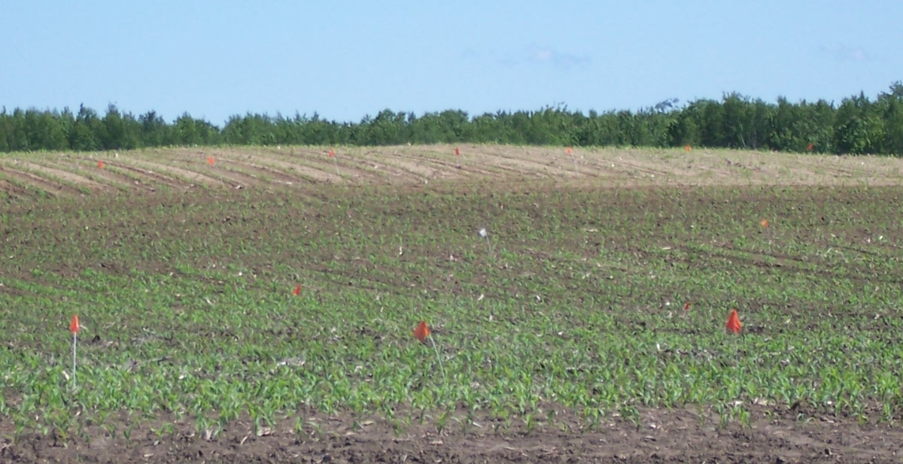

Expected Milk Yield
Expected milk yield per acre was calculated by multiplying the expected milk per ton of dry matter (this is calculated from other quality parameters) by the tons of dry matter per acre. There were significant differences in expected milk yield per acre among the hybrids tested (Figures 5, 6, and 7). Across all hybrids, there was an average expected yield of 19,827 pounds of milk per acre. There was a significant linear correlation between relative maturity and expected milk per acre (r² = 0.31) (Figure 8).

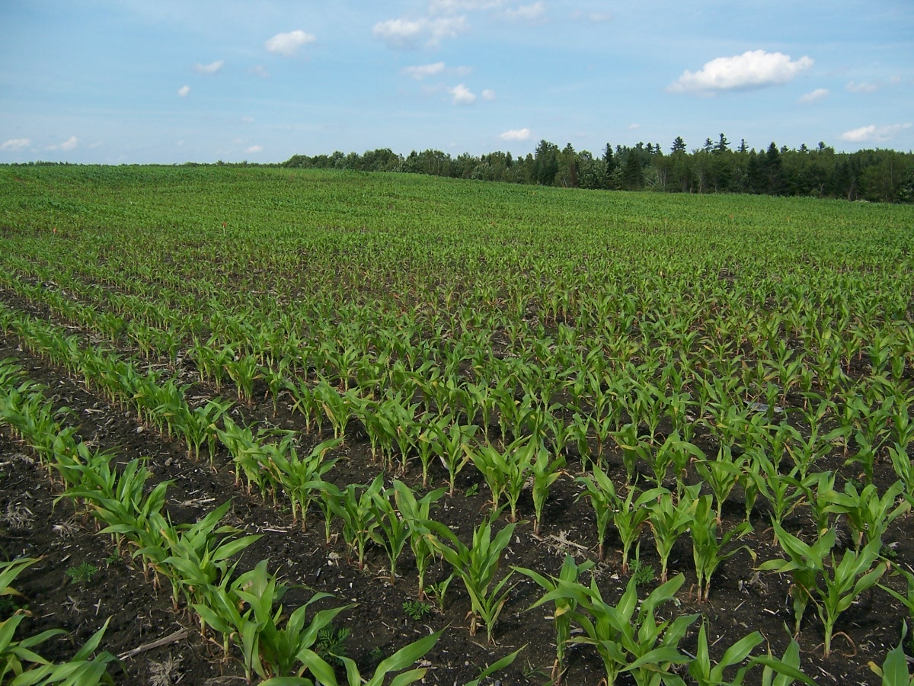
Quality

There were significant differences in percent dry matter acre among the hybrids tested (Figures 9, 10, and 11). Across all hybrids, there was an average dry matter of 36.7%.

Dry matter decreased as relative maturity increased, as shown in Figure 12. There was a significant linear effect, and this relationship explained a moderate amount of variability in the data (r² = 0.39). Unlike the last two years, most hybrids showed optimal or higher than optimal dry matter levels at harvest.

There was no linear correlation between relative maturity and digestibility or net energy of lactation (Figures 13 and 14).

Relative maturity had a statistically significant effect on soluble protein as % CP (Figure 15). This relationship was weak, with an r² of 0.15. Crude protein and adjusted crude protein did not show such an effect.

CONCLUSIONS

2010 was a good year for silage corn production in Maine. This year, there were both differences among hybrids and a significant linear effect of relative maturity on yield corrected to 30% dry matter. This linear correlation indicated 1.8 tons/acre increase in yield (30% dry matter) for every additional 10 days of maturity. Results from two of the previous three years also showed similar correlations, with an increase of 1.1 (2007) and 0.97 (2008) tons/acre for every additional 10 days of maturity. Although these relationships are weak (low r²), they do seem to be consistent. Please note that in 2009 there was no significant linear correlation between relative maturity and yield.

In 2010, there were significant differences in expected milk yield among hybrids. The linear relationship between expected milk yield and relative maturity was significant, with longer-maturity hybrids having greater yield. Expected milk yield was also calculated in 2009. That year, there were no differences among hybrids, but there was a significant linear relationship showing increased milk yield with longer-maturity hybrids.

At harvest time in 2010, some of the shorter-maturity hybrids showed higher than recommended dry matter content, potentially contributing to poor fermentation. Yields of these short season hybrids may have been higher if harvested at the appropriate moisture content. Despite somewhat lower yields, these short season hybrids offer options for improved cover crop establishment and the potential for double cropping, improving the total yield of digestible nutrients per acre. In all four years of the trials, there has been a significant linear relationship between relative maturity and dry matter, with later-maturing hybrids having lower dry matter. Except for 2010, most hybrids, especially those with longer maturities, showed lower dry matter content than recommended.

As in previous years, in 2010 there were no other notable significant effects of relative maturity on quality parameters.

We would like to thank Dave Barker and the farm crew at Barker Farm for all their effort. Thanks are also extended to the seed dealers who helped with the planting, harvest, and seed donation and to staff and students who helped in the field and in the office.

