Cover crop establishment and Percent Cover
Maine Trial Gold Top Farm

% Cover November 2009
Planting Date  Cover crop | 9/18/2009 | 9/22/2009 | 9/28/2009 | 10/12/2009
Winter  Rye | 27.9% | 11.8% | 5.9% | 1.7%
Winter Triticale | 12.1% | 6.9% | 2.7% | 1.0%
Winter Wheat | 9.4% | 8.4% | 1.7% | 0.6%

% Cover May 2010
Planting Date  Cover crop | 9/18/2009 | 9/22/2009 | 9/28/2009 | 10/12/2009
Winter  Rye | 89.1% | 86.6% | 85.3% | 60.9%
Winter Triticale | 85.8% | 90.7% | 82.3% | 41.4%
Winter Wheat | 83.8% | 81.8% | 72.9% | 51.6%

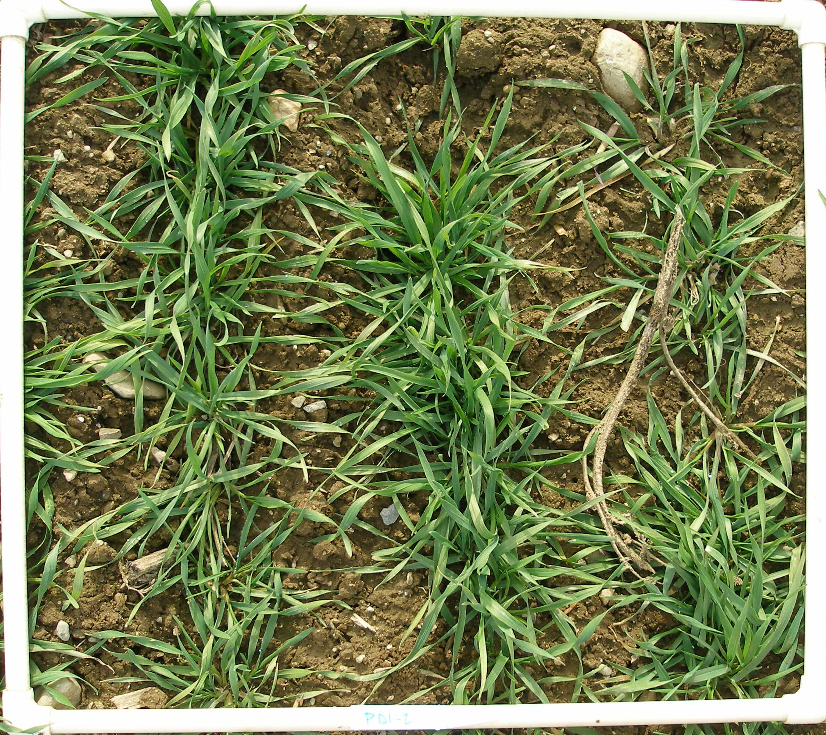Planted 9/18/2009
Cover crop establishment date
Pictures taken Nov 2009
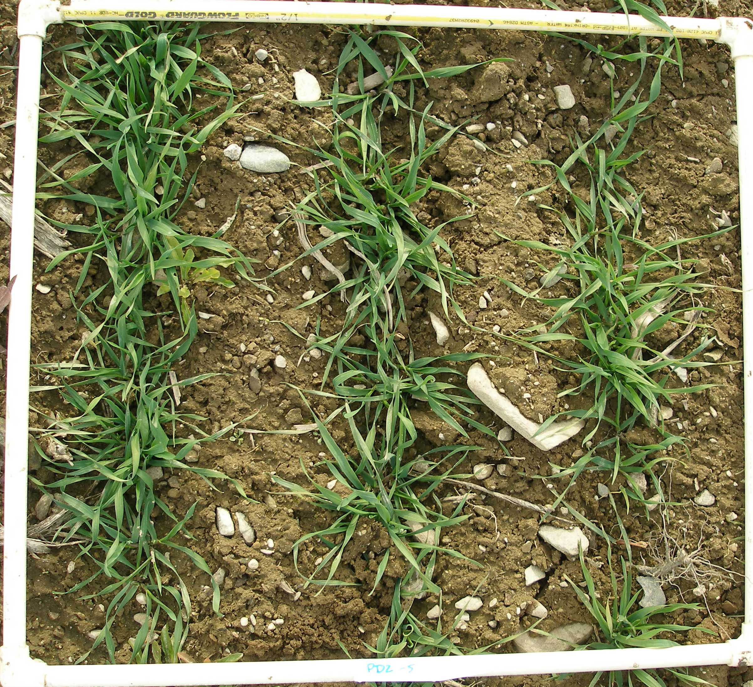Planted 9/22/2009

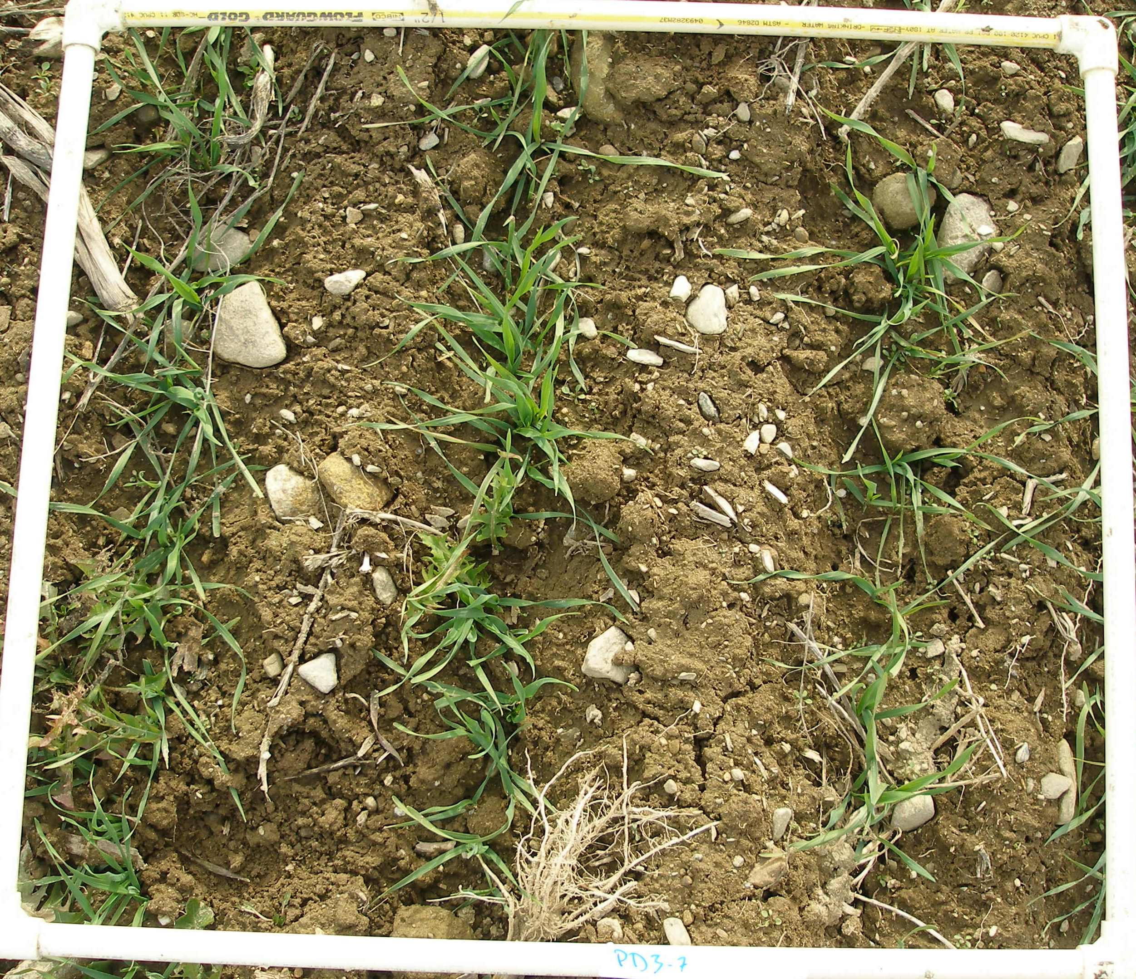Planted 9/28/2009

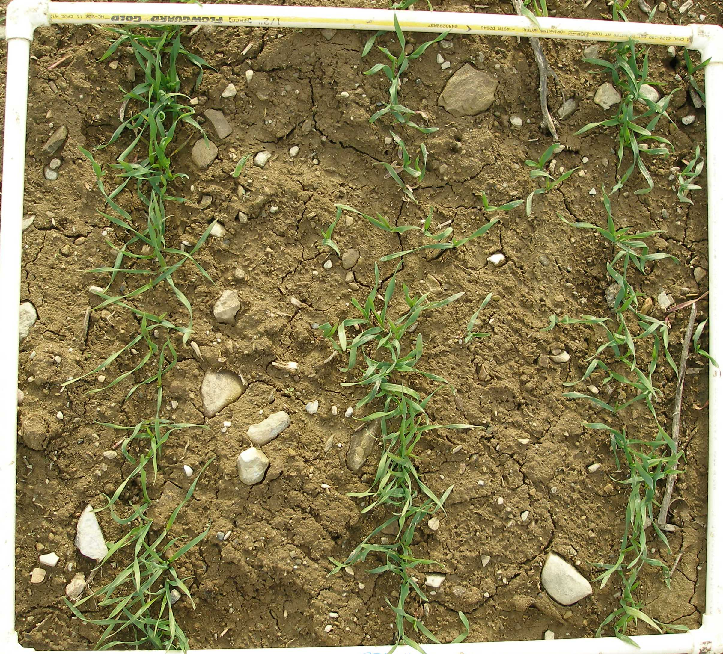Planted 10/12/2009

