Influence of Cultivation Method on Ammonia Volatilization and Corn Silage Yield Following Manure Application
Introduction
Nitrogen (N) management of corn fields is of increasing importance as the price of N fertilizer rises and as the negative impact of agricultural volatiles such as ammonia become better recognized. The time of manure application and the method of manure incorporation into the soil will influence both ammonia volatilization and therefore the amount of nitrogen available to crops. Preliminary research is intended to test a method of assessing ammonia volatilization as well as to look for differences among three combinations of manure application and tillage as affecting ammonia volatilization, soil N during the summer following spring manure application , and yield of a silage corn crop grown on the experimental field.
Materials and Methods
In the spring of 2010, a field at the University of Massachusetts Amherst Crops and Animal Research and Education Center (CAREC) in South Deerfield, MA, approximately 100 ft x 200 ft was selected for the experiment. The field did not have a history of manure application. Stubble had been left from corn grown the previous season. The field was subdivided into three 200 ft long strips, each approximately 30 ft wide. One strip was conventionally disked, one strip was cultivated with an Aerway® vertically to a depth of about 8 inches, and the third strip was left bare. At approximately 8:00 AM on May 27, 2010, liquid manure was spread uniformly by truck at a rate of about 6,000 gallons per acre. Immediately after application, the third strip of the plot was disked. At the same time, 12 ammonia collection units, four for each treatment, were set up on the field to measure ammonia volatilization. A depiction of the apparatus is shown in Figure 1. Each unit remained at one location for one hour, and then the jar collecting the ammonia was removed for N analysis. For the first 8 hours, the apparatus was moved hourly to another location within the plot. After 8 hours, units were placed on the plots for one hour periods four times over the following three days. Corn was planted in all plots on June 1. No additional fertilizer was used on the plots.
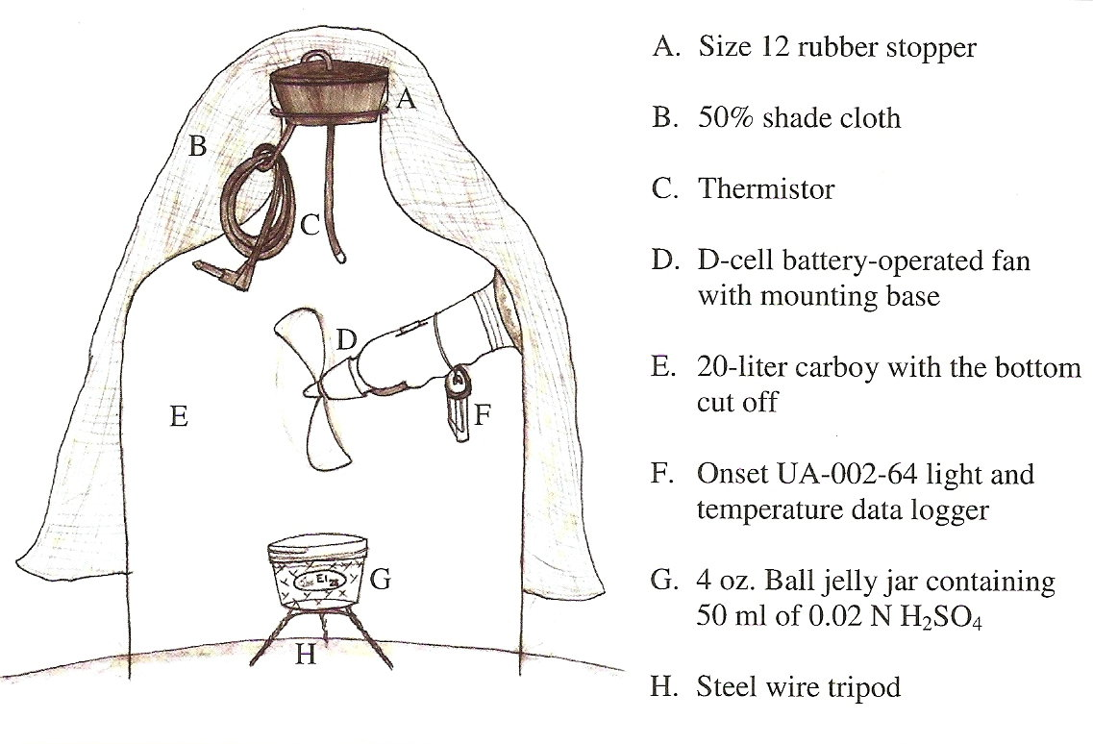
Figure 1. A depiction of the apparatus used to collect ammonia samples.
Ten foot sections of each plot were harvested on September 3, 2010 for yield evaluation. Ears and stover were separated in order to assess silage quality, as well as yield. In addition, stalk samples were taken for analysis to determine nitrate status of the plants.
Results
Manure analysis showed 19.1 lb N per 1000 gallons, of which 10.4 lbs was in the form of ammonia. This translates into 62.4 lbs ammonia N per acre. Figure 2 shows ammonia loss over the first 8 hours following manure application. The immediate disking of the manure in soil reduced loss of N through volatilization of ammonia. Volatility is increased by many factors including high temperature and wind. The day of application was hot with temperatures in the ammonia collection chamber ranging from 67ºF at the time of manure application to the mid-90’s by the 7th and 8th hours of ammonia collection. Afternoon temperatures also reached the low 90’s on days 2 and 3 following the manure application. For all three treatments, the greatest single hour loss of ammonia was during the first hour following manure application. Ammonia loss continued after 3 days, but the rate was always calculated as less than 0.5 lb N per acre per day by the third day following manure application. Measured ammonia N loss was up to about 5 lbs N per acre in the three days following manure application when no post-manure cultivation was used. This was reduced to 1 lb per acre when the field was disked immediately. Pre-application cultivating with the Aerway was better than conventional disking, but was not nearly as effective in preventing N loss as was post-application disking.
Figure 2. Influence of manure/ tillage combinations on
ammonia volatilization following manure application.
Table 1 shows yields of corn silage grown on the three application treatments. The middle (Aerway section) of the field had substantial weed problems which likely led to reduction of silage yield, as well as quality defined by earcorn percentage. CSNT result of less than 500 indicates that more N would have been helpful to the crop. The very low CSNT value of the Aerway plot may be related to the weed problem, as well.
Overall, silage yield and quality were best on the post-manure-application disked part of the field. Loss of up to 5 lbs ammonia-N loss out of 62 lbs ammonia-N applied per acre was documented over the first 3 days following application when manure was not incorporated.
Table 1. Yield characteristics of silage corn as influenced by manure incorporation method.
Method | Silage^{z}  Ton/ acre | Earcorn^{y}  Ton/ acre | Percent Ear  by dry weight | CSNT^{x}
Disk→Manure→Plant | 27.5 | 5.6 | 51.2 | 321
Disk→Aerway→Plant | 22.0 | 4.1 | 45.9 | 79
Manure→Disk→Plant | 28.1 | 5.9 | 52.7 | 1655
^{z} Silage yield adjusted to 70 percent moisture
^{y} Earcorn yield adjusted to 25 percent moisture
^{x} CSNT corn stalk nitrate-N concentration at harvest ( μg nitrate-N per gram stalk tissue)

