Univ. of Vermont, Entomology Research Laboratory
661 Spear St., Burlington, VT 5405-0105
Phone (802) 656-5440
Fax (802) 656-5441

November 22, 2010

Dear Grower;

How much could you save on energy consumption in your greenhouses?

What can we do to help YOU save money on energy use?

We all hate to complete surveys, BUT, this is not just another one to take up your time. Results will be used to develop programs that DIRECTLY meet YOUR needs. We received a Sustainable Agriculture Research and Education grant to encourage energy conservation among greenhouse growers in Maine, New Hampshire and Vermont. Our first step is to learn what growers’ energy demands are and what they are doing for energy conservation. Based on the survey results, we will develop strategies to help growers enhance energy conservation.

Please complete the enclosed survey by January 5. It is designed to take less than 8 minutes. When complete, place it in an envelope and mail it to us. Your answers will be confidential. We will send you a summary of the results in the future.
To show our appreciation, when we receive your completed survey, we will send you a copy of our “Greenhouse Manager’s Guide to Integrated Pest Management”.

Thanks very much!


Sincerely yours,

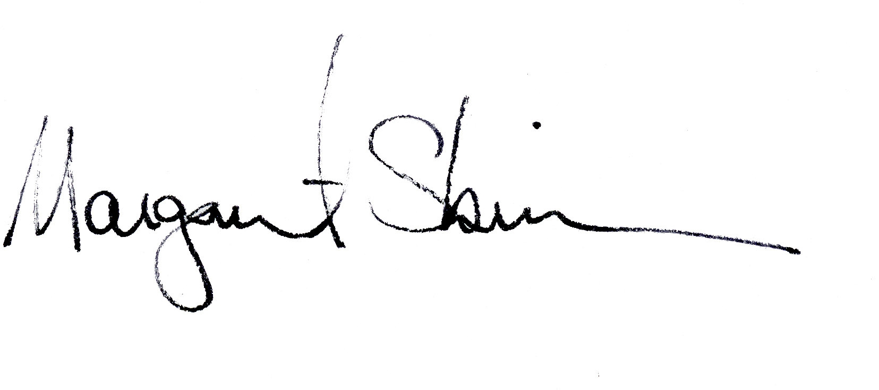
Bruce L. Parker

Margaret Skinner

This project is funded by the NE SARE Research And Education Program and UVM College of Agric. & Life Sciences with matching support from several public and private organizations.

Survey of Greenhouse Energy Use and Conservation in
Energy Conservation in Greenhouse Production in Northern New England

We are conducting this survey to determine energy use in greenhouses in ME, NH and VT and conservation measures growers take to reduce consumption. Research and outreach programs will be developed to meet grower needs based on the results. YOUR ANSWERS WILL BE TOTALLY CONFIDENTIAL.

1) What type of horticultural business or organization are you affiliated with and what is your position? (Check all that apply)

_____Retail vegetable grower ____ Wholesale vegetable grower ____Interiorscapes
_____Retail ornamental grower ____Wholesale ornamentals grower ____Cut flower grower
_____Landscaper ____Garden center: ____ Co/Owner
____ Head grower ____ Greenhouse worker: ____Univ. researcher
____ Research tech. ____Other (specify):___________________________________________

2) Where is your business or office located? (Check 1)
Maine New Hampshire Vermont Other (where?)
3) How many hired workers (equivalent to full time) do you employ?

None 1-2 3 - 4 5–6 over 6 (how many?) Not applicable
3) What percentage of your revenue comes from these greenhouse grown crops (% of total revenue)? Total should equal 100%.

Bedding plants | Flowering  potted plants | Foliage  plants | Perennials | Cuttings/Plugs | Cut flowers | Vegetables
Vegetable starter plants |  | Other: |  | Other:

4) How many square feet of greenhouse do you have?

1 – 10,000 10,001 – 25,000 25,001 – 50,000 50,001 – 75,000 75,001 – 100,000 over 100,000

5) What percentage of your total greenhouse space do you use each month over the year?

Jan | Feb | Mar | Apr | May | Jun | July | Aug | Sept | Oct | Nov | Dec

6) What kind of heating and cooling systems do you have in your greenhouses? (Check all that apply)

____ Oil fired heater
____ Propane gas fired heater
____ Wood fired heater
____ Pellet fired heater
____ Solar powered heater
____ Swamp cooler
______ Horizontal air vents
______ Geothermal heating syst.
______ Electronic thermostats
______ Horizontal air flow syst.
______ Manure heating systems
______ Wind generator system
_
______ Bottom heat
______ Biodiesel fired heater
______ None
______ Other (specify):_____________ ______ Other (specify):_____________
______ Other (specify):_____________

7) Approximately how much do you spend per year on fuel to heat your greenhouses?

Less than $10,000 $10,001–25,000 $25,001–50,000 $50,001–75,000 over $100,000

8) Approximately how much do you spend per year on electricity in your greenhouses?

Less than $10,000 $10,001–25,000 $25,001–50,000 $50,001–75,000 over $100,000
9) How many of these energy saving measures do you use in any one of your greenhouses? (Check all you use)

____ High efficiency boiler
____ High efficiency furnace
____ Insulation energy curtain
____ Oil heater
____ Solar water storage
____ Use DIF
____ High insulation plastic
____ Seal gaps around doors & vents
____ Electronic thermostats
____ Bottom heat
____ Horizontal air flow system
____ Geothermal heating systems
____ Energy efficient light bulbs
____ Wind generator
____ Bubble insulation system
____ Solar panels
____ Energy audit
____ Annual furnace/boiler checkup
____ Don’t grow cold sensitive plants
____ Remay covering over crops
____ Plastic covering over crops
____ Adjust planting dates
____ Grower cool-temperature plants
____ Side wall insulation
____ End wall insulation
____ Other type of heat storage:
____ Other (specify): __________

10) What limits you from improving your energy conservation? Rank each as follows: 1 = a little limiting; 2 = moderately limiting; 3 = very limiting.

____There are no limits (if you select this, select no others)

____ Too expensive to make changes
____ Negative impact on production (high humidity, etc.)
____ Don’t have time to make the changes
____ Don’t know what to do
____ Don’t know the cost benefits
____ Don’t know if I qualify for tax incentives
____ It is too complicated
____ Other:

____ Other:

11) What would most help you adopt more energy conservation measures? Rank each as follows: 1 = a little helpful; 2 = moderately helpful; 3 = very helpful.

____ Provide free energy audits
____ Provide tax incentives for energy conservation costs
____ Prepare/circulate fact sheets on energy conservation
____ Set up energy conservation demonstration programs
____ Hold educational workshops for growers
____ Assistance with learning of available incentive programs for energy conservation
____ Establish a professional energy advising service
____ Conduct efficacy trials and publish the results
____ Provide computer links to communicate problems
____ Other:

12) What research/information is needed to help you implement more energy conservation measured? Rank items below as follows: 1= low need; 2= moderate need; 3= great need.

____ Cost benefit analysis
____ Energy saving benefits
____ Negative production aspects (humidity, access, etc.)
____ Production guidelines that reduce energy use
____ Degree day monitoring
____ Other:

THANK YOU FOR YOUR ASSISTANCE!

Please place this in an envelope and return it to:

Cheryl E. Frank, Entomology Research Laboratory
661 Spear Street, Burlington, VT 05405-0105

Additional comments are most welcome:

If you would like a free copy of the “Greenhouse Manager’s Guide to IPM”,
where should we send it?

Name:

Address:

