Making Your Compost/Mulch Product Work for You!

FREE Compost/Mulch Marketing Workshop

Friday, January 28, 2011

Whether selling compost or mulch is your primary business or a side business, this workshop is for you! The workshop will provide marketing insights and sales techniques, including technical information on compost applications and benefits, feedstocks, quality standards, and marketing principles. Learn tips on developing a marketing plan for your compost/mulch operation, how to position your product, the ins-and-outs of compost market segments, bulk sales vs. bagged, distribution strategies, and making money on tipping fees. Sales strategies will also be covered, including sales points, using social media and new media techniques, branding, and customer education tips.

Registration is $20; $10 for NOFA NJ Conference registrants. Registration is limited…so register early! Register online at Northeast Organic Farming Association of New Jersey (http://nofanj.org/wc_preconference.htm).

When: Friday, January 28, 2011 from 9:30 am – 4:00 pm

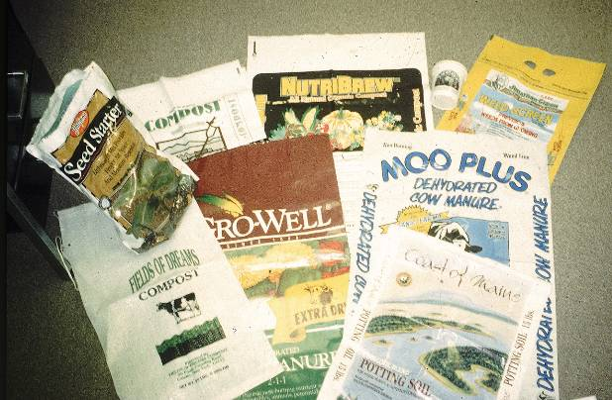
Where: Coach Barn Garage
Duke Farms
Hillsborough, NJ
Presenters:
Michael L. Westendorf, Ph.D., PAS
Extension Specialist in Animal Sciences
Rutgers University
http://animalsciences.rutgers.edu/

Loren S. Muldowney, M.S.
Staff Scientist Rutgers/NJAES Soil (and compost!!) Testing Lab
http://njaes.rutgers.edu/soiltestinglab/

Frank Kerns
JH Reid Recycling
www.jhreidgc.com

Erich V. Bremer, Supervisor, Organic Certification Program
New Jersey Department of Agriculture, Division of Marketing and Development
www.state.nj.us/agriculture/divisions/md/prog/jerseyorganic.html

Athena Lee Bradley, Projects Manager
Northeast Recycling Council, Inc.
www.nerc.org

Sponsors
Northeast Recycling Council, Inc. • Northeast Organic Farming Association of NJ •
New Jersey Department of Environmental Protection

For more information, contact Athena Lee Bradley at 802.254.3636 or by email at athena@nerc.org. Funding for the workshop is from the Northeast SARE (Sustainable Agriculture, Research, and Education).

