Making Your Compost Product Work for You!
FREE Compost Marketing Workshop/Field Day
Millerton, New York

Sponsored by the Northeast Recycling Council, Inc., New York State Department of Environmental Conservation, SUNY Cobleskill, and Cornell Waste Management Institute

Whether selling compost is your primary business or a side business, this workshop is for you! The workshop will provide marketing insights and sales techniques, including technical information on compost applications and benefits, feedstocks, quality standards, and marketing principles. Learn how to develop a marketing plan for your compost operation, how to position your product, the ins-and-outs of compost market segments, bulk sales vs. bagged, distribution strategies, and making money on tipping fees. Sales strategies will also be covered, including sales points, using social media and new media techniques, branding, and customer education tips.

The workshop is free, but all attendees must register in advance. To register or find out more information, contact Athena Lee Bradley at 802.254.3636 or by email at athena@nerc.org. Lunch provided.

When: Tuesday, March 30 from 9:30 am – 4:00 pm

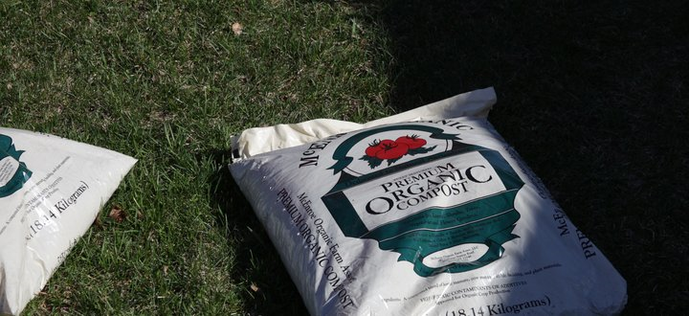
Where: McEnroe Organics
5409 Rte 22
Millerton, New York

Presenters:

Jean Bonhotal, Associate Director
Cornell Waste Management Institute
http://cwmi.css.cornell.edu/

Athena Lee Bradley
Northeast Recycling Council
www.nerc.org

Ray McEnroe
McEnroe Organics
http://www.mcenroeorganicfarm.com/

Funding for the workshops is from the Northeast SARE (Sustainable Agriculture, Research, and Education).

