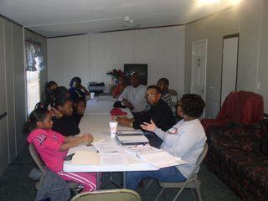
The project process started with the development of a project plan to include the youth, young adults and senior from within the community.

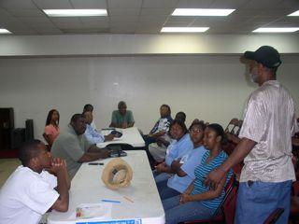
Students taking part in a farmers market planning meeting in Uniontown, Alabama.

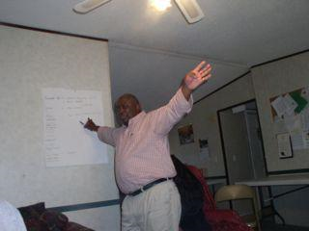
Andrew Williams, a retired USDA employee, lives in the community and serves as project director. Here, he is engaged in the strategic process.

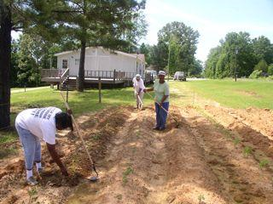
The seniors of the community enjoyed the project as well, and it gave them an opportunity to be physically engaged.

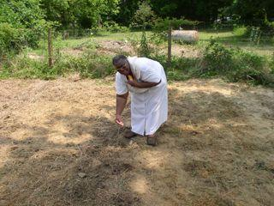
TUCCA provided outreach to other communities. Here, Mrs. Mackie Cowort of Union Springs, AL is planting in her garden which was prepared by TUCCA staff.

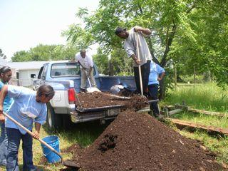
Students learn the use of organic soil amendments as opposed to chemicals that are harmful to the body.

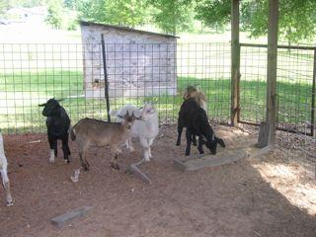
Goat production was a part of project training as it relates to farm raised meats.

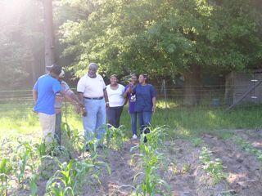
Rev. Lacornia Harris, president of TUCCA, provided instruction to young adults concerning how God created the land to produce food for people.

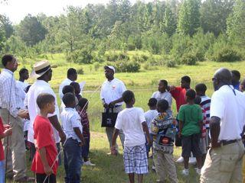
This project was about creating awareness among young African American boys to ensure that they understand the natural resources of the community.

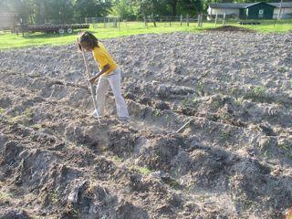
The use of hand tools and the culture associated with food production was acknowledged and practiced such as getting up early and enduring the heat and bugs.

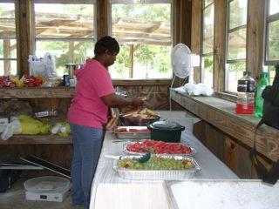
Food preparation and nutritious food from the land was at the forefront of this project.

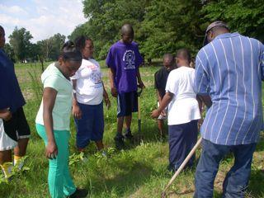
During the project process, adults taught the youth how to harvest produce.

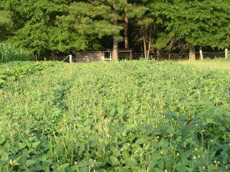
In this project row spacing according to crop variety was stressed in an effort to teach the use of land for food production according to the square foot.

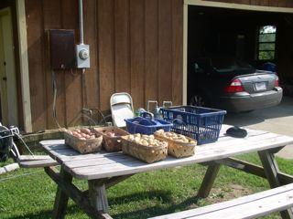
Youth and youth and young adults learn how to package produce to sale and to give away to families in the community.

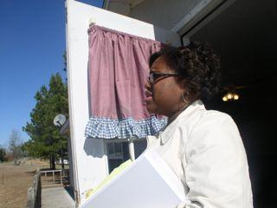
This project involved young adults in the project process management. Keisha Turner-Abrahams, who has her Juris Doctorate, served as the project administrator.

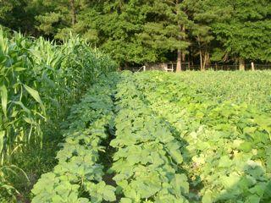
The Taylor Community made an effort for youth and young adults to learn how to grow a variety of food crops organically.

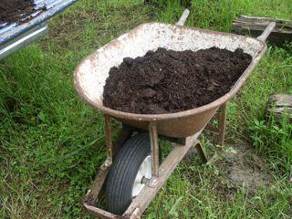
Compost is a good soil amendment to help the soil become “alive” for plant growth. Producing food organically provides safe food for families.

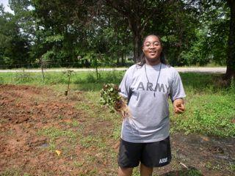
Student farmer participating in transplanting sweet potato seedlings.

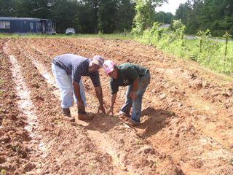
Father teaching daughter how to prepare soil for planting vegetable crops.

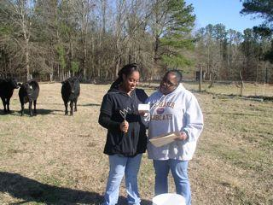
Testing the soil is the first step in the preparation of food production. Here Breanna Tucker receives instruction from Keisha Turner-Abrahams on how to send soil samples.

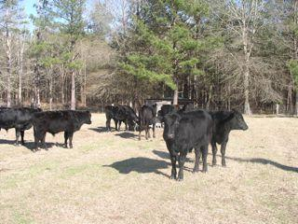
Livestock was a part of the learning process as well. Here, such beef products will be used as a part of the community food process.

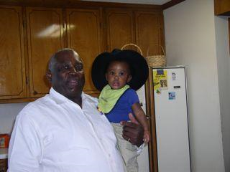
Making sure that the land in the community is still available for use by the next generation was the main focus of the project. Here, the project director “passes the hat” on to his grandson, Nicholas, II.

