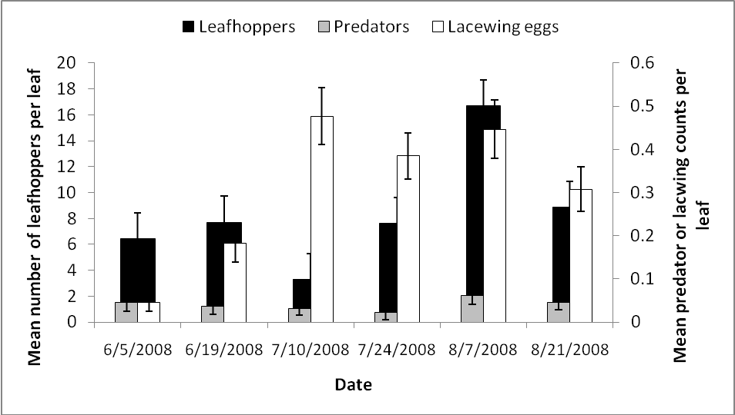
Fig. 12: Mean (± SEM) number of leafhoppers, predators and lacewing eggs counted during visual inspection of 10 leaves per experimental plot every two weeks from June 6th through August 21st, 2008.

