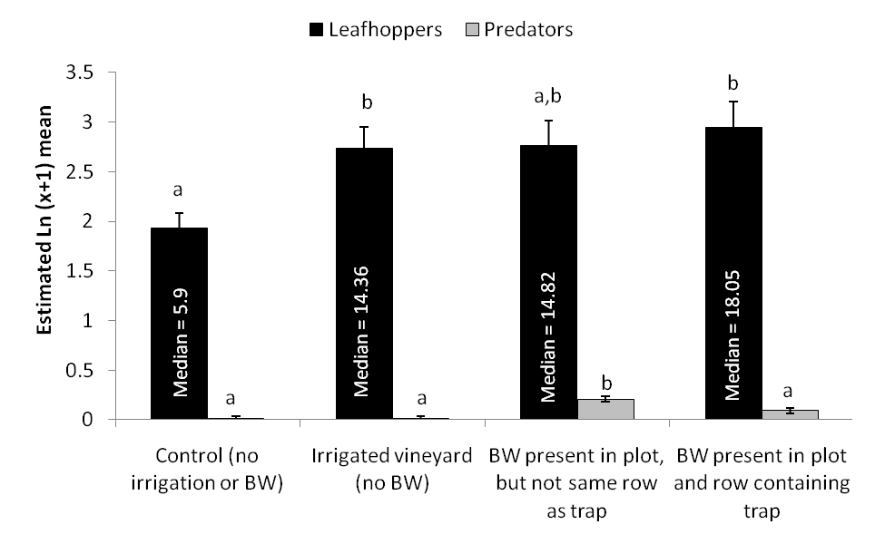
Fig. 13: Estimated mean (± SEM) number of leafhoppers and predatorys counted during visual inspections of grape leaves in four treatments in a vineyard during August 2008 (BW = buckwheat; bars contains back-transformed median counts per leaf; different letters indicate signficant differences [p < 0.10] between treatments).

