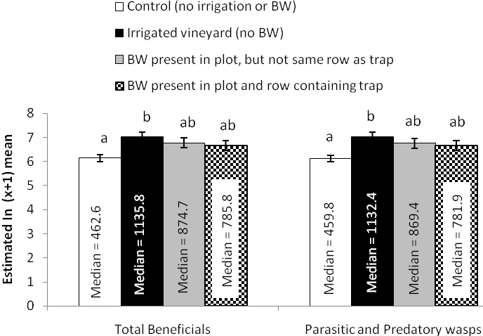
Fig. 8: Estimated mean (± SEM) number of beneficial insects and parasitic and predatory wasps counted on sticky traps deployed in four treatments in a vineyard during July 29th, 2008 and August 12th, 2008 (time period 4) (see Fig. 7).

