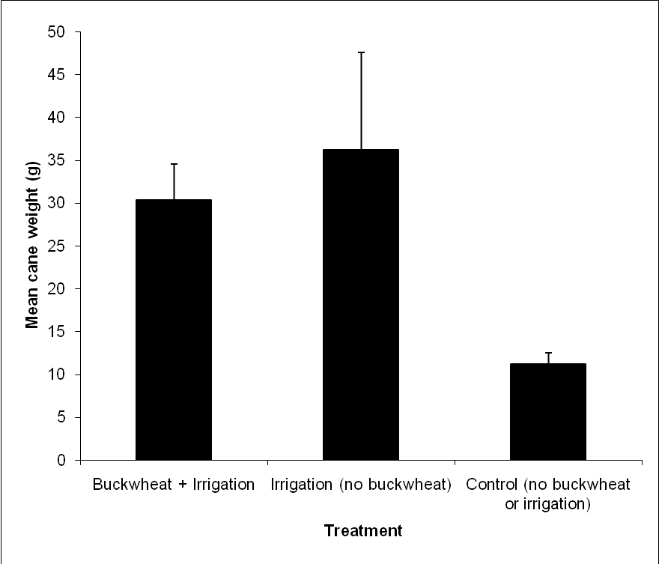
Fig. 16: Mean cane weight per vine when canes were removed in October 2008 from three vines located in each treatment.

