1 Project Name and Contact Information.

Evaluation of Southern Peas as Cash Cover Crop in Pennsylvania. FNE08-625

Final Report

Michael J. Byers
Demeter’s Garden
203 Chestnut Street
Spring Mills, PA 16875
814 571 8247
mjbyers@aol.com

2. Goals.

The goal of this project is to evaluate southern peas (common names, cowpeas, black-eye peas, crowder peas, etc.) as an income producing crop also capable of increasing nitrogen availability in the following planting year. Increased nitrogen availability will reduce fertilizer costs for small organic farms without an on-farm source of animal manure. Three varieties of southern peas will be evaluated with regard to season suitability, yield and market acceptance.

3. Farm Profile.

Demeter’s Garden is a certified organic raspberry and produce farm located on 25 acres in Centre County, PA. Mike and Virginia Byers have operated this farm part time for seven years gradually adding other small fruit such as gooseberries, red currants and black currants as well as specialty produce (okra). Yield from these plantings is marketed through farmers’ markets in Centre County as well as being processed into value added products like jam, jellies, syrups and baked goods. Mike also operates an apiary and markets honey locally and throughout PA and the NE. In 2008 a small hop planting was established with the intent to supply local brewpubs. A modest inventory of equipment (tractors, tillage, sowing, mowing, and cultivation) is used in support of these crops.

4. Participants.

Dr Elsa S. Sanchez, Dept of Horticulture, 202 Tyson Building, University Park, PA 16802. Dr Sanchez’ current research work includes compost application rates in organic crops and methods to reduce weed pressure including cover cropping. She contributed to the project design and randomization.

Chef Mike Ditchfield, Pennsylvania College of Technology. Chef Mike participated in discussions concerning the marketability of southern peas and their use in restaurants.
- Project activities

A test plot measuring 200 feet by 100 feet was selected in a field previously used for sweet sorghum production. Soil samples were taken from 5 areas within the plot and combined within the area and sent for soil analysis and fertilization recommendations.

Four replicate plantings of three varieties of southern peas were established. For each variety (Texas Pinkeye Purple Hull, California 46, and Cream 40), five 100 ft contiguous rows (36’ apart) were planted in each replicate block. Planting location within blocks followed a randomization provided by Dr. Sanchez. Planting date was June 9, 2008 and rate was 30 lbs/acre. Depth was 1.5 inches. A John Deere 290 planter with bean plates on the slowest setting was used to deliver seed at approximately 5’” spacing in the row. Plants emerged on 6/16/08 and were cultivated twice beginning on 7/9/08. Plant population for each variety was determined by counting plants within multiple 18” strips, determining an average and multiplying by 10,000. Hand weeding commenced 7/25 and continued through 8/9/08. Pea harvest commenced 8/16/08 (Texas Pinkeye) and finished 10/3/08 (Cream 40). Remaining vegetation was plowed under 10/15/08. Each replicate variety was picked, the peas weighed, shelled (using a Model 675 “Little Sheller” from Taylor Manufacturing Company, Moultrie, GA), and the shelled peas weighed. Shelled peas were packaged in 1lb bags for sale at market. Excess peas were washed and packaged in 3 lb bags and frozen.

- Results.

Mechanical problems with the planter resulted in skips for 2 replicates. Cultivation “mishaps” produced additional gaps in the rows. A correction factor was applied to the yield data from these replicates in order to provide comparison to a common area. Considerable variation in yield for all varieties was seen across the replicate plots. The D plot had the highest yield for 2 varieties and the B plot had the lowest yields for 2 varieties.
Table 1. Plant Population and Yields of Pods and Shelled Peas
 |  | Variety
 | Texas Pinkeye | Cream 40 | California 46
Plants/acre | 66667 | 80000 | 70000
Replicate
A | 37.9/13.96 | 39.80/18.70 | 32.85/17.43*
B | 20.72/7.09 | 21.07/10.20* | 24.61/11.09*
C | 29.54/9.65 | 21.24/9.90 | 16.2/7.72
D | 85.43/32.94 | 30.75/14.5 | 31.32/14.06
Total pod (lbs) | 173.59 | 112.86 | 105.05
Total Shelled (lbs) | 61.74 | 53.20 | 50.30
Shellout (%) | 35.6% | 47.3% | 47.6%
Shelled peas (lbs/acre) | 494 | 426 | 402
*corrected for missing rows

Table 1 lists the essential findings of the project. Little difference in shelled pea yield was seen within the varieties chosen. Shellout percentage was lower for Texas Pinkeye, confirming the observation that these pods were slightly fleshier. The yields per acre are about 50% of values reported in literature from southern universities.

No appreciable difference in nitrogen levels were seen in soil tests taken in the spring of 2009as compared to tests taken prior initiation of the project. However, sweet sorghum planted in 2009 in an area that included the 2008 test plot showed visual differences in the “green” in the first month of growth.

7. Conditions

May 2008 was cold and wet. These conditions delayed direct planting activities until June 9. We expected to have seeding complete by third week in May. However, this delay in planting resulted in a harvest delay of only 1 week based on our previous small trial in 2007. On the positive side, the delay in planting probably contributed to the quick emergence (7 days).

8. Economics

Seed costs were less than estimated ($70 vs. $140) as a result of identifying bulk seed sources in the South. Harvest labor was about as estimated, requiring about 4 hours on each of 14 picking days to pick and shell peas. The purchased pea sheller worked very well, exactly as advertised. Capacity was 2-3 bushels of pods (50-75lbs) per hour. We also found that the sheller works well with garden peas, broad beans and edamame. Fifty two percent of the actual yield of fresh shelled peas were sold a local farmers market for $3.00/lb (bagged but not cleaned of snaps, etc.) for total of $240. About 10% were sold as frozen peas in 3lb package at the market (after the picking season). The remaining inventory was sold frozen to a restaurant at $2.50/lb. Total proceeds were $422.50 per 0.5 acre of peas.

9. Assessment

The most significant observation at this point in the project is that we completely missed the importance of inoculating the pea seeds prior to planting. The test plot had been in grasses for several years prior to the trial; and cowpeas require a specific inoculant that differs from inoculants used for soybeans or alfalfa. By 2 weeks after emergence the pea plants showed signs of choriosus (yellowing) that continued for 6 weeks. Having the appropriate Rhizobium in the root zone would most likely have increased the yield.

Weed control is also very important. Use of early mechanical weeders such as a rotary hoe would have reduced the amount of hand weeding.

10. Adoption

Even without knowing if the nitrogen availability in the test plots is improved we are planning to plant peas again in the spring of 2009 and incorporate them into our rotation. The peas were well received by our market customers.

We have planted southern peas in both 2009 and 2010. We have inoculated seed both of these years, and have seen no chlorosis. Plant height and vigor were increased over the 2008 crop. In 2009, seed for one of the test varieties was not available and a semi-vining variety was substituted. The rows of this variety grew together and became impossible to walk thru after the initial picking. This experience emphasizes the importance of testing small amounts of various varieties to identify those that show the best performance in each farm local.

Customer response remains positive. We start getting request for peas in July and some customers buy peas in bulk to freeze. We intend to continue including southern peas in our crop rotations.

11. Outreach

We prepared a handout containing nutritional information and recipes for black-eyed peas that were given to customers at the farmers market. In August 2008 we participated in the Centre County Farm Tour organized by PASA. We hosted 85 visitors in a 4 hour time span. The handout described above was available as well as tours of the research plot although the crop was not mature at the time of the tour. Web advertisements for the weekly market as well as the farm tour highlighted the availability of peas.

Several pea recipes were prepared for a benefit luncheon. Tasters were polled regarding their experience. All of those polled indicated and interest in purchasing peas.

The complete project report was presented in Poster format at the 2009 farm tour and also at the 2009 PASA Conference. For the 2010 farm tour recipes were prepared for tasting by attendees.

12. Summary

The goal of this project is to evaluate southern peas (common names, cowpeas, black-eye peas, crowder peas, etc.) as an income producing crop also capable of increasing nitrogen availability in the following planting year. Four replicate plantings of three varieties of southern peas were established at a population of 70,000 plants/acre following soil tests. Picking commenced August 16 and continued for 6 weeks. Peas from each replicate were weighed after picking, shelled using a Taylor Little Giant pea sheller and the shelled peas weighed again. Texas Pinkeye was the earliest variety and had the greatest yield.

Overall shelled pea yield was 151 lbs which were sold at farmers market or to restaurants at average of $2.75/lb. Some customers were familiar with fresh black-eye peas and were pleased to find in the market. Others unfamiliar with the products that purchased peas made additional purchases. The product was well received. No appreciable difference in soil nitrogen in the plot was detected in soil test taken the following spring. The labor required for harvesting and shelling and the need for weed control are negatives.

Michael J. Byers
January 27, 2011
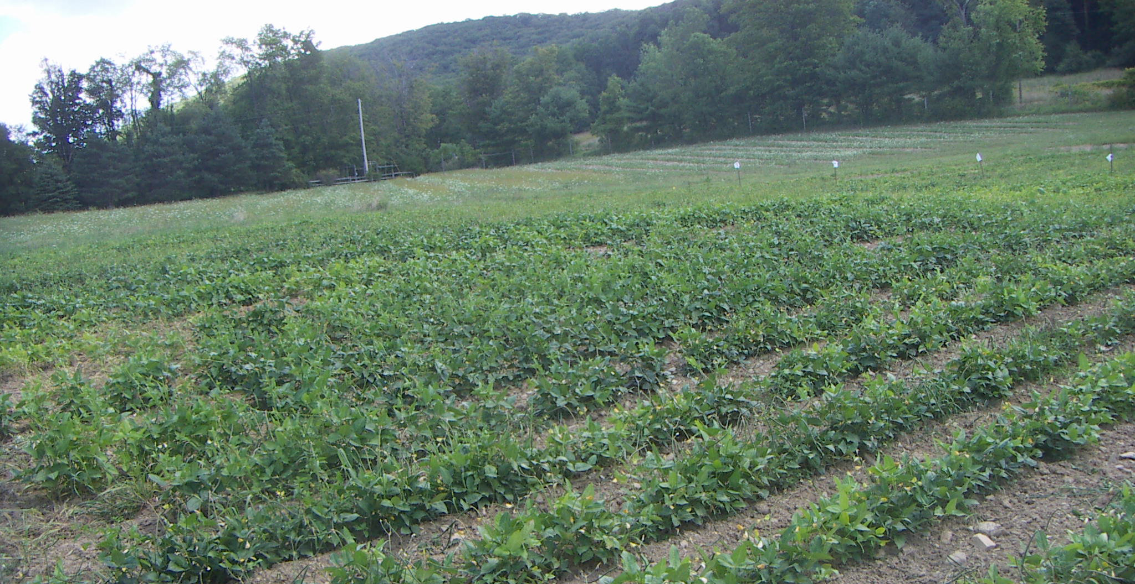
Figure 1. Replicate Plots, mid bloom, early August

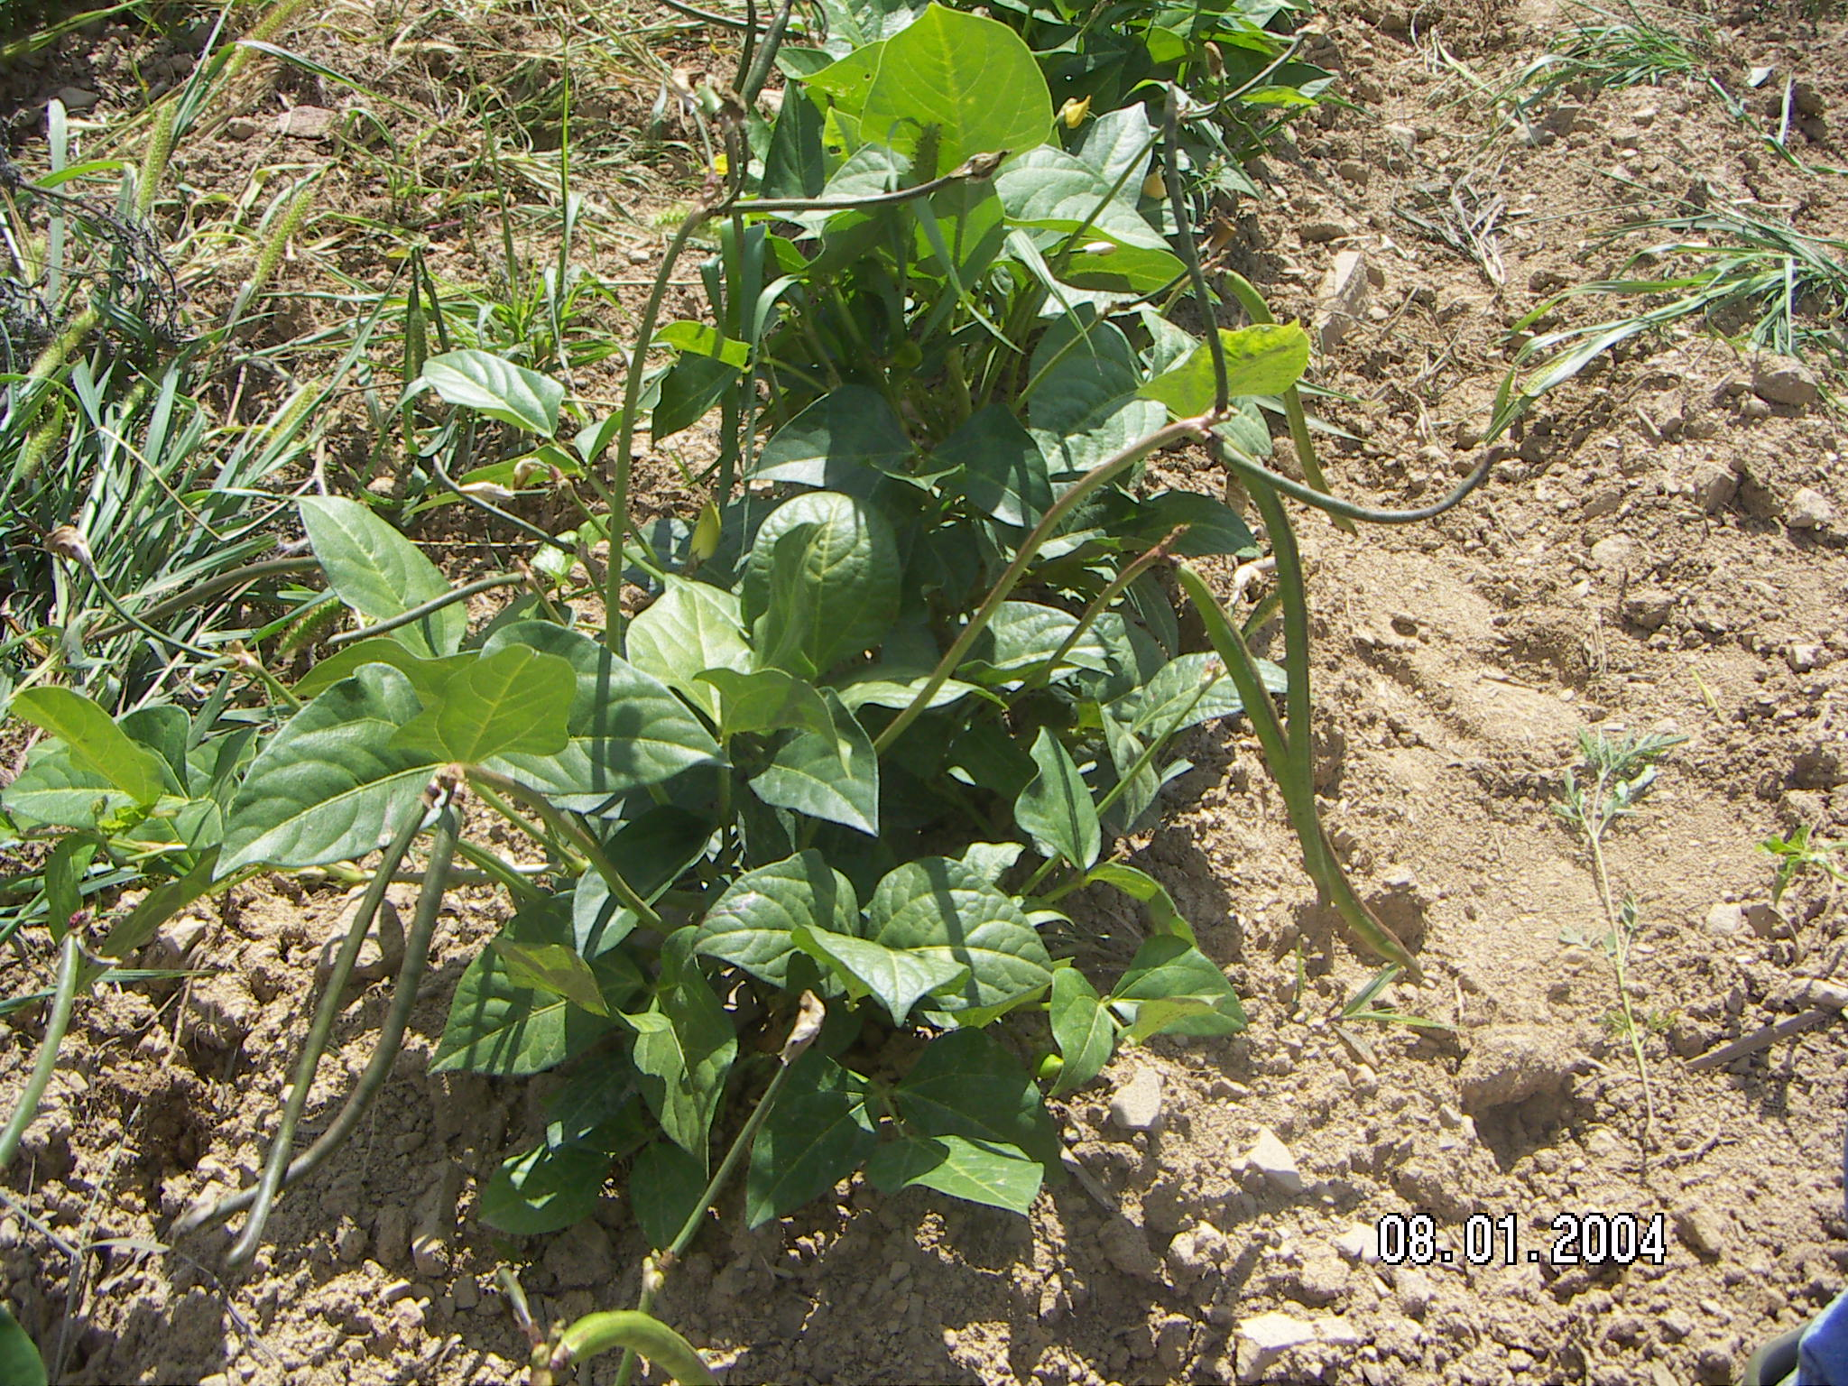

Figure 2. California 46. Pod set on runners, other varieties made few runners

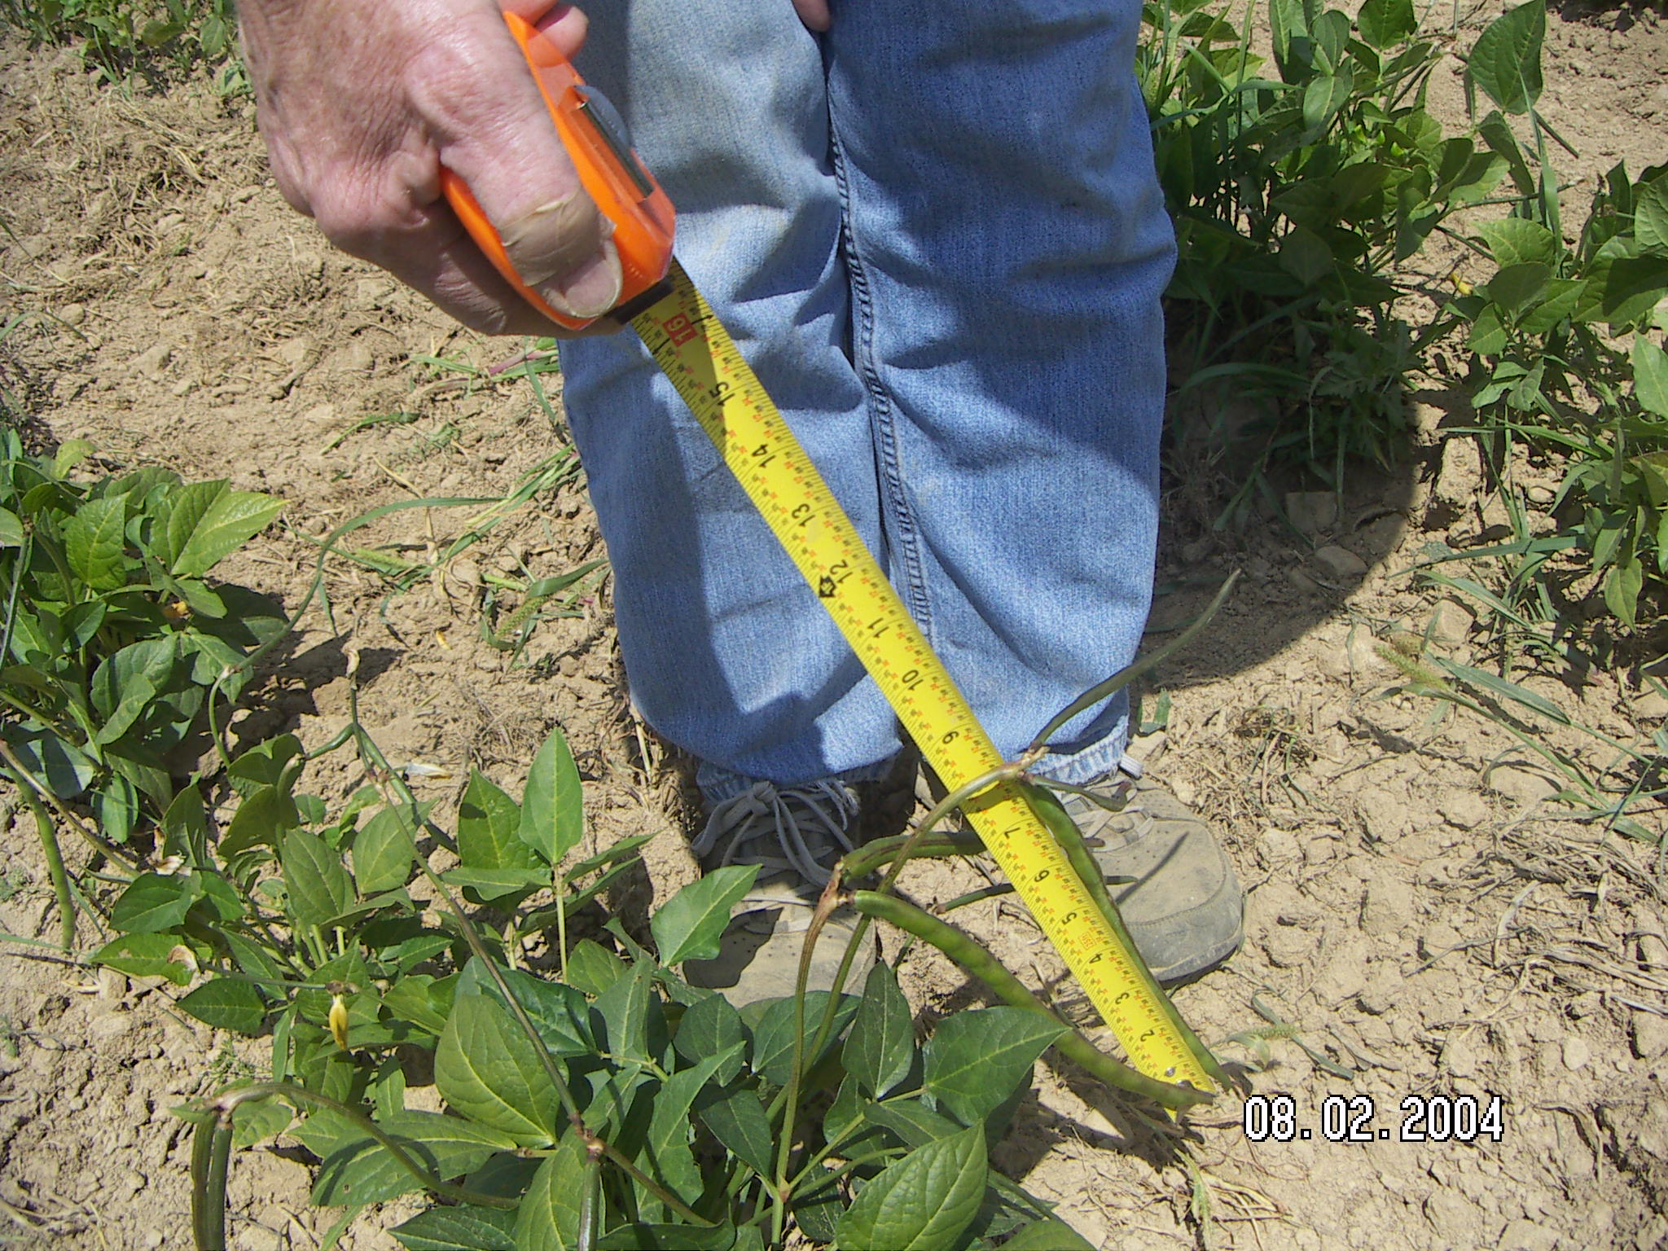

Figure 3. Pod length8-10 inches on all varieties

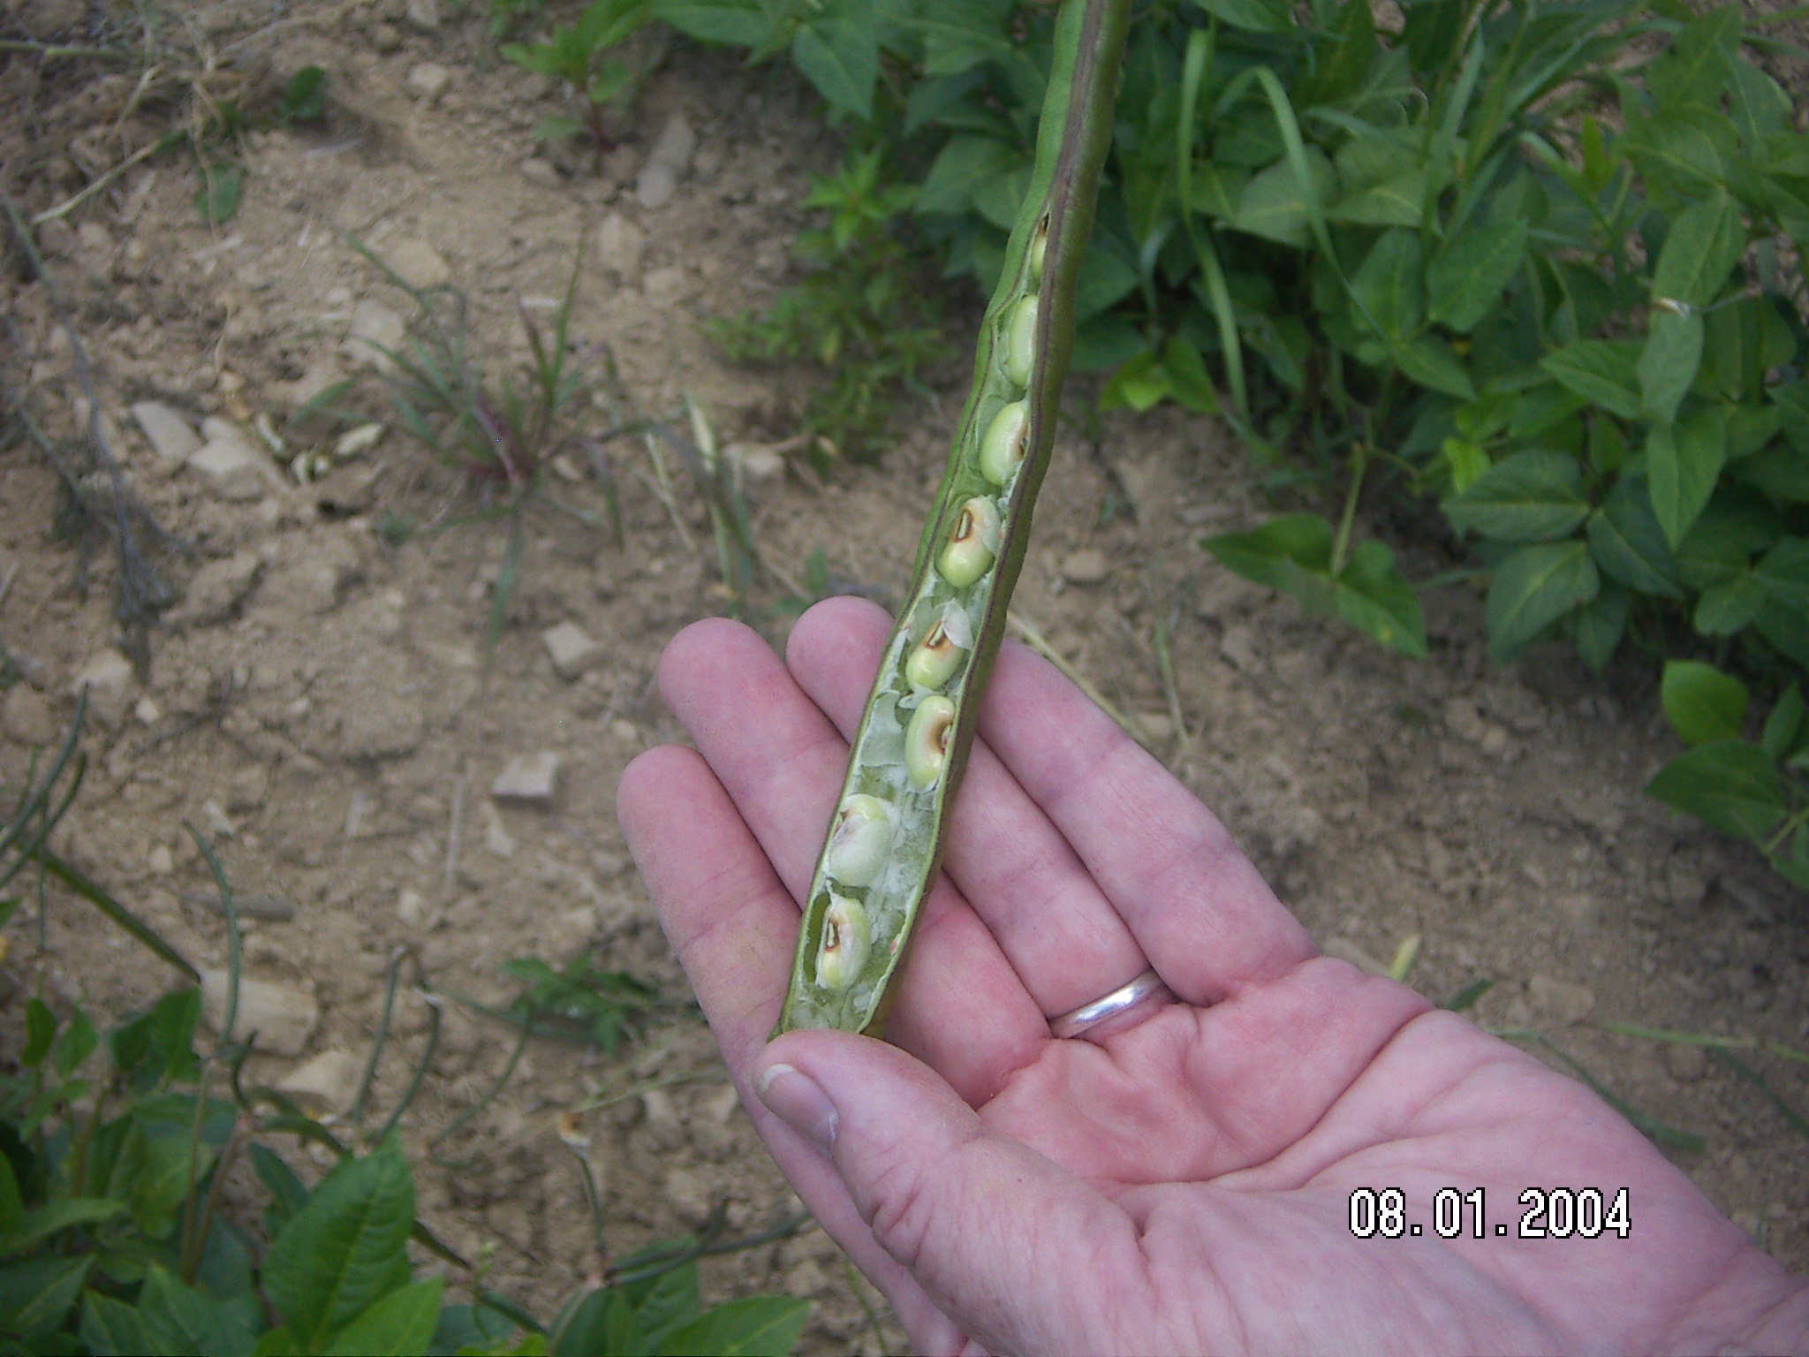

Figure 4. Ten to 12 peas per pod

