Variable yield goal manure management strategy
Site Yr I
Site Yr II
Site Yr III
Site Yr I
Site Yr II
Site Yr III
Site Yr I
Site Yr II
Site Yr III
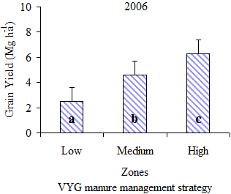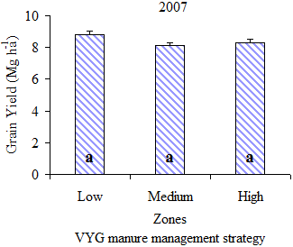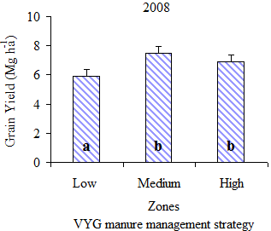
Constant yield goal manure management strategy
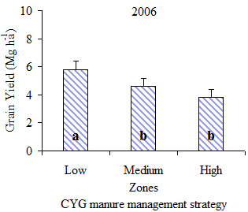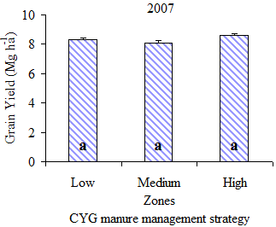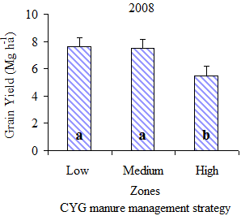
Variable yield goal N fertilizer management strategy
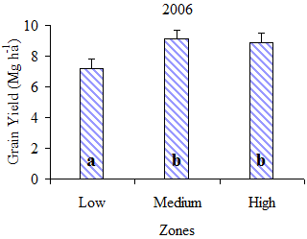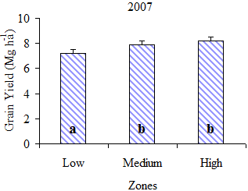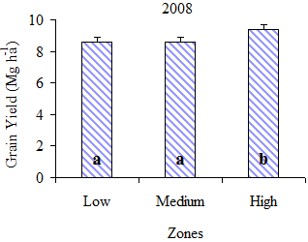
Figure 1. Mean grain yield across low, medium and high management zones for variable yield goal manure, constant yield goal manure, and variable yield goal N management strategies under limited irrigation conditions. Within a site-year, bars with different letters are significantly different at P ≤ 0.05 level of significance.

