St. Lawrence County
Agriculture plastics
recycling project

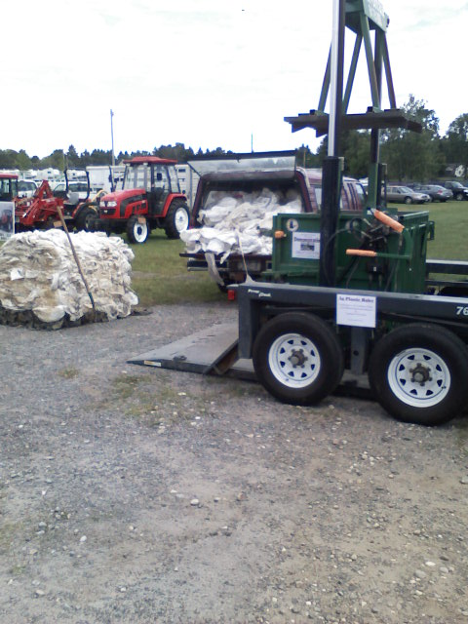
Baling Ag Plastics at the St. Lawrence County Farm

northeast sare partnership grant
Final Report

March 1, 2011

