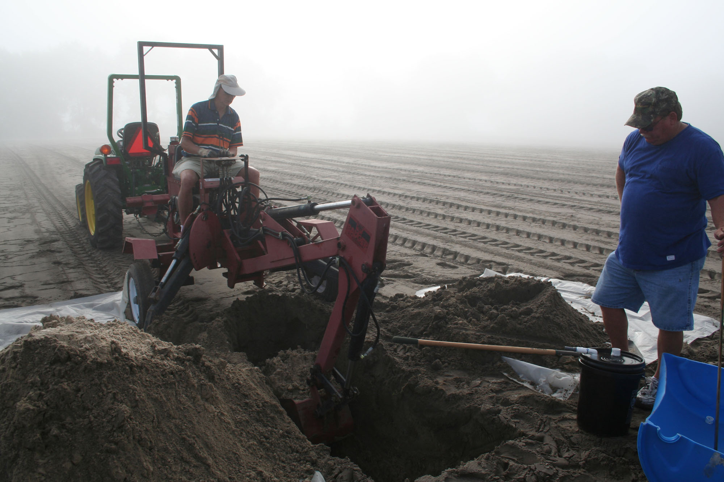
Figure 2. Lysimeter installation on the Hoover Farm near Live Oak, FL on October 16, 2008. Shown are Eric Simonne (Professor, Horticultural Sciences, University of Florida on backhoe) and Mike Alligood (Biologist, University of Florida).

