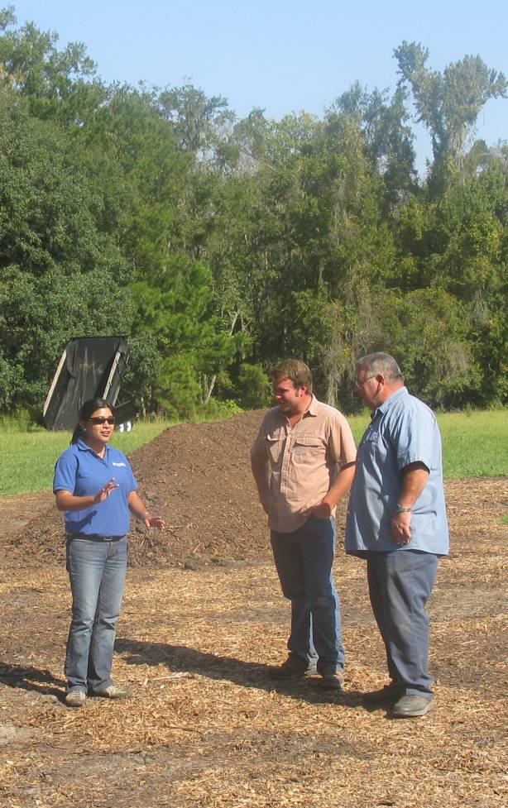

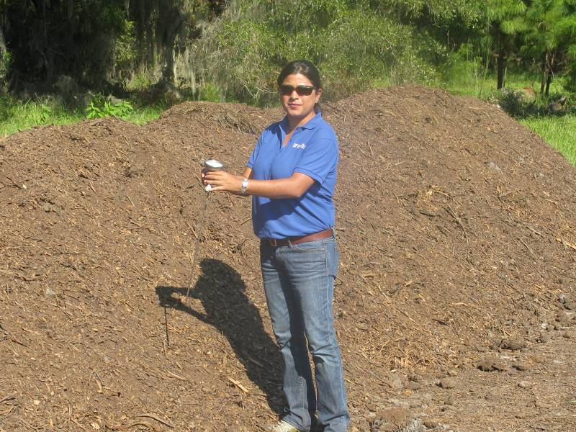
Figure 3. UF-IFAS Suwannee County Extension agent Elena Toro visits with Bradley Hoover Jr. and Brad Hoover Sr. (left to right) at the Hoover Farm near Live Oak, FL. Pictured is the farm’s composting operation.

