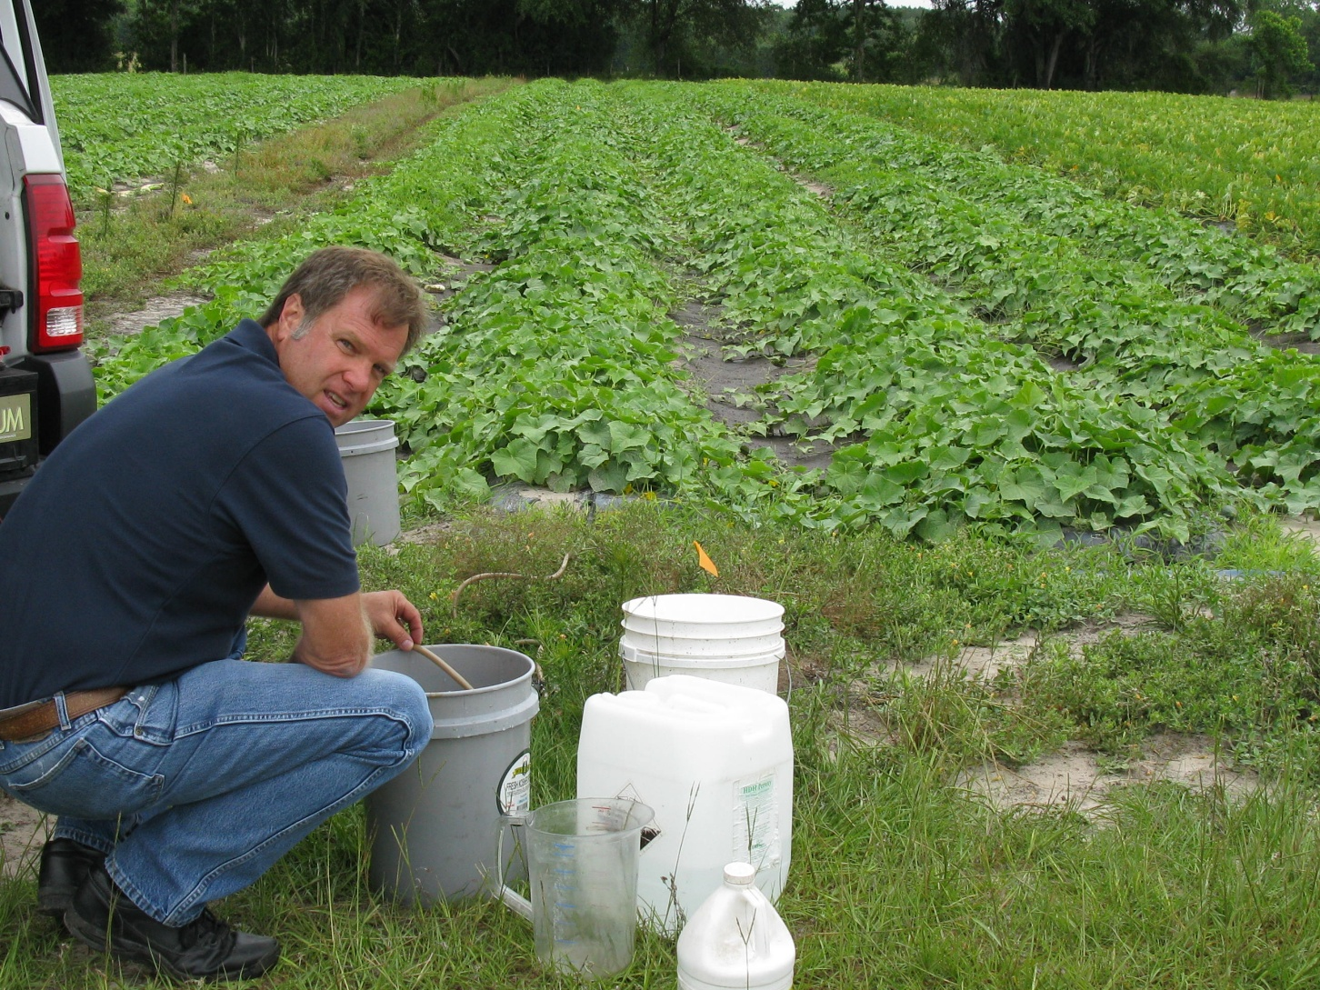
Figure 4. UF-IFAS North Florida Research and Education Center – Suwannee Valley Multi-county vegetable production agent Bob Hochmuth collects leachate from a drainage lysimeter on the Hoover farm near Live Oak, FL.

