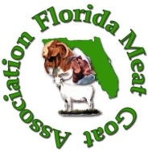
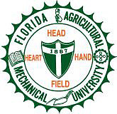
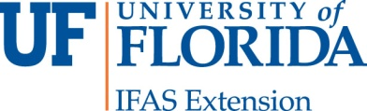

Florida Meat Goat Feasibility Study: Farmers Survey

Dear Producers,

In an effort to better understand the meat goat industry in the state of Florida as it relates to farmers, vendors and consumers we are asking for your participation in answering a few questions on this farmer’s survey. This survey was developed by the Florida Meat Goat Association, the University of Florida – IFAS Extension and Florida A&M University’s, Cooperative Extension Program. This feasibility study was funded by Southern SARE, the Producer Grant Program. Your responses to this survey are very important and will help in advancing research and educational information on marketing of goats in this state.

This is a short survey and should take you no more than 10 minutes to complete. Please click on the link below to go to the survey or copy and paste the link into your internet browser.

Survey link: (They can paste their own website link here)

Your participation in this survey is voluntary and all of your responses will be kept confidential. No personally identifiable information will be associated with your responses in any reports of this data. Should you have any questions or comments, please feel free to contact me at ritapruette@yahoo.com, angela.mckenziejakes@famu.edu or Nola.Wilson@marioncountyfl.org.

We appreciate your time and consideration in completing the survey. Thank you for participating in this feasibility study. It is only through the help of farmers like you that we can collect the much needed data to help the Florida Meat Goat Industry flourish as a vital component of Florida’s agriculture industry.

Many Thanks,

Rita Pruitt, SARE grant recipient, farmer, Meat Goat Association member
Helen Hill, President Meat Goat Association
Angela McKenzie-Jakes, FAMU Cooperative Extension Program
Nola Wilson, UF/IFAS Extension Service

