SARE PARTNERSHIP GRANT: ONE08-092

FINAL REPORT

TITLE: Low input management practices for container ericaceous nursery crops

Image 1: Plant growth of azalea SS cultivar as affected by P. cinnamomi in various treatments.
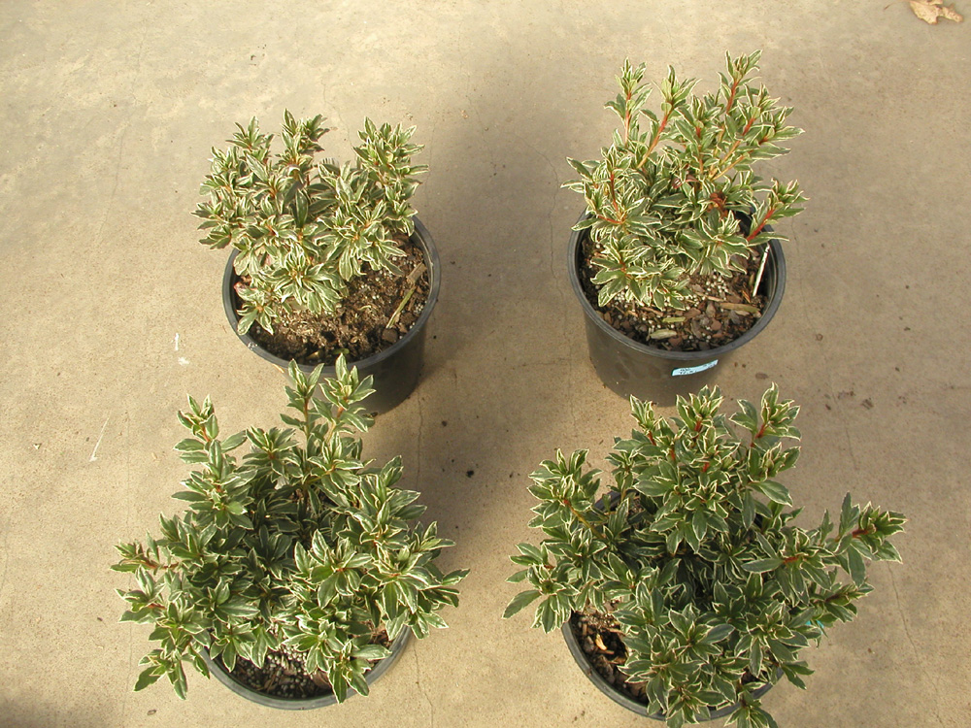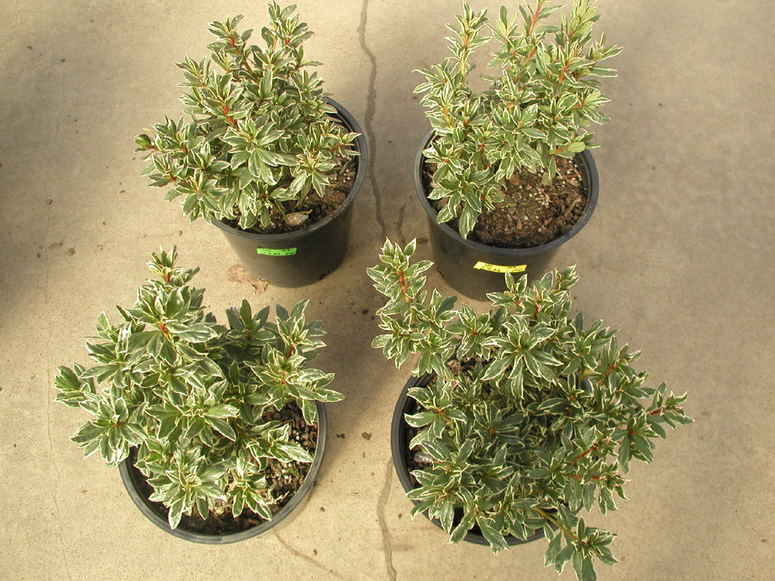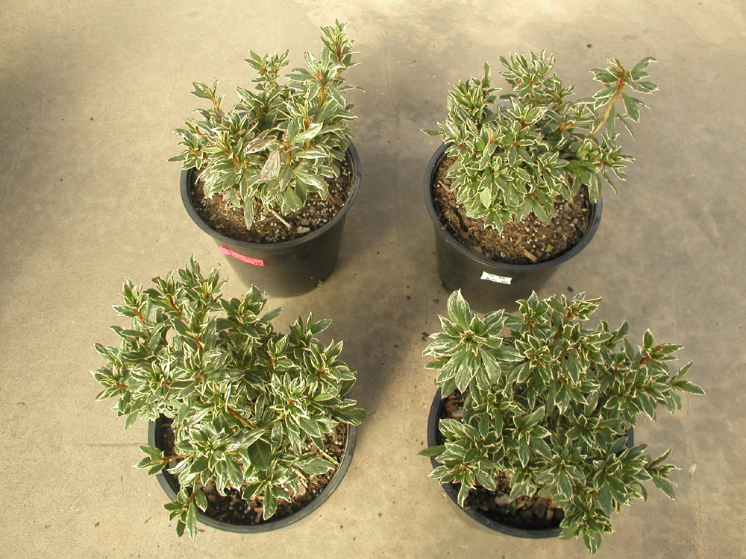
Phyto-infected
Control
Natural myco +Fert
Commercial myco +Fert
Fertilizer
Photo credits: Dr. Gladis Zinati

