SARE PARTNERSHIP GRANT: ONE08-092

FINAL REPORT

TITLE: Low input management practices for container ericaceous nursery crops

Image 2. Plant growth of azalea DVW cultivar as affected by P. cinnamomi in various treatments.
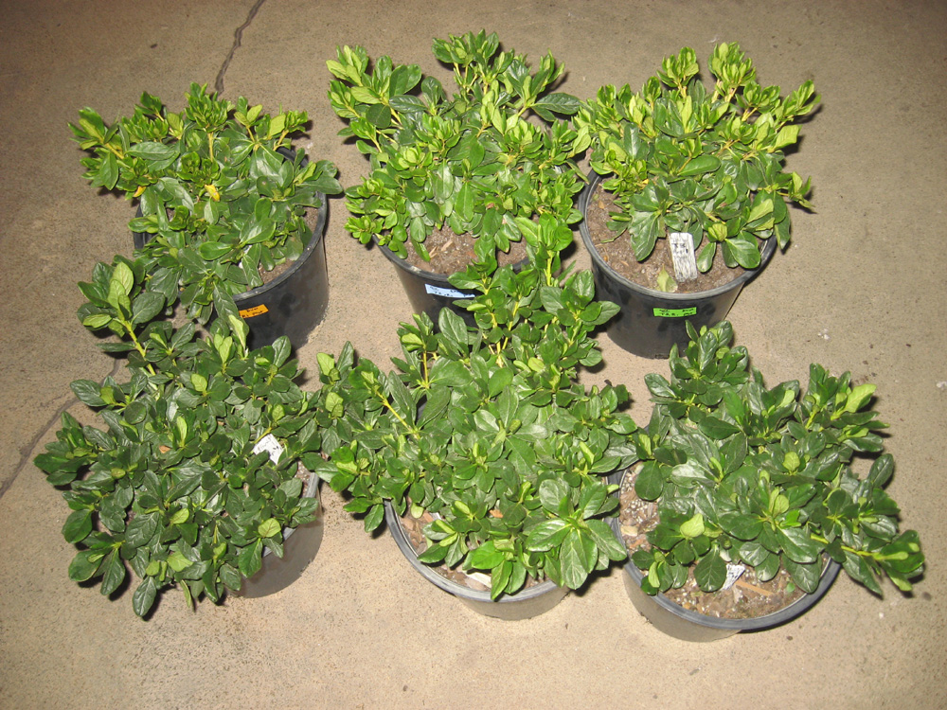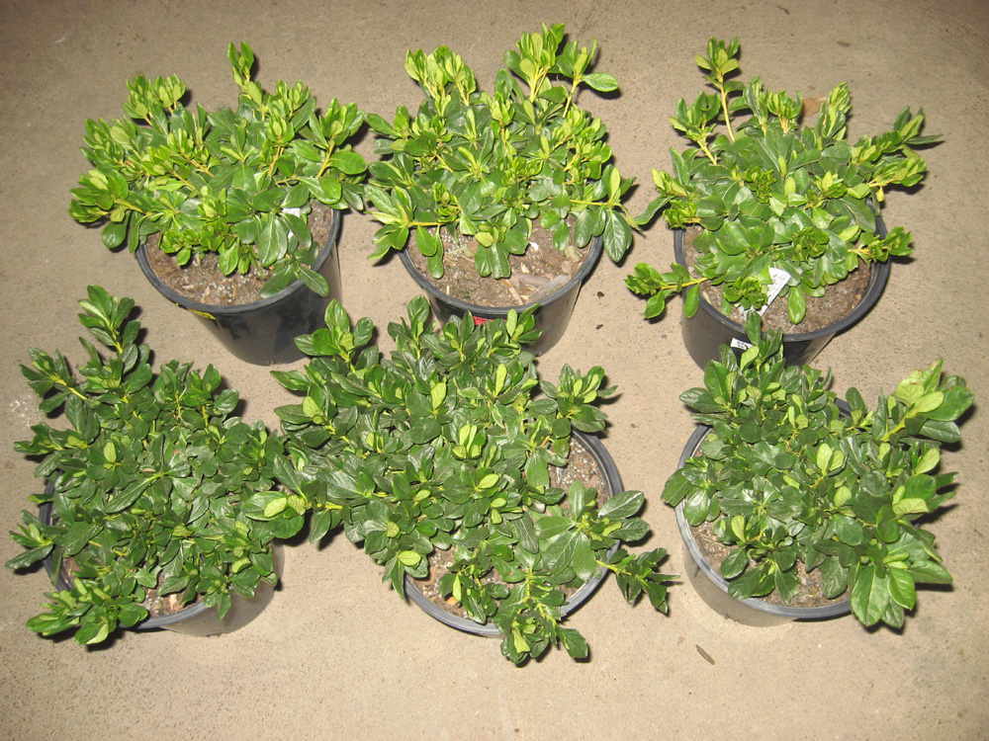
Phyto-infected
Control
Natural myco + fert
Commercial myco + fert
Fertilizer
Photo credits: Dr. Gladis Zinati

